ORAL VASOACTIVE MEDICATIONS:
A Review of Midodrine, Droxidopa and Pseudoephedrine
DePace NL, Vinik AI, Acosta C, Santos L, Murray GL, and Colombo J
ABSTRACT
No Abstract
Copyright: © 2022 by the authors. Submitted for open access publication under the Journal of Individualized Medicine and Therapies, of the Society of Individualized Medicine and Therapies, Inc.

INTRODUCTION
The medical term “orthostatic” is defined as relating to, or caused by, an upright or standing posture. Orthostatic Intolerance (OI) is an umbrella term for several conditions in which symptoms are made worse by upright posture and improve with recumbency. OI includes Postural Orthostatic Tachycardia Syndrome (POTS) and Orthostatic Hypotension (OH). In addition, Vasovagal Syncope is often co-morbid with Orthostatic dysfunction, as it presents with similar symptoms due to the fact that both lead to poor cerebral perfusion. For all of these conditions involving poor cerebral perfusion, there are only two drugs approved by the FDA and they are specifically for OH. The two approved drugs are vasoactive: Midodrine (ProAmatine) and Northera (Droxidopa). The management of these two drugs requires specialization and is why most common therapies for Orthostatic dysfunction and Syncope have been non-pharmacological (i.e., fluids with electrolytes, compression garments at multiple levels, isometric maneuvers, elevating head at night, and avoidance of known triggers, including large meals, heat exposure, and emotional stress). However, in many cases the non-pharmaceutical measures are not sufficient to meet the clinical goals of improving symptoms and function of patients. Here, we will focus on the pharmacological therapies. Midodrine and Northera have been used successfully off-label to treat POTS and all other OI disorders. The neurogenic forms of these Orthostatic disorders have, in general, the Dysautonomia Sympathetic Withdrawal (SW) as the etiology of the corresponding pathogenesis []. A reason why the Dysautonomia Vasovagal Syncope is included is that the Vagal excess (aka., Parasympathetic Excess or PE) is associated with Vasovagal Syncope. PE may mask SW.
This review will expand the knowledge of Midodrine and Northera, as well as Pseudoephedrine, describe their advantages and disadvantages, and describe their comparative data. We will include examples of patients with serial testing. It is hoped that this article will help to make the clinician more comfortable diagnosing these disorders and using these mainstay treatments as first-line therapy to treat this large population of patients with poor Quality of Life (QoL) and poor functioning. With treatment, these patients have improved QoL, largely helping them to return to productive lifestyles. With heart rate variability coupled with respiratory activity testing [], OI disorders, including pre-clinical forms, are easily detected, documented, and diagnosed by all clinicians. Treatment of OI disorders tends to be in the realm of the Cardiologist, Neurologist, and Endocrinologist; serial testing may be easily facilitated using P&S Monitoring.
Currently, diagnoses of OI conditions are also in the domain of Cardiologists, Neurologists, and Endocrinologists specifically, although all clinicians may be trained to diagnose. The Cardiologist, however, is typically the most experienced and trained to titrate these vasoactive medications. Some Cardiologists are also trained in the additional ancillary medication(s) that are often needed, such as volume-expanding agents, including Florinef (Fludrocortisone) and Desmopressin (DDAVP), and in some POTS cases, beta-blockers and Corlanor (Ivabradine). They are specifically trained in serially treating and following such patients in monitoring their HR, BP, and weight responses. These patients are complicated, and, while they may be diagnosed by even Family Medicine practitioners, they need to be referred to Cardiology to prescribe and be followed appropriately, especially as chest tightness, palpitations, and shortness of breath are present in high percentages of these patients. The use of these medications may reduce or, in some cases, increase these symptoms. The Cardiologist is best suited to exclude significant intrinsic cardiac disease as the cause of these symptoms, making it easier for them to titrate medications to reach an acceptable clinical endpoint.

ORTHOSTATIC DYSFUNCTION
There is a complex interplay between the heart, blood vessels, and the nervous system (primarily the autonomic nervous system, including both of its branches) that must all coordinate properly in the struggle against gravity to simply stand up or for any change to a head-up posture. This is the consequence of having a brain that may be located higher than the heart. Upon standing (or assuming any head-up posture), venous pooling increases in the lower, peripheral veins due to the inertia of blood being higher than neuromuscular activity. Note, this is a basis for Respiratory Sinus Arrhythmia. With every inhalation, Heart Rate (HR) normally increases a little and then decreases a little with every exhalation. People normally inhale just before assuming a head-up posture (standing), which already begins to increase HR to begin to move blood to overcome the discrepancy in inertia.
Upon assuming a head-up posture, 500 ml to 1000 ml of blood may pool in the lower, peripheral vasculature under abnormal conditions (Orthostatic Dysfunction) or needs to be shifted up to the abdomen to support the heart in pumping blood to the brain (maintaining normal brain perfusion, as well as cardiac perfusion) under normal conditions (see Figure 1) []. Decreased venous return decreases arterial pressure, ventricular filling, and cardiac output, and decreases Baroreceptor and Cardiac Mechano-receptor activity. The decreased receptor activity stimulates the Intermediolateral Cell Column in the Thoracic and Lumbar regions of the Spinal Column via Paravertebral Ganglionic Cells and activates Hypothalamus, Midbrain, and Brainstem nuclei to, among others, activate the two branches of the Autonomic Nervous System (ANS). In turn, Parasympathetic discharge increases and Sympathetic discharge decreases in the Nucleus Tractus Solitarius. The referenced Sympathetic activity elicits both an alpha-adrenergic (Sympathetic) response to the peripheral vasculature and a beta-adrenergic response to the heart, both increasing systemic BP. The increase in Parasympathetic activity in response to Baro- and Mechano-receptor activity stimulates the Sinus Node (of the heart) and decreases HR.

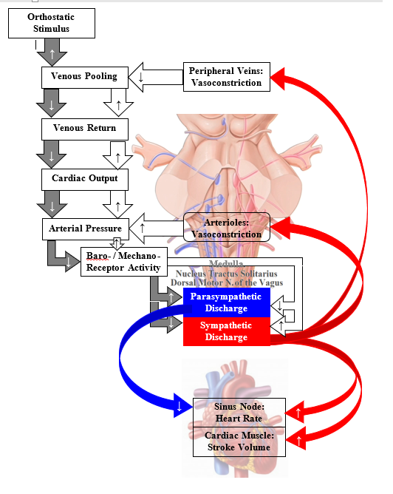
Figure 1: Circulatory Response to Orthostasis (pink represents Nucleus Tractus Solitarius). See text for details [Adapted from 3, Slide 2]

Normally, the decrease in cardiac output, arterial pressure, and baro- and mechano-receptor activity stimulates Sympathetic discharge, which releases Catecholamines, mainly Norepinephrine, from post-ganglionic cells. Through the beta-adrenergic system, this release stimulates cardiac muscle to increase stroke volume and, through the alpha-adrenergic system, stimulates both peripheral vein vasoconstriction and arteriole vasoconstriction. The increase in vasoconstriction increases venous return, arterial pressure (respectively), ventricular filling, and cardiac output. These increases in turn increase Baro- and Mechano-receptor activity and return the Parasympathetics and Sympathetics (P&S) to the resting state, thereby, supporting quiet standing.
Under Orthostatic Dysfunction conditions, there is a breakdown in any one or more of these P&S (autonomic) reflexes, or there may be some end-organ dysfunction (i.e., dysfunctional lower peripheral vein valves or the walls of those veins). Therefore, Orthostatic Dysfunction has several causes. The normal compensatory mechanism to increase blood pressure (BP) does not occur, or may be delayed, in patients with Orthostatic Hypotension (OH). Their BP remains low, which triggers symptoms. BP typically returns to normal once the patient sits or lies down, but this depends on the severity of the underlying cause. A more detailed look of these processes in the brain stem is provided in Figure 2 []. Some of the afferent sensory ganglia of the Glossopharyngeal (IX-CN) and Vagus (X-CN) Nerves are located in the Nucleus Tractus Solitarius (NTS), which takes BP information in the form of Baro- and Mechano-receptor signals from the heart and two arterial sinuses (Aortic Arch and Carotid Sinus), integrates them, and distributes them within the brainstem and up to the cortex. One of the outputs of the NTS that goes to the Nucleus Accumbens (the “Pleasure Center”) is the short path through the brain to modulate HR and thereby BP via the IX-CN to the Sinus Node of the Heart. This is also the primary source of the whole-body sensations associated with Orthostatic Dysfunction, and it helps forewarn of possible loss of balance. In normal Orthostatic function, this pathway is inhibited.
The longer pathway is through the Ventrolateral Medulla (VLM). The other NTS output is received by the Caudal VLM (CVLM). Stimulation of the CVLM elicits depressor responses, including a decrease in BP. In normal Orthostatic function, the depressor function of the CVLM is inhibited. The CVLM then communicates with the Rostral VLM (RVLM), which is the main brainstem BP control nucleus. In normal Orthostatic function, RVLM will signal a (temporary) increase in BP to compensate for the effect of gravity on blood pooling in the lower extremities as transmitted by the Baro- and Mechano-receptors. The requisite modulatory signals from the RVLM are transmitted down the spinal cord, out to the Sympathetic Chain Ganglia at both the level of the heart (the beta-adrenergic response to Orthostatic changes) and lower down the Chain for the lower, peripheral vasculature (the alpha-adrenergic response to Orthostatic changes) and then to the target organs.
Disruption of any of these pathways or damage to any of these nuclei or ganglia or their associated end-organs may lead to Orthostatic Dysfunction and its related symptoms. The effect of brain (Cortex) swelling from concussion or stroke may compress the brainstem and lead to symptoms of Orthostatic Dysfunction. In fact, brain trauma of any sort, including mental (e.g., PTSD), may disrupt any of these brainstem pathways, especially given that the Limbic System is involved through the Nucleus Accumbens. The “giddiness” or euphoria associated with addictive substances and addiction itself elicits lightheadedness through the involvement of the Nucleus Accumbens.

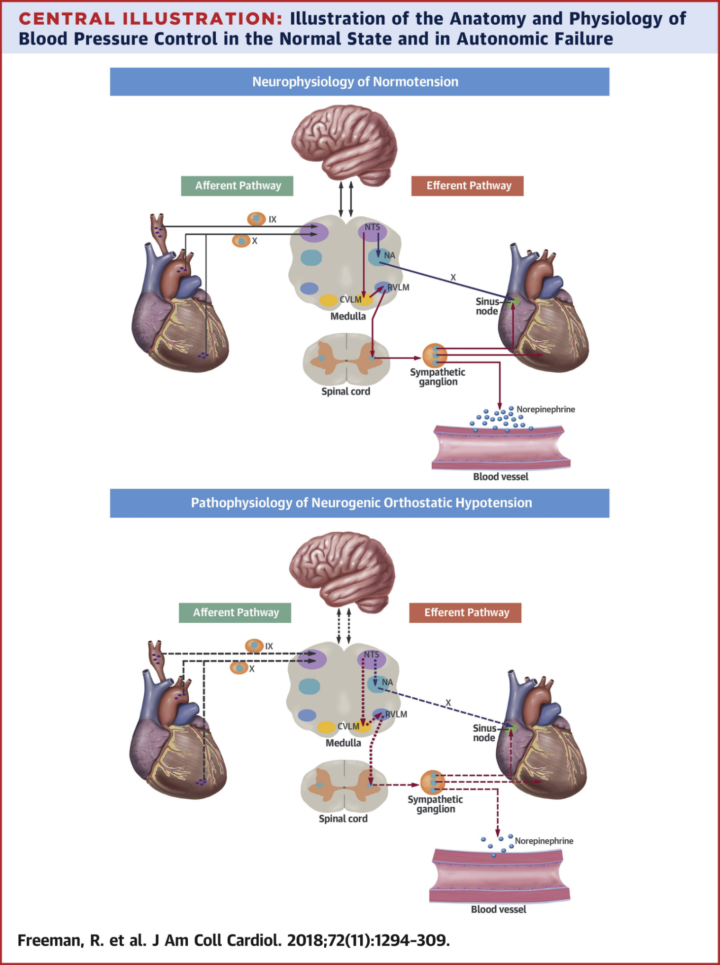
Figure 2: The anatomy and physiology of blood
pressure control: the upper panel displays the
neurophysiology of normal Orthostatic function,
and the lower panel displays the pathophysiology
of Orthostatic Dysfunction. Abbreviations: IX, 9th
Cranial Nerve (Glossopharyngeal Nerve); X, 10th Cranial Nerve (Vagus N.); CVLM, Caudal Ventrolateral Medulla; NA, Nucleus Accumbens; NTS, Nucleus Tractus Solitarius; RVLM, Rostral Ventrolateral Medulla. [4]

The involvement of the RVLM under prolonged Orthostatic Dysfunction may be the source of secondary hypertension. In an attempt to maintain normal brain perfusion with significant venous pooling, the body seems to adjust BP higher to compensate for the Orthostatic Dysfunction. Apparently, to help ensure proper brain perfusion upon standing, if BP drops by 10 mmHg (systolic) for example, then the brain seems to reset the resting BP to be 10 mmHg higher than normal for standing to ensure proper perfusion. As a specific example, if resting, systolic BP is 110 mmHg and the required standing, systolic BP is 120 mmHg, but upon standing the BP drops to 100 mmHg, then eventually, the resting, systolic BP will become 130 mmHg. This becomes a problem when a cardiologist sees a persistently high, resting, systolic BP, without any other information or with the concern that Hypertension is more of a clinical risk than lightheadedness, and tries to treat the Hypertension as the primary dysfunction. Then, as we often see, the patient’s body defeats the therapy or the patient feels worse, due to lightheadedness or fatigue, and becomes non-compliant, or the patient’s BP becomes labile or difficult to control.
Prolonging this situation (high Systolic BP and venous pooling, perhaps exacerbated by anti-Hypertension therapy) may lead to Heart Failure. Remember, Diastolic BP may also fall in Orthostatic Dysfunction. A drop in Diastolic BP may result in poor cardiac perfusion, resulting in a heart that is being driven to work harder to increase systolic BP with fewer resources due to poor venous return compounded by lower Diastolic pressure. Again, continued anti-Hypertension therapy only serves to exacerbate this condition by attempting to further lower both Systolic and Diastolic BP. As a result of all of these forces, Pulse Pressure increases and a Pulse Pressure of more than 60 mmHg is a risk indicator for Heart Failure.
Our experience in most of our patients is that treating Orthostatic Dysfunction as the primary, while taking care to not exacerbate any already high BP conditions, will first lead to a relief of the Orthostatic Dysfunction, and then (eventually) a relief of the Hypertension. The latter often occurs organically, unless there are end-organ issues. such as increased arterial stiffness. Approximately three months after relief of Orthostatic Dysfunction, should high BP linger, then anti-Hypertension therapy is recommended.
The common neurological cause of Orthostatic Dysfunction is a lack of a proper alpha-1-Sympathetic stimulation. We call this neurologic cause Sympathetic Withdrawal (SW), measured as a decrease in Sympathetic activity upon standing (see Figure 3, top) []. Proper alpha-1-Sympathetic stimulation (see Figure 3, bottom) causes vasoconstriction of the peripheral vasculature. This vasoconstriction brings blood to the heart and supports the heart in delivering blood against gravity to the brain. SW is the autonomic dysfunction underlying POTS, (postural) neural-OH (NOH), and neural Orthostatic Intolerance (OI) disorders [5,13]. OI are Orthostatic Dysfunctions that do not meet the specific clinical criteria of POTS or NOH but are either trending in that direction or carry the symptoms of those disorders (pre-clinical conditions). In these pre-clinical conditions, the additional information of SW with the trend in HR or BP towards POTS or NOH, respectively, enables earlier identification and pre-clinical diagnoses and treatment. Why make your patients wait and suffer until their HR or BP changes are so great as to be potentially disabling or cause them to fall or otherwise cause more problems before we are able to treat them? This additional information could potentially reduce morbidity and mortality risk [9,10].
Given that the P&S branches of the ANS work synergistically, we should take a moment to mention the Parasympathetic component and the synergy. First, remember that the Sympathetics are the reactionary branch and that they react to the threshold set by the Parasympathetics. Normally upon standing, the Parasympathetics first decrease to potentiate and minimize the (alpha-) Sympathetic response (as indicated by the blue portion of the response curve in Figure 3, bottom, labeled “Normal”). This begins the process of vasoconstriction to move blood up to the abdomen to help the heart pump blood to the brain. Then, the Sympathetics increase (represented by the red line increasing, going to the right, in the Stand Response figure; Figure 3, bottom labeled “Normal”). This Sympathetic increase sustains the vasoconstriction and continues to shift the majority of the blood volume from the feet, against gravity, to the abdomen so that the heart may more easily pump it to the brain. This stand Sympathetic increase (the red response shown at the beginning of section ‘F’ in the P&S Trends plot, Figure 4) should be significantly less than that for Valsalva
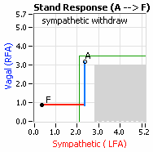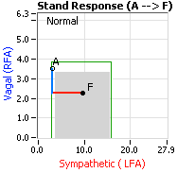 (section ‘D’ in the P&S Trends plot, Figure 4), at least a 3:1 ratio, Valsalva to stand.
Figure 3: Stand Response plots: Normal (bottom) and Sympathetic Withdrawal (SW, top) [5]. The abscissa represents Sympathetic activity and the red portion of the curve documents the patient’s Sympathetic response to stand in beats per minute² (bpm²). The ordinate represents Parasympathetic activity and the blue portion of the curve documents the patient’s Parasympathetic response to stand in bpm². Point ‘A’ represents the patient’s resting (sitting) P&S responses and point ‘F’ represents the patient’s stand P&S responses. The grey area of the graph represents the range of normal Stand responses given the patient’s own resting response (point ‘A’, which is always in the upper left corner of the normal area).
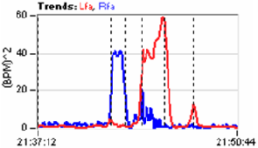While a normal Parasympathetic response is typically assumed in response to a Sympathetic challenge (i.e., Valsalva or stand), in dysfunctional cases, a normal Parasympathetic response is not always the actual response. The Parasympathetics, for some reason, may increase upon assuming an upright posture (e.g., standing). We call this Parasympathetic Excess (PE) [5]. We note this here because PE may mask SW (Figure 5, top) by artificially inflating the Sympathetic response to upright posture [5]. Yet, with PE therapy, SW is often unmasked (Figure 5, bottom) [5]. Therefore, if PE is demonstrated with a BP or HR trend that may indicate NOH or POTS, respectively, and symptoms of PE are reported, we tend to treat both PE and SW together [,]. This minimizes a lack of tolerance to therapy, because the other cause of lightheadedness persists. It also minimizes early, repeat visits for additional therapy for the other cause of lightheadedness.
A B C D E F
Figure 4: P&S Trends plots from a healthy, young, adult subject. Time is represented on the abscissa and P&S (RFa, blue & LFa, red, respectively) is represented on the ordinate. The six sections of the graph (‘A’ through ‘F’) are the patient’s responses to the six phases of the clinical study: A) Resting baseline, B) Deep Breathing, C) Baseline, D) Valsalva Challenge, E) Baseline, and F) Stand. [5].
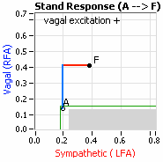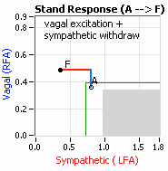Think of a car as the model. The Parasympathetics are the brakes, and the Sympathetics are the accelerator. When you are stopped at a red light with your foot on the brakes and the light turns green, what is the first thing you do? … You take your foot off the brakes. Even before you touch the accelerator, you begin to roll; you already begin to accelerate. Taking your foot off the brakes minimizes the amount gas (read that as Adrenaline) and acceleration (read that as Sympathetic stress) you need to reach your desired speed. The P&S nervous systems normally act in much the same manner: first, the Parasympathetics decrease to facilitate and minimize the Sympathetic response, and then the Sympathetics increase. Sympathetic Withdrawal is the abnormal decrease in alpha-Sympathetic activity upon standing (Figure 3, bottom).
Figure 5: Stand Response plots displaying Parasympathetic Excess: Top, possibly masking Sympathetic Withdrawal (SW), and Bottom, demonstrating SW [5]. See Figure 3 for details.
PE is a hidden abnormality to most autonomic testing. Since most autonomic tests only measure total autonomic function (P + S), there is an underlying assumption or approximation that must be made. The standard assumption in the overall stress response is that the Sympathetic response is much greater than the Parasympathetic response, since the Parasympathetics are supposed to decrease and the Sympathetics are supposed to increase. Note, for P&S Monitoring, in addition to the “bad” stresses that are well known and considered (e.g., Psychosocial stresses), we consider upright posture as stress also, as well as exercise and other “good” stresses. Since stress is known to be mediated through the Sympathetics, and they are, it is assumed that the net Sympathetic response is the primary issue, and it is. However, the underlying assumption is that the Parasympathetics decrease as is expected and normal. This is not always the case. In fact, an increase in Parasympathetic activity at just this wrong time will inflate the resulting Sympathetic response, for it is well known that the Parasympathetics set the threshold around which the Sympathetics respond. This is why we claim PE to be hidden to most other autonomic measures. It is hidden because of the need for the above assumption when diagnosing from a mixed measure of total autonomic function. The fact that the Parasympathetics establish this threshold is also why we typically treat PE as the primary autonomic dysfunction. Then, after PE is relieved, often any resulting Sympathetic Excesses are relieved. Then, ultimately excesses in BP or HR are relieved, assuming no end-organ dysfunction. The last two steps may take a little time, possibly a couple of months each, depending on age and duration of disorder. [5]
PE (whether Valsalva or stand – simulating Sympathetic stresses) is associated with the following: difficult-to-control BP, blood glucose, hormone level, or weight, difficult-to-describe pain syndromes (including CRPS), unexplained arrhythmia (palpitations) or seizure, temperature dysregulation (both response to heat or cold and sweat responses), and symptoms of depression or anxiety, ADD/ADHD, fatigue, exercise intolerance, sex dysfunction, sleep or GI disturbance, lightheadedness, cognitive dysfunction or “brain fog”, or frequent headache or migraine. [5]
Also, we specify that vasoconstriction is a function of the alpha-Sympathetic branch of the Sympathetic nervous system. As you know, there is also a Beta-Sympathetic branch that primarily that controls and coordinates the heart and lungs. We have labeled an abnormal beta-Sympathetic increase (excess) Sympathetic Excess (SE, upon standing, Figure 6, bottom). SE is associated with Syncope [5,]. SE with PE (Figure 6, top) is Vasovagal Syncope (VVS: PE is associated with the Vagal component and SE is associated with the Syncope component) [8]. SE with an abnormal HR response to stand is Neurogenic Syncope [8]. Cardiogenic Syncope is a diagnosis by omission of the other two [8]. Of course, there may be combinations of the above, such as Neurocardiogenic Syncope [8]. Like SW, PE and SE provide additional information to enable improved differential diagnoses, earlier detection, and earlier therapy to improve patient outcomes [8].
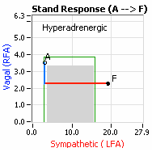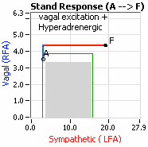SW is present when the alpha-1 Sympathetics do not respond appropriately upon standing. This will produce symptoms of lightheadedness, syncope (fainting), pre-syncope, fatigue, brain fog, difficulties finding words, cognitive and memory difficulties, and sleep difficulties [5]. In the USA, 20 million people are known to have OI symptoms [3] which significantly impact individuals’ ability to function, and thereby, their Quality of Life (QoL) and work and disability status.
Figure 6: Stand Response plots displaying Sympathetic Excess, an indication for possible Syncope: Top, with Parasympathetic Excess (PE, indicating possible Vasovagal Syncope), and Bottom, without PE (indicating possible Neurogenic or Cardiogenic Syncope, depending on additional data). Neurocardiogenic syncope could be indicated by either depending on additional Cardiological data [5]. See Figure 3 for details.
Patients with OI who are younger are predisposed to develop the more extreme condition of POTS (see OI Algorithm, Figure 8). POTS patients are predominantly female. Women tend towards POTS. This is due to the fact that, on average, women are born with physically smaller hearts than men. Therefore, when their hearts become deconditioned, their hearts do not have the leverage to increase pressure to deliver more blood to the brain, so it resorts to the only other way, and that is to increase rate to deliver more blood to the brain. This increased rate is Tachycardia. Figure 7 displays data from a typical POTS patient. The Orthostatic Dysfunction is demonstrated by the SW as displayed in Figure 7, right panel, and the Tachycardia is demonstrated by the cardiogram (Figure 7, left panel red (upper) trace). Figure 7, right panel, is the Cardio-Respiratory Coupling graph for this patient with the lower (gray) trace displaying the instantaneous Respiratory Activity and the upper (red) trace displaying the HR during the first five minutes of standing from a seated posture. Note how the HR does not return to baseline as would be normal, but increases and continues to increase throughout the stand period and, for the most part, exceeds 120 bpm.
OH typically occurs in older people (see Figure 8) and often accompanies other disorders or diseases, such as Parkinson’s Disease, Diabetes, and Amalyoid disease, as well as many other chronic diseases or disorders (including chronic pain disorders). Chronic diseases or disorders often involve autonomic dysfunction, and a first symptom of Autonomic Dysfunction is Orthostatic Dysfunction. Orthostatic Dysfunction is arguably the most debilitating symptom of autonomic dysfunction [,]. OH patients tend to be older, their hearts tend to be larger, and larger hearts attempt to leverage more pressure; however, in NOH patients, this fails and pressure drops due to the SW and consequent lack of vasoconstriction.
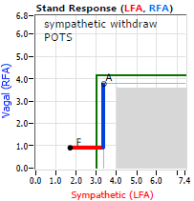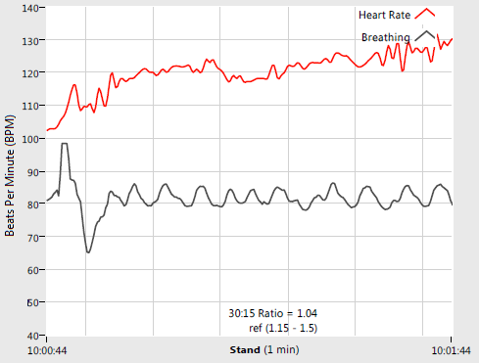Previously, based on waveform assessment with beat-to-beat BP and tilt-table testing, NOH is differentiated into three sub-types: 1) Classical NOH, 2) Delayed NOH, and 3) Initial NOH (see Figure 9) [4]. A beat-to-beat BP with tilt test of a patient demonstrating Vasovagal Syncope is presented in Figure 10 [].
Figure 7: Postural Orthostatic Tachycardia Syndrome (POTS) patient’s Cardio-Respiratory Coupling graph (CCG, top) and Stand Response plot (bottom, see Figure 3). The red curve in the CCG is the cardiogram (bpm²) and the gray curve is Respiratory Activity (mV). The Cardiogram demonstrates Tachycardia and the Response plot demonstrates Orthostatic Dysfunction (Sympathetic Withdrawal). Together, the two graphs indicate POTS [5].
VVS is a common co-morbidity with OI patients. For example, we document VVS in approximately one-third of our POTS patients. While Orthostatic Dysfunction is an alpha-Adrenergic dysfunction and is characterized by SW, Syncope is a beta-Adrenergic dysfunction and is characterized by a stand Sympathetic Excess (SE). Therefore, it is possible for both to co-exist (e.g., see Figure 12). The Vagal excess or Parasympathetic Excess (PE) that characterizes the Vagal component of VVS may occur at any time during P&S testing. With VVS or Reflex Syncope, there is often an abrupt Sympathetic Withdrawal (SW) or vasodepressor response as Blood Pressure (BP) falls. Heart rate may drop as well, possibly due to a secondary beta-adrenergic withdrawal due to the orthostatic volume shift. Note, if PE occurs upon standing, it often masks SW, and the Orthostatic Dysfunction is inferred by abnormal changes in HR or BP with symptoms. In this Orthostatic Dysfunction and VVS patient sub-population, anti-cholinergic therapy (very, very low-dose anti-depressant therapy, e.g., no more than 10.0 mg Nortriptyline, qd, dinner) is prophylactic in treating co-morbid VVS. While SW is often a secondary dysfunction due to being masked (as confirmed by tilt or P&S testing), Midodrine is still the first line therapy, helping to relieve both dysautonomias: Orthostatic Dysfunction (OI, POTS, or NOH) and VVS.

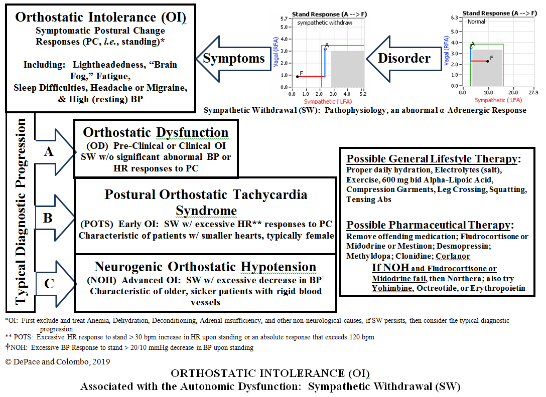
Figure 8: Orthostatic Intolerance (OI) associated with the Autonomic Dysfunction: Sympathetic Withdrawal (SW). Orthostatic Dysfunction starts as SW (typically asymptomatic), due to disease or trauma (mental or physical), and progresses to OI (SW with symptoms), then progresses to POTS (SW with Tachycardia upon standing) in younger patients or NOH (SW with a drop in BP upon standing) in older patients [6]. Corlanor is an option for POTS only.

Vasovagal Syncope is also known as a "simple fainting spell." It is mediated by a neurological reflex within the body. What happens is a patient has a temporary loss of consciousness when a neurological reflex is activated. This reflex causes a sudden dilatation of the blood vessels of the legs where pooling of blood occurs in the lower extremities. It can also cause a slow HR, sometimes down to 20 beats per minute, which can also lead to reduced cardiac output. At times, both mechanisms can be operative, simultaneously. Oftentimes, VVS is known as Neuro-Cardiogenic Syncope or Reflex Syncope. First, we will briefly review the Vagus Nerve (see picture, below). The Vagus Nerve is the 10th cranial nerve in the body. There are 12 cranial nerves that emanate from the Central Nervous System. It is the longest nerve in the body. It has two branches of sensory nerve cells in the body, and it connects the brain stem to the body. What it actually does is allow the brain to monitor and receive information about many of the various organs' different functions in the body, linking many organ systems to the brain. The Vagus Nerve is an intricate part of the ANS, a part of what we term the Parasympathetic Nervous System. This is a part of the nervous system that slows digestion, slows HR, and causes the urinary bladder to contract or the GI tract to have motility. The Vagus Nerve is also 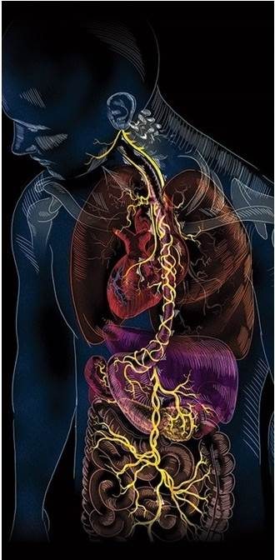
monitored for sensory activities and motors information for movement within the body.
The Vagus nervous system has Parasympathetic special motor and sensory functions. For example, the sensory input from the throat, heart, lungs, and abdomen is part of the Vagus nerve. It has special sensory functions in providing sensation behind the tongue at the back of the mouth and top of the throat – the gag reflex. In terms of motor functions, it provides an important function for the muscles in the neck responsible for swallowing and speech.
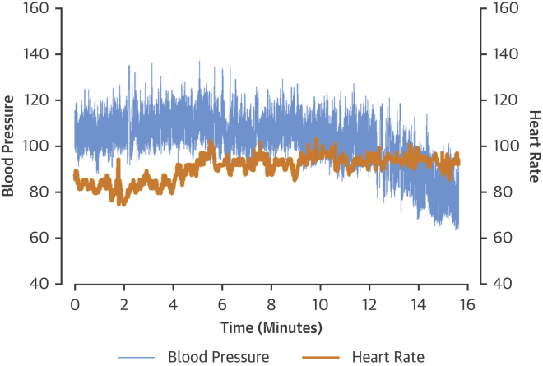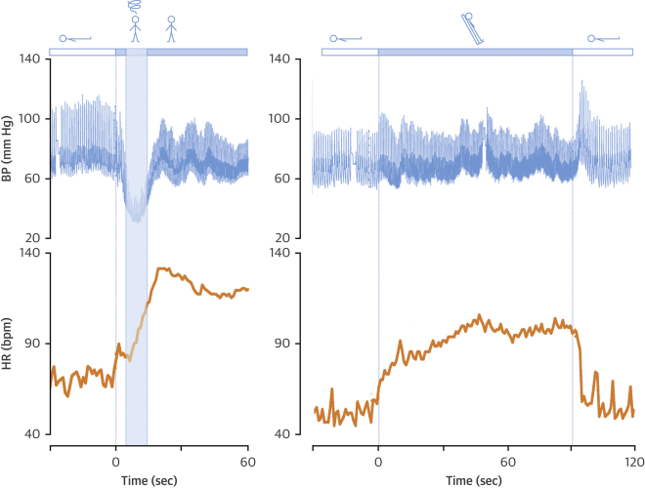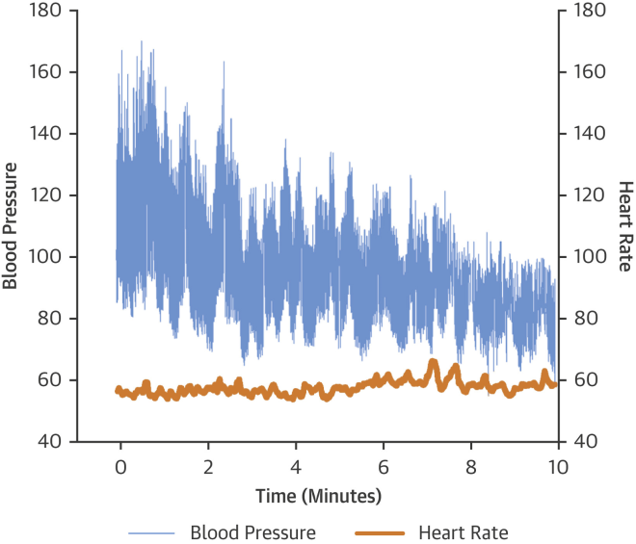
As mentioned above, the Parasympathetic function is important for the urinary tract, digestive tract, respirations, and HR functioning. The Vagus nerve activity is extremely important in our bodily functions, such as urination, defecation, and sexual function. Many people who suffer from gastrointestinal symptoms have an abnormality of the communication between the brain and the gut, the so-called brain-gut connection. The Vagus Nerve delivers information from the gut to the brain, and then back again through the motor branches connected to the gut muscles to move the stomach and intestines – this is the source of “butterflies” in your stomach when you are nervous about something as well as the motility needed to digest your food and eliminate waste.
Figure 9: Beat-to-beat BP waveforms (blue curves) with accompanying cardiograms (brown curves) from tilt-table testing demonstrating responses from patients with:
1) Classical NOH, upper left;
2) Delayed NOH, upper right; and
3) Initial NOH; re-printed from [4].
The Vagus Nerve is also important in lowering HR and BP. When it becomes overactive, it can prevent the HR from pumping blood to the brain, which can occur with Vasovagal Syncope. Excess in Vagus activity intermittently can cause loss of consciousness.
While tilt-table testing is often considered the test of choice for differentiating Vasovagal Syncope (see Figure 10), the simple placement of the patient on the tilt-table already treats the patient. Strapping the patient on the table stimulates the Sympathetic nervous system and the patients do not become symptomatic. P&S Monitoring tests for Vagal or Parasympathetic Excess (PE) without the need for tilt-table and is often more revealing. Furthermore, in patients where the Orthostatic Dysfunction of POTS or other orthostatic types of fainting (where the BP drops because blood pools in the legs due to a failure of the Sympathetic nervous system), and the PE of VVS are co-morbid, tilt-table is unable to differentiate the two. As a result, some do not believe they may co-exist. Yet they are caused by dysfunctions in two different branches of the ANS. P&S Monitoring is the only technology that is able to objectively quantify Parasympathetic activity, without assumption or approximation, and, therefore, reliably and repeatably document and differentiate VVS as well as chronic PE (see Figure 11).
Chronic PE may include VVS, but whereas VVS is episodic or even recurrent and patients act and appear normal between episodes, chronic PE is persistently symptomatic with persistent or chronic fatigue being the typical chief complaint. Chronic PE involves: difficult-to-control BP, blood glucose, hormone level, or weight, difficult-to-describe pain syndromes (including CRPS), unexplained arrhythmia (palpitations) or seizure, temperature dysregulation (both response to heat or cold and sweat responses), and symptoms of depression or anxiety, fatigue, exercise intolerance, sex dysfunction, sleep or GI disturbance, lightheadedness, cognitive dysfunction or “brain fog”, or frequent headache or migraine [5].
If you consider the P&S nervous systems as the “brakes” and “accelerator” of your car, chronic PE is like “riding the brakes” or driving with your emergency brake on. When you “accelerate”, you still go, but you need to over-rev the engine to get up to speed. As a result, little stresses are amplified, little worries become great fears, little concerns become anxieties, little touches become painful, little reactions become allergic inflammatory reactions; all because the PE is forcing the Sympathetics to over-react. This is a source of fatigue and conditions like depression with anxiety (bipolar disease), attention deficit disorders, PTSD, and labile hypertension. There are many causes of chronic PE, mostly involving some sort of physical, mental, or physiological trauma, including severe illness, surgery, injury, trauma (both

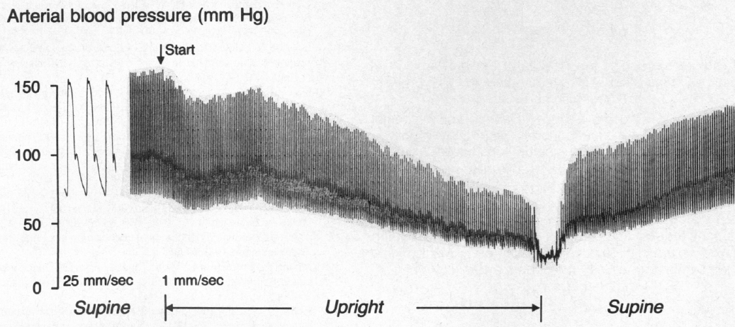
Beat-to-Beat BP (mmHg)
Figure 10: Vasovagal Syncope Response beat-to-beat BP (mmHg) response to tilt-table test. Head-up tilt at “Start,” for duration of “Upright.” Syncope occurred just before the end of “Upright” [11].

Figure 11: Stand Response plot demonstrating SW, from Figure 3, repeated here for convenience [5].
physical or mental), exposure, or even numerous pregnancies. The good news is that PE, whether chronic or Vasovagal, is treatable.
Again, with VVS, there is a sudden activation of the Vagus Verve. This is something that can occur episodically and be recurrent. It also can be chronic and can cause flare-ups with crescendo phases that occur where people can go into almost Syncopal phases of fainting every day. VVS can be precipitated by emotional stress or standing upright for long periods of time or even prolonged sitting. It is oftentimes situational and can be caused by a hot environment, coughing spells, emotions, or urination (so-called Micturition Syncope), eating a large meal, severe pain or ongoing chronic pain, and alcohol consumption. Autonomic testing with a tilt-test or P&S testing (P&S Monitoring) is sometimes necessary to document VVS. These tests can show the actual reflex occurring, where there is slowing of the heart or a progressive early drop in BP which is gradual and the onset is without symptoms. This is later followed by a rapid drop in BP and finally a slow HR. As shown in our example above, VVS is often preceded by a prodrome, which is nausea, excessive fatigue, sweating, diaphoresis, or other GI symptoms, such as abdominal pain or feelings of defecation. These prodromes should be recognized by the patient so they can lie down, elevate their legs on a box or a chair, and avoid an overt syncopal attack (passing out).
In all patients with Orthostatic Dysfunction, a deconditioned heart is a primary disorder, and the associated primary autonomic disorder is SW (see Figure 11). A deconditioned heart does not necessarily mean that the skeletal muscles of the body are deconditioned. Patients with Orthostatic Dysfunction and deconditioned hearts are often in good physical condition and are (or were) able to exercise, even rigorously. In fact, the exercise made them feel better (temporarily) because it engaged the skeletal muscles to help bring blood to the heart to improve circulation, including to the brain. Their feet were warmer and in less pain, and their brains were better perfused and more “awake,” resulting in less “brain fog” and memory or cognitive difficulties. The exercise was a form of temporary, self-medication. While exercise is ultimately the best medicine to recondition the heart, the alpha-Sympathetic nerves also need to be “retrained” to respond properly and increase to cause the required vasoconstriction needed to support the heart.
On another note, Autonomic Dysfunction may involve multiple dysfunctions. As in the Stand Response Plot introduced above and repeated for here convenience (see Figure 12, top), Orthostatic Dysfunction (e.g., SW) is often accompanied by a Vagal or Parasympathetic Excess. PE may be associated with Vasovagal Syncope. Again, the PE (represented by the blue line increasing in the Stand Response plot, Figure 12, top) is the Vagal component, followed by the SW (represented by the red line decreasing in the Stand Response plot Figure 12, top). The response plot is a representation of the average P&S responses over the stand portion of the clinical study. Sometimes, abnormal P&S responses are lost in the averaging process. The lower graph in Figure 12 presents the Trends Plot that is associated with a Stand Response Plot that reports normal, as in Figure 3, bottom. This is a Trends Plot depicting the P&S response to the clinical study from an adult patient with SW underlying POTS and Vasovagal Syncope, who is age-, gender-, and BMI-matched with the normal adult Trends Plot from earlier in this manuscript.
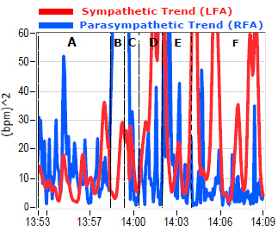 In this Trends Plot, Syncope is indicated by the fact that the peak Sympathetic activity (red curve) during stand (Section ‘F’) is comparable to the peak of the Sympathetic response to Valsalva (Section ‘D’). This Sympathetic Excess, as it turns out, is a beta-adrenergic response. PE is indicated by the excess P-activity (blue curve) throughout the test, including the stand portion. Together, they indicate Vasovagal Syncope. As is often the case, and confirmed by the BP response to stand and reconfirmed later in this case by the unmasking of SW with therapy, the PE inflates the Sympathetic responses, including the alpha-adrenergic response. While the decrease in BP in response to standing (a drop of 8mmHg, systolic) did not qualify for NOH, the fact that the Sympathetic response was amplified by the PE suggests that the BP response was also buoyed. The HR response to stand included peaks in excess of 120 bpm. Together, the SW with the abnormal BP response to stand indicates OI. The OI, together with the HR responses greater than 120 bpm, indicates POTS. This is a complicated case of a fairly young (32 y/o) and seemingly healthy female with a complex of symptoms and Dysautonomia, including both POTS and Vasovagal Syncope. This patient was treated with low-dose Midodrine (2.5 mg, tid, titrated very slowly, over eight weeks) for OI, very low-dose Nortriptyline (2.5 mg, qd, dinner) for PE, and high-dose (r)ALA (600 mg, bid) also for OI, with low-dose beta-blocker (Propanolol, 10 mg, prn), and a recommendation for low-and-slow exercise (e.g., a slow version of the Modified Dallas Program []) for six months, also for the PE.
Figure 12: Stand Response plot (top) and P&S Trends plot (bottom) demonstrating multiple Autonomic Dysfunctions leading to multiple co-morbidities, in this case, POTS with Vasovagal Syncope. Compare Trends plot with a normal Trends plot in Figure 4. See text for details.
With P&S Monitoring (aka, Cardio-Respiratory Monitoring) [2,5], separate but simultaneous measurements of P&S nervous system activity are available in an easy-to-administer and -perform test in the clinic. With documentation of both SW and PE, both conditions may be treated simultaneously: one treatment to reverse SW (e.g., Midodrine or Northera with Alpha-Lipoic Acid) and one treatment to relieve PE (e.g., very low-dose Anticholinergics or low and slow Exercise).
Currently, there are three oral vasoactive medications (Midodrine, Droxidopa, and Pseudoephedrine) that are often used to treat ANS disorders. Mestinon (Pyridostigmine) is occasionally used and considered by some as an indirectly acting vasoactive drug. We usually use these medications in situations where there is SW (upon standing) and when symptoms of OI occur, including: Postural Orthostatic Tachycardia Syndrome (POTS), typically in the earlier stages of Autonomic Dysfunction, and Orthostatic Hypotension (OH), typically in the later stages of Autonomic Dysfunction (see Figure 8). They may also be used in Vagal or Reflex Syncope.
Compression stockings, fluids, and salt can be useful in these instances, but oftentimes vasoactive medications, which help constrict the veins in the lower extremities are more useful in conjunction with these other modalities. Autonomic Dysfunction with SW is usually due to a decreased ability of post-ganglionic Sympathetic neurons to release Norepinephrine. We often see this in OI disorders where patients complain of “brain fog,” especially when standing or sitting upright for long periods of time. Brain fog may include cognitive or concentration abnormalities, word-finding abnormalities, and short-term memory loss, as well as fatigue, symptoms of depression or pre-Syncope, and even occasional frank Syncope. Many times, patients have to lie down to get relief from these symptoms, and they feel giddy and dizzy. OI is the main contributor to persistent fatigue and Chronic Fatigue Syndrome (CFS). It is also a main contributor to exercise intolerance.
MIDODRINE (PROAMATINE)
For OH, there are two vasoactive drugs approved by the USFDA: Midodrine and Northera (Droxidopa). These two drugs have been used successfully off-label to treat POTS, OH, and all OI disorders in general which have SW as the etiology of the corresponding pathogenesis. This review will expand the knowledge of Midodrine and Northera, describe their advantages and disadvantages, and describe their comparative data. We will include examples of patients with serial testing. It is hoped that this article will help to make the clinician more comfortable diagnosing these disorders as well as using these mainstay treatments as first-line therapy to treat this large population of patients with poor QoL and poor functioning. With treatment, these patients have improved QoL, largely helping them to return to productive lifestyles. With Cardio-Respiratory Testing (P&S Monitoring) [2], OI disorders are easily able to be detected, documented, and diagnosed by all clinicians. Treatment of OI disorders tends to be in the realm of the Cardiologist, the Neurologist, and the Endocrinologist; and serial testing may be easily facilitated using P&S Monitoring.
Currently, diagnoses of OI conditions are in the domain of Cardiologists, Neurologists, and Endocrinologist specifically, although all clinicians may be trained to diagnose. The Cardiologist, however, is typically the most experienced and trained to titrate these vasoactive medications. The Cardiologists are also trained in the additional ancillary medication(s) that are often needed, such as volume-expanding agents (Fludrocortisone and Desmopressin) and beta-blockers (e.g., in POTS cases). They are specifically trained in serially treating and following such patients in monitoring their HR, BP, and weight responses. These patients are complicated, and, while they may be diagnosed by even Family Medicine practitioners, they need to be referred to Cardiology to prescribe and be followed appropriately, especially as chest tightness, palpitations, and SOB are present in a high percentage of these patients. The use of these medications may reduce or, in some cases, increase these symptoms. The Cardiologist is best suited to exclude significant intrinsic cardiac disease as the cause of these symptoms, which will make it easier for them to titrate medications to reach an acceptable clinical endpoint.
Midodrine (ProAmatine) is the most commonly used first-line drug in patients with OI, which, with Autonomic Dysfunction, is due to SW (there are other reasons for OI, mostly vascular in nature). Oftentimes, these patients can present with an accelerated tachycardia or POTS syndromes on standing or OH (including Neurogenic Orthostatic Hypotension, NOH) when standing. Many times, a BP or HR does not change significantly, and they just have evidence of SW. SW is detected with simple outpatient testing known as Cardio-Respiratory testing or P&S testing [5]. Midodrine is often started at 2.5 mg three times a day, titrated very slowly from half a pill every other morning for two to three weeks, to one pill a morning for two to three weeks, to one pill every morning and noon for two to three weeks, and finally to three pills a day (morning, noon, and evening). Note, at this dose, you should not lie flat for at least two hours after dosing. If you need to lie down, make sure you have two pillows under your head. In more severe cases, we may need to advance the Midodrine to 5 mg, three times a day, and one can go up to 10-15 mg three times a day in the most severe cases. (At these higher doses, you should not lie flat for four hours after dosing without at least two pillows under your head, or a wedge pillow, which is better.) Of course, Midodrine is contra-indicated for supine hypertension and high BP []. One hundred pills of Midodrine at the low dose generally cost a little over $100.00. Midodrine has also been used post-surgery and in septic shock patients in some studies to increase BP.
Eventually, once the Midodrine has retrained the alpha-Sympathetics to vasoconstrict upon standing, BP may actually decrease [13]. This decrease is due to the reduction in cardiac workload resulting from a reintegration of the lower vasculature with the heart in pumping blood to the brain.
Midodrine is an oral, peripherally-acting, alpha-Adrenergic agonist. It was approved by the FDA in 1996 for OH [4], and is often used intra-dialysis for hypotension or BP drops that occur with end-stage renal disease patients on dialysis who become hypotensive []. It is most frequently use as noted for Autonomic Dysfunction states, such as OI, OH [,,], and POTS [3,] patients [,,,,,,], as well as Vagal or Reflex Syncope []. Midodrine has been used in other situations besides the aforementioned Autonomic Dysfunction states [,,,,,]. It has been used in Septic Shock patients to improve BP [,,] and in a syndrome called Hepatorenal Syndrome, where it improves renal function []. In the Intensive Care Unit (ICU) [,], Midodrine has been used to substitute for a low dose of intravenous Phenylephrine, Vasopressin, or Norepinephrine.
Upon ingestion, the drug undergoes an enzymatic reaction to enact a metabolite Desglymidodrine. It has a similar mechanism of action compared to Norepinephrine. There may be an increase in BP due to the increased return of blood from the lower extremities to the heart while the heart is continuing to pump harder to draw blood from the lower extremities. This increase in BP is relatively short lived, perhaps up to nine to twelve months. The initial dosing of Midodrine should be avoided in patients with supine hypertension and restricted to patients with resting BPs less than 160/90, according to one study [13]. Otherwise, the increase in BP due to Midodrine may potentially lead to stroke.
Patients with NOH often present with compensatory systemic Hypertension. This is the reason anti-hypertensives may be used concurrently with Midodrine, such as Clonidine or Hydralazine. A very high BP does not preclude the use of Midodrine if the system Hypertension is adequately treated with these agents, except in patients with Pure Autonomic Failure, where Clonidine can raise BP [,]. Therefore, in conditions with OH and hypertension, selective therapies must be cautiously tailored in specific instances. Typically, patients with OH are treated during the day with pressor agents and patients should remain upright to prevent hypertension. Following an oral administration, 90% of Midodrine is rapidly absorbed. It may even be absorbed through the buccal mucosa, and patients have even chewed it to get a quick response, rather than swallowing it. So, it is absorbed through the mouth directly. The metabolite Desglymidodrine peaks within 1-2 hours with the subsequent half-life of 3-4 hours and is excreted in the urine; more on this below in “Mechanism of Action.”
The most frequent side-effects of Midodrine are piloerection (“Goose Bumps” on the skin), chills, scalp pruritus (“itchy” or “crawly” scalp), numbness and tingling on the face or throughout the body, and urinary retention or, at times, urethra discomfort, especially in males with benign prostatic hypertrophy. Please note that these symptoms are indications that the medicine is working. We understand that these symptoms may be overwhelming. That is why, as above, we highly recommend that the prescribed dosage be titrated very slowly, perhaps over as much as three months. We found this to be especially necessary in cases where patients have been previously prescribed high doses of Midodrine (10mg or more tid).
Many patients are frightened with the initial side-effects of Midodrine. Again, these include the piloerection, scalp pruritus, and paresthesias in the face. Droxidopa, which we will discuss later, has been associated with better treatment adherence compared to Midodrine because it does not have these early side-effects. We tell the patients these are really not side-effects but may be an indication that the vasoconstriction is actually working, and we are encouraged to see these reported symptoms, which reassures the patient has been compliant with the medication, it is being absorbed, and it is working. In fact, these symptoms are the result of the vasoconstriction we are attempting to restore in these patients. For those without SW, vasoconstriction is common, frequent, and largely ignored; like the shirt on your back. Until it was just mentioned, you are mostly unaware of it. This is the new normal we are promoting with vasoconstriction. You or your patients need to become used to it.
Again, Midodrine was cleared for the treatment of symptomatic OH. OH is a BP drop that makes people feel dizzy when they stand up [4]. In 2010, the USFDA proposed the withdrawal of Midodrine (ProAmatine), because of lack of studies that verified the clinical benefits of the drug. It was stated in a written statement by the USFDA that at the time, neither the original manufacturer nor any generic manufacturer had demonstrated the drug’s clinical benefit. However, further studies did show its efficacy, and the withdrawal was repealed. Studies in the ICU showed that Midodrine was effective to wean IV-pressors and shorten ICU and hospital length of stays [37,38]. At the time, over 100,000 patients were taking Midodrine for conditions that would otherwise be disabling and complaints were numerous. Subsequent studies have confirmed the efficacy of Midodrine in OI disorders [4]. We have used it off-label for other OI symptoms such as POTS [18].
Midodrine has been studied for OH and recurrent reflex Syncope (Vasovagal Syncope). In a systematic review [20], 11 trials involving 593 patients were included and reviewed. Three trials addressed health-related QoL in patients with recurrent reflex Syncope showing improvement with Midodrine. Seven trials addressed symptom improvement in matched, pooled data showing improvement with Midodrine in patients with OH. The evidence was low or moderate, but the confidence was present that suggested Midodrine showed a clinical and outcome improvement in patients with OH and Vagal Syncope.
Very little Midodrine crosses the Blood-Brain Barrier. However, occasionally, headaches have been reported, especially in the beginning, due to some of its vasoconstrictor effects. This may include additional head pressure due to more blood flow to the head and brain.
As mentioned, Midodrine has been used in Cirrhosis-related hemodynamic complications [14,36]. Another agent, Octreotide, has also been used in these instances with success. Further studies are still needed in this area.
Midodrine should only be considered when non-pharmacologic strategies (e.g., high-dose Alpha-Lipoic Acid [7]) with or without volume expanding drugs have failed to alleviate the patient's symptoms. However, we find that oftentimes pharmacologic agents, life-style changes, and even volume expansion drugs, such as Fludrocortisone and Desmopressin, are not effective as a stand-alone therapy. In fact, there are many problems with Fludrocortisone [], and there is a question of long-term results causing fibrosis; we are very careful in prescribing it, and only give it to patients that need further therapy on top of Midodrine. Therefore, Midodrine is a first-line agent. Midodrine can also lower HR, especially when used with alpha-Adrenergic blocking agents or even Beta-Blockers, and therefore HR should be monitored carefully when on Midodrine. Oftentimes, this is a beneficial effect, as many patients with OI disorders have a form of POTS with high HRs, and they welcome the decrease in the HR when Midodrine is started. When a person is on Midodrine, they should avoid over-the-counter drugs, such as Pseudoephedrine or other alpha-Adrenergic agonists. Again, one should not lay flat after taking Midodrine for at least two hours (at very-low dose, or four hours at higher doses) because it can raise BP at times with an overshoot. Midodrine should be taken 5 to 10 minutes before rising, right at the bedside to counter early morning sever symptoms. The final dose should be taken three (3) to four (4) hours before laying down, including in bed. We generally prescribe it at 8am, 12pm, and 4pm in most patients. This may vary depending time of waking.
MIDODRINE MECHANISM OF ACTION:
The mechanism of action of Midodrine is actually quite complex. It is a selective Alpha-1 Adrenergic Agonist and stimulates alpha-Adrenergic receptor activation on both the arterial and venous vasculature. This causes vasoconstriction of blood vessels and a decrease in venous pooling, especially in the extremities; therefore increasing BP with upright postures. In other words, during changes in posture, alpha-1 receptors help to raise BP temporarily to counter the effects of gravity and the inertia of blood, helping the heart to maintain proper blood flow and profusion pressures within the brain (and heart) to prevent lightheadedness and reductions in brain and nervous system function and the function of other systems at the level of the heart or higher. The primary effect of Midodrine that is felt by patients who have a tendency to have their BP drop is that it helps to prevent their BP from dropping when they stand up. This is often reported as a relief in brain fog, memory or cognitive difficulties, trouble finding words, and fatigue.
Many patients say they are reluctant to take Midodrine because it will raise their BP and exacerbate their hypertension. Given the low dosages of Midodrine used, it usually raises BP slightly when standing, and may eventually reduce BP [13] once the lower vasculature begins to constrict, properly supporting the heart and, thereby, reducing cardiac workload. Typically, Midodrine is used to prevent the BP from dropping and also to enhance venous return to the heart. It is when one lies supine that BP can rise significantly and, therefore, if people have to lie down, we have them lie down on a wedged pillow or on an incline, or with at least two pillows under their heads. This is also why Midodrine is contraindicated for supine hypertension. Midodrine does not stimulate beta-Adrenergic receptors. With more blood returning to the heart, the pre-Midodrine, requisite, compensatory rise in BP to counter the lack of a rise in peripheral resistance upon standing that is Orthostatic Dysfunction is also relieved, and BP is ultimately reduced once proper peripheral vasculature function is re-integrated with proper cardiac blood flow [13]. Midodrine lacks central nervous side-effects since it does not cross the Blood-Brain Barrier in contrast to other nonselective Sympathomimetic agents. Midodrine does not cause cardiac stimulation, palpitations, or arrhythmias. It has no known effects on the pulmonary, renal, or blood coagulation function or changes in blood glucose or lipids.
The efficacy of Midodrine has been shown in double-blind controlled studies [21]. The minimally effective dose is 2.5 mg. Doses are typically given at 8:00 in the morning, 12:00 noon, and 4:00 p.m. The maximum recommended dose is 30 mg a day but may be rarely exceeded in patients with severe OH. While Midodrine is contra-indicated for Supine Hypertension, careful consideration and follow-up with a dose reduction or an additional anti-hypertensive agent may help those with severe OH. We recommend Clonidine or Hydralazine, if possible, for BP control in these patients []. One should be careful with beta-blockers and using Midodrine and also Digoxin because it can lower HR. One should not use Midodrine with Monoamine Oxidase (MAO) Inhibitors, as this can result in Hypertensive crises. Midodrine’s active metabolite, Desglymidodrine, is renally eliminated. Therefore for Chronic Kidney Disease patients, Midodrine should be initiated at lower dosages, such as 1.25 mg to 2.5 mg tid, in small increments. A 33-patient study demonstrated that Midodrine was well tolerated and effective in treating symptomatic OH [21]. This was a phase-4, double-blind, placebo-controlled, randomized tilt-table study.
In a Journal of the American College of Cardiology State of Review article, [4], an algorithm (Figure 13) for treating OH began with avoiding triggers, such as large meals and hot baths. It recommended increasing salt and water and “low-and-slow” exercise, including reclining bicycle, water jogging, or water aerobics. Physical measures to raise BP were recommended. The next steps are compression garments, sleeping with the head of the bed elevated, and rapid tap water ingestion for symptomatic OH arrival. As a
first-line Sympathomimetic agent, Midodrine or Droxidopa (Northera) were recommended next. Later, add-on agents such as Fludrocortisone (Florinef) or a Vasopressin analogue such as Desmopressin were recommended, as needed, to increase central blood volume and thereby supplement volume expansion. If further treatment was needed, an add-on or substitute Sympathomimetic agent such as Pyridostigmine (Mestinon) or Atomoxetine (Strattera) were recommended.
Avoid triggers (e.g., large meals, hot baths, prolonged standing, warm ambient temperatures),
Increase water and electrolyte intake;
“Low-and Slow” Exercise (e.g., supine exercises, recumbent bicycle, water aerobics);
Use physical maneuvers to raise blood pressure.
Compressive garments;
Sleep with the head of the bed elevated;
Rapid tap water ingestion for symptomatic orthostatic hypotension.
Add first-line sympathomimetic agents: Midodrine or Droxidopa.
Add agents to increase central blood volume: Fludrocortisone or Vasopressin analogue
Add or substitute a second-line sympathomimetic agents: Pyridostigmine or Atomoxetine analogue
Figure 13: NOH Therapy Algorithm [Modified from 4, open access]
Midodrine works by increasing standing Systolic BP, in a dose-dependent manner, with peak efficacy in one hour (see Figure 14) []. Titration upwards is based on the patient's clinical symptoms and BP responses (see Figure 15) [43]. One multicenter study showed that Midodrine increased standing BP by 21.8 mm Hg and resulted in improved scores in lightheadedness and other symptoms. This is higher than what we often see in clinical practice. Two studies showed that Midodrine improved standing BP by 21-22 mmHg and various symptoms of dizziness, lightheadedness, fatigue, low energy, syncope, inability to stand, and depression in patients with Neurogenic OH (NOH) with various causes improved. Due to tendency for BP to rise during the day, many have recommended decreasing the dose of Midodrine as the day goes on, which we have found to be very useful. We often start with 5 mg in the morning and add 2.5 mg in the next two doses. This is especially true with patients who are symptomatic when arising in the morning.
It has been stated that Midodrine needs to be used with caution with renal impairment, starting on very low doses of 2.5 mg or even 1.25 mg every eight hours. We have found it very successful in treating patients with hemodialysis who drop their BP.
Midodrine reduces venous pooling. It has been especially useful in children with POTS with peripheral denervation. Midodrine is not recommended in patients upon activation of the Sympathetic Nervous System with reduced blood volume. Some patients with POTS benefit from Theophylline, which is a vasoconstrictor and has been used to treat Dysautonomia. Others have used Methylphenidate, which stimulates alpha receptors and has increased
vascular resistance in the periphery and has been used in POTS patients with hypotension. However, there is a risk of addiction, and we try to avoid this. We also attempt to stay away from Methylphenidate due to the increases in HR we have seen with this agent. Clonidine, a direct-acting, central, alpha-2 Adrenergic agonist, as well as Ivabradine (Corlanor) and beta-blockers, have been used occasionally on POTS patients []. Oftentimes, these are meant to be an add-on to Midodrine. In POTS patients, Midodrine has been shown to have better effects than intravenous saline [22]. It has also been shown to be effective in neuropathic POTS due to its effects on vascular resistance [18].
Figure 14: Dose response curves for Midodrine (top) and its metabolite, Desglymidodrine (bottom). [Reprinted from 43]
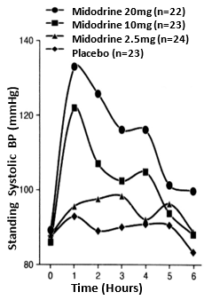 A recent systemic review and meta-analysis [26] discussed Midodrine for the prevention of Vasovagal Syncope. It was very effective in the prevention of head-up tilt-induced Syncope, but its results in this study were somewhat poor in terms of double-blinded trials. We have found, however, Midodrine to be very effective in treating people with Vasovagal Syncope, especially when used with low-dose, anticholinergic agents, such as Tricyclics, SSRIs, or SNRIs (e.g., 10mg, qd, dinner, Nortriptyline, or 20mg, qd, Duloxetine; rarely do we titrate higher to prevent additional symptoms).
Figure 15: Midodrine-BP time course of action [Reprinted from 43].
There are many that will state that POTS and Vasovagal Syncope do not, or even cannot, co-exist. Those that do also profess that it is not possible to measure the Parasympathetic Nervous System in isolation of, but simultaneously with, the Sympathetics. Therefore, since the Parasympathetics cannot be measured, according to those individuals, the two dysfunctions cannot co-exist. In fact, regardless of whether or not the Parasympathetics can be measured, Syncope is a beta-adrenergic dysfunction, a condition of the heart, and POTS or any other neurogenic orthostatic dysfunction is an alpha-adrenergic dysfunction, a condition of the peripheral vasculature. In our clinic, we find that approximately one-third of our POTS patients also demonstrate Vasovagal Syncope. While very low-dose anti-cholinergics help to relieve the Vagal or Parasympathetic Excess that underlies Vasovagal Syncope, Midodrine is still the first-line therapy and helps to relieve both.
Midodrine has been a useful adjunctive to intravenous vasopressor agents in adults with shock. A meta-analysis [34] showed that Midodrine did not have an effect on ICU or hospital length of stay. This was a negative study for Midodrine as an adjunctive to intravenous vasopressors. Other studies have shown a benefit. An efficacy and safety of Midodrine in critically ill patients study showed that Midodrine could be safely utilized as an adjunctive therapy to increase mean arterial pressure in patients on IV vasopressors [37]. Another study demonstrated the utility of Midodrine in the recovery phase of septic shock [33]. This study also demonstrated that Midodrine may reduce the dose of IV vasopressin from septic shock and may be associated with reduction in length of stay. Therefore, there has been conflicting data on this.
Please note that Midodrine has a shelf half-life of only eight weeks from opening. It can be prescribed for OH or Neuro-Cardiogenic Syncope. It is relatively contra-indicated in severe Hypertension, severe cardiac disorders such as Hypertrophic Obstructive Cardiomyopathy, certain cardiac valve disorders, Thyroidtoxicosis, Pheochromocytoma, acute Nephritis, Urinary Retention, Hyperthyroidism, Narrow Angle Glaucoma, pregnancy or breast feeding, proliferative Diabetic Retinopathy, and serious Prostate disorders. Patients receiving SSRIs or Antiarrhythmic drugs, Decongestants, or some appetite suppressions may have an exaggerated response to Midodrine. Patients should be careful with drugs that can cause Bradycardia as mentioned before, such as Digitalis and beta-blockers, as one can get a more exaggerated lowering of the HR. This can also occur with Clonidine occasionally.
In an interesting article, “Novelties in Heart Failure Therapy” [], Midodrine and Pyridostigmine were compared. The comparison showed that Midodrine and Pyridostigmine can both be beneficial in patients with Heart Failure and only Midodrine is beneficial in Hypotension. Using Midodrine in Hypotensive patients with Heart Failure was associated with a two-fold decrease in medication load and hospitalization days, with improvement to optimal medication for Heart Failure, and improvements in Left Ejection Ventricular Fraction (LVEF, indicating improved mortality risk) and symptoms (improved morbidity risk). Pyridostigmine use in Heart Failure was associated with beneficial effects in cardinal remodeling and with improvement in Ejection Fraction, especially in animal models, and with better exercise tolerance in humans. An article on Congestive Heart Failure (CHF) [29], showed that Midodrine improves the LVEF and clinical outcomes, with significant reduction in total hospitalizations, as it allowed for up titration of neurohormonal antagonist (i.e., Angiotensin Converting Enzyme-Inhibitor, or ACE-I) therapy leading to improved outcomes. Ten consecutive patients with Heart Failure due to Systolic Dysfunction and symptomatic Hypotension interfering with optimal medical therapy were started on Midodrine. After six months, a higher percentage of these patients were on optimal Heart Failure therapy. Therefore, we routinely use Midodrine in patients with very low BP when we cannot institute ACE-I, beta-blockers, and Aldosterone antagonists in patients who will need these to improve their prognosis and LVEF.
Reversible Cerebral Vasoconstriction Syndrome due to Midodrine in a patient with Autonomic Dysreflexia has been described [30]. This is a rare neurological condition that typically presents with sudden onset Thunderclap Headaches associated with or without focal neurologic defects.
Midodrine increases systemic vascular resistance and should be used cautiously in patients with Hypertension and used only in patients who are considerably impaired despite standard clinical care. Midodrine has a receptor affinity for Alpha-1 solely in contradistinction to other vasopressors which may react with other receptors. Supine Hypertension, as noted, is a complication of Midodrine and has to be looked for.
Often, patients with long standing SW present with elevated to moderately high, resting BP. Often, we find that in these patients, the higher-than-normal resting BP is compensatory for the associated drop in BP upon standing (see the example near the beginning of this manuscript). Unfortunately, without the additional information from P&S Monitoring, the cardiologist perceives the higher BP as the primary and treats as such. However, oftentimes, the patient feels worse (more lightheaded or exercise intolerant), or the patient’s BP becomes difficult to control and the patient is perceived to be non-compliant and the relationship degrades. In contrast, with the additional information from P&S Monitoring, the OI would be treated as the primary (with the high BP a consideration in therapy planning), and once the standing BP normalizes, the resting BP will normalize, typically within three to six months, assuming no hardening of arteries or other end-organ effect.
There are ongoing clinical trials of Midodrine for the treatment of refractory Hypotension in patients otherwise ready for discharge from the ICU [38]. Potential for bias was increased by single center and observational design studies in the past and, therefore, multicenter studies are needed. One study investigated the prescription of high dose Midodrine started at 2.5 mg every eight hours titrated to 40 mg every eight hours in the ICU.
Midodrine is a first-line drug for the treatment of OH. We use it also as a first-line drug for treatment of POTS, OI syndromes in general, and Vasovagal Syncope. This should be prescribed and titrated under the auspices of an experienced specialist who has used this in the past for Autonomic Dysfunction syndromes.
Alpha-Lipoic Acid (ALA), a super-antioxidant selective for nerves, supports and may potentiate the actions of Midodrine. Autonomic Dysfunction is often a result of oxidative stress on the autonomic nerves (as well as the rest of the cells of the body). The oxidative stress is often a result of serious illness or injury, surgery, mental or physical trauma, etc. Often the first and most debilitating symptom of Autonomic Dysfunction is Orthostatic Dysfunction [9,10]. ALA helps to heal the effects of oxidative stress, especially on the Mitochondria in the nerves, leaving Midodrine to “re-train” the nerves to properly vasoconstrict. Florinef potentiates the effects of Midodrine, and vice versa, enabling lower dosages of both when used together, thereby limiting the side-effects of both agents.
NORTHERA (DROXIDOPA)
Another agent, Northera (Droxidopa) was approved by the FDA for OH in 2014. Northera was approved to treat OH in Japan in 1982. It was approved under an accelerated approval program. This program allows for approval of drugs to treat serious diseases based on clinical data showing that the drug has an effect on clinical measures and is reasonable to predict a good outcome. Northera did have a box warning about the risk of increased BP while laying down, which is known as supine Hypertension. This is common in patients that have Autonomic Dysfunction and can cause stroke. Individuals must sleep with their heads up and their upper body elevated. Before the approval in February 2014 of Northera, the only other USFDA agent approved for treatment of OH was Midodrine (ProAmatine), an oral alpha-1 Adrenergic receptor agonist.
Northera (Droxidopa) is a synthetic amino acid analogue that is metabolized by Dopa-Decarboxylase to Norepinephrine (Figure 16) []. It is therefore a synthetic Norepinephrine prodrug. Norepinephrine increases BP through peripheral artery and venous vasoconstriction, and therefore it is known as vasoactive agent. Droxidopa is indicated for the treatment of orthostatic dizziness (lightheadedness) and pre-Syncopal feelings of "blackouts" in adults with symptomatic OH caused by Primary Autonomic Failure, including due to
Phenylethanolamine N-methyltranferase
Droxidopa
NE
Epinephrine
Myocardium
Blood Vessels
CNS
Aromatic L-Amino-Acid Decarboxylase
↑HR (β1)
↑Vasoc (α1)
↓NE (α2)
↑Vasod (β)
Locus
Coerulues
Figure 16: Metabolism and pathways of Northera (Droxidopa) [Modified from 46].

Parkinson's disease, Multiple System Atrophy, Pure Autonomic Failure, Dopamine Beta-Hydroxylase deficiency, and non-Diabetic Autonomic Neuropathy. These latter disorders and diseases include other systemic diseases such as Amyloidosis. Droxidopa is available in 100, 200, and 300 mg hard gelatin capsules.
Droxidopa is an analogue of Levodopa (Figure 17). It is very similar in structural formula. Droxidopa is a pro-drug converted to Norepinephrine which can activate alpha-1 Adrenergic receptors. Droxidopa, unlike Midodrine, will cross the Blood-Brain Barrier and enhance Norepinephrine production in the Central Nervous System. Droxidopa can be metabolized into Norepinephrine and Epinephrine (Figure 18.) in combined alpha- and beta-Adrenergic receptors and have various physiological responses depending on the tissue it affects.
The time course of action of Droxidopa is presented in Figure 19. Upon oral intake, Droxidopa is converted to Norepinephrine by Dopa-Decarboxylase, both peripherally and centrally. This is the same enzyme that
converts Levodopa to Dopamine in the treatment of Parkinson's Disease. The medication is started at 100 mg three times a day (every four hours) and can be taken with or without food. One should take the last dose at least 3-4 hours before retiring and
Figure 17: Droxidopa is an analog of Levodopa. [Modified from 3, Slide 6]
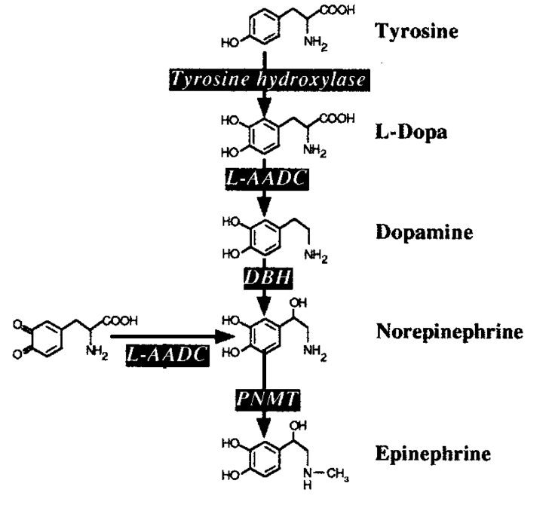
Figure 18: Catecholamine Metabolism [Modified from 3, Slide 5]. L-AADC, L-aromatic amino acid decarboxylase ; DBH, dopamine -hydroxylase; PNMT, phenyleth- anolamine-N-methyltransferase.

going to bed. The maximum dose is 600 mg three times a day. [3]
Droxidopa has been compared to Midodrine in the treatment of OH []. Patients using Droxidopa were more likely to remain on treatment longer than patients on Midodrine, presumably due to fewer side effects and possibly due to enhanced efficacy (see Figure 20) [46]. However, the dose of Droxidopa is considerably higher than Midodrine and pre-certification with the insurance company is required. Patients on Midodrine were 27% more likely to become non-compliant than those on Droxidopa, which is indicative of better compliance with Droxidopa (Figure 21) [46,].
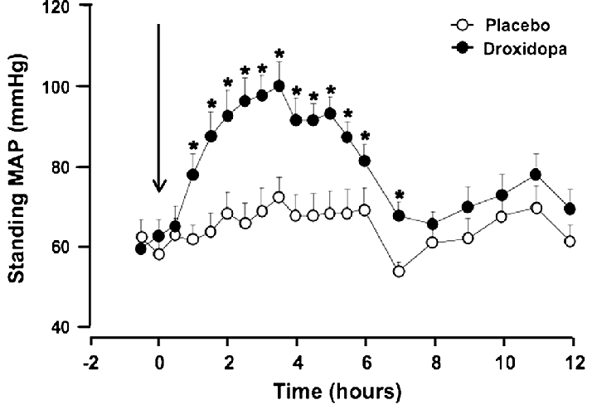
Figure 19: Time course of action of Northera (Droxidopa) and Orthostatic BP (Mean Arterial Pressure, MAP, mmHg). Dosing starts at time 0 hours [Modified from 3, Slide 8].
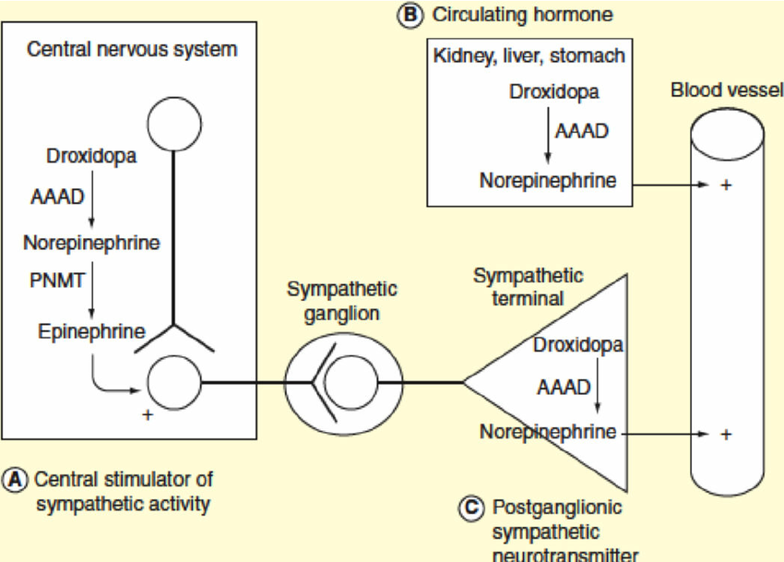
Figure 20: Potential sites of action of Northera (Droxidopa). Catalysts are indicated in rectangle boxes: AAAD, Aromatic L-amino acid decarboxylase and PNMT, Phenylethanolamine N-methyltranferase) [Modified from 3,Slide 7]

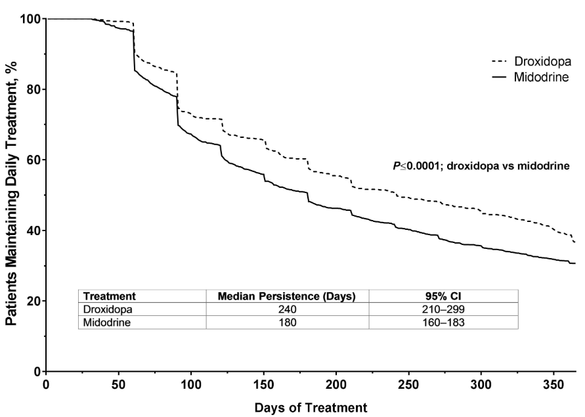
Figure 21: Persistence or patient compliance with Northera (Droxidopa) as compared with Midodrine (ProAmatine) [Modified from 46].

Droxidopa is well-tolerated and improves symptoms of neurogenic OH (NOH) [,,]. Some patients do fail to respond and are often benefited by the addition of Midodrine, which works as a pro-drug and results in vasoactivation. Together, the two may be synergistic, and we have found success in using both of these agents together. However, care must be taken not to produce significant supine Hypertension, which could be quite significant.
Long-term safety of Droxidopa in patients with symptomatic NOH was published in 2016 []. Rates of cardiovascular adverse side-effects, including supine Hypertension, were low. Most of the side-effects were related to the patient’s underlying neurological disease (e.g., Parkinson’s or Pure Autonomic Failure) []. Droxidopa has a favorable benefit-to-risk ratio in patients with NOH. The most frequently recorded adverse effects were falls, urinary tract infections, headaches, Syncope, and dizziness or lightheadedness.
The long-term effects of Droxidopa do not appear to be use-prohibitive. There were low incidences of cardiovascular events in patients with NOH on Droxidopa [,]. Comparative analysis with Droxidopa and Midodrine showed that supine Hypertension was significantly greater for Midodrine but not for Droxidopa when compared to placebo []. Both Droxidopa and Midodrine, however, did improve standing systolic BP. Droxidopa has also been shown to be effective in treatment of POTS, apparently improving some symptoms of OI in patients with POTS []. Other studies have shown that, in addition to POTS, which is a chronic form of OI, Vasovagal Syncope was also benefited by Droxidopa treatment []. It improves both Sympathetic Splanchnic arterial vasoconstriction and Sympathetic Splanchnic venoconstriction in POTS and Vasovagal Syncope patients. It was postulated that this would be an ideal drug to improve the Orthostatic response to POTS and Vasovagal Syncope patients.
Articles have been published on Droxidopa for the short-term treatment of symptomatic NOH and Parkinson's disease and its effectiveness []. Droxidopa has also been shown to improve symptomatic OH and Multiple System Atrophy and Pure Autonomic Failure patients and provide a hemodynamic and symptomatic benefit. One case report of adding Droxidopa to Fludrocortisone and Midodrine in a patient with NOH and Parkinson's Disease demonstrated how three agents could be effective in patients with refractory OH disorders [].
A very uncommon but rarely recognized disorder is Transthyretin Amyloidosis. These patients could present with diarrhea, OH, cardiac disease, CHF, and bi-lateral carpal tunnel syndrome []. OH in patients with this disorder can be a consequence of heart failure due to Amyloid Cardiomyopathy or volume depletion due to diarrhea or drug effects or Amyloid Autonomic Neuropathy. Diagnosis is usually made with positive biopsy in affected organs or genetic testing for the mutations associated with specific type of Amyloid, for example, assessing for mutations in the TTR gene for Transthyretin Amyloidosis. Amyloid Autonomic Neuropathies are tested for by Immunofixation (IFE), Serum Protein Electrophoresis (PE), Serum and Quantitative Free κ and λ Light-Chain (FLC), and Plus Ratio Serum. Treatment with Droxidopa has been shown to be effective in these disorders and improving OH [32]. Cardiovascular autonomic testing, with beat-to-beat BP, often shows absent BP overshoot after release of the Valsalva strain. The lack of overshoot indicates impaired Baroreflex-mediated Sympathetic activation. These patients also have both sensory and Autonomic Neuropathies and can have abnormalities in EMG testing and small fiber assessment (e.g., Sudomotor testing or skin biopsy). When gastrointestinal (GI) symptoms are present, biopsy of the GI tract may often yield positive results. When cardiac disease is present, biopsy of the heart can also show abnormalities. Many of these patients get post-prandial Hypotension which results in blood pooling within the Splanchnic circulation. Northera (Droxidopa) has been shown to be helpful here also. Off-label uses of Droxidopa for Hypotension, Diabetic Autonomic Neuropathy, and Hypotension related to Autonomic Dysfunction and Rheumatoid Arthritis have also been described [54,,]. Droxidopa may be less likely than Midodrine to exacerbate supine hypertension [].
The main obstacle in using Northera (Droxidopa) is the cost, and insurance companies always require pre-certification for payment. It is a very expensive drug. Whereas Midodrine is not very expensive, Droxidopa can cost thousands of dollars per month if not covered by insurance. Given Droxidopa’s mechanism of action, Physicians must be cautious if patients are on medications that increase Norepinephrine, such as Sympathomimetics, alpha-1 Adrenergic agonists, or alpha-2 Adrenergic agonists, as negative synergistic effects may occur.

PSEUDOEPHEDRINE
Pseudoephedrine is occasionally used at 30-60 mg every six hours to treat OH disorders. It is used in Autonomic Dysfunction disorders where there is decreased ability of postganglionic Sympathetic neurons to release Norepinephrine. It acts as an agonist in both Adrenergic (Sympathetic) branches, specifically through: alpha-1, and beta-1 and beta-2 Adrenergic receptors. It is rapidly absorbed in the GI tract. Within 15-30 minutes, it takes onset, duration is 4-6 hours, and is very inexpensive. Pseudoephedrine is a sympathomimetic drug of the Phenethylamine and Amphetamine chemical classes. It can be used as a nasal and sinus decongestant, as a stimulant, or as a wakefulness-promoting agent in the higher doses. It could be used both orally or as a topical decongestant. Interestingly, Pseudoephedrine has also been used as a first-line prophylactic for recurrent Priapism [], and it has been used in the ICU for refractory or severe hypotension [,]. Erection is largely a Parasympathetic response which may be reversed by Pseudoephedrine. Sympathetic action of Pseudoephedrine may serve to relieve this condition. It is often also used off-label for urinary incontinence. It is contraindicated in patients with Diabetes, cardiovascular disease, significant Hypertension, significant Coronary Artery Disease, Prostate Hypertrophy, Hyperthyroidism, Closed-Angle Glaucoma, and in pregnant women. It has direct action on the Adrenergic receptor system. Vasoconstriction is predominately an alpha-Adrenergic receptor response. It also relaxes the smooth muscle in the bronchi because of its beta-2 Adrenergic receptor affect. It is a chemical precursor to Methamphetamine, and there is increasing Regulatory restriction on this drug.
A comparison of Ephedrine and Pseudoephedrine should be noted. Both drugs have an Adrenergic effect. They are both Ephedra Alkaloids, classified as stimulants that mimic what Adrenalin does to the body. Ephedrine and Pseudoephedrine are both precursors of Methamphetamine. With Ephedrine, however, a different chemical structure is found in a hydroxyl branch. Ephedrine is typically used to counteract OH, while Pseudoephedrine is used to decongest nasal passageways. One is a cis-variant chemical and one is a trans-variant chemical (very similar structures). Both have the capacity to increase BP in patients, and Ephedrine is more powerful; however, Pseudoephedrine is more available.
Use of over-the-counter Ephedra Alkaloids have been associated with potentially serious cerebral vascular events, especially Hemorrhagic Stroke []. The compound Phenylpropanolamine has been largely substituted by Pseudoephedrine. Ephedra Alkaloids were shown to increase BP significantly in individuals with impaired Baroreflex function [68]; these individuals are largely Dysautonomia patients. The concomitant ingestion of Ephedra Alkaloids and water produces a greater increase in BP [68]. It is well known that drinking water rapidly can induce a Sympathetic response (see Figure 22). This interaction of drinking water with Ephedra Alkaloids can be beneficial in the treatment of OH, they postulated. However, on the other hand, it could contribute to cardiovascular complications associated with diffuse use of Ephedra Alkaloids, given than Baroreflex function varies widely in normal individuals, and it was impaired in several medical conditions. We avoid the use of Ephedra Alkaloids and Pseudoephedrine in patients because of this stroke risk and Hemorrhagic risk. Also, the regular chronic dosing of Pseudoephedrine (30 to 60 mg tid or qid) and Ephedrine (15 to 40 mg tid) to treat Hypotension or OH increases the probability of significant adverse effects such as Tachycardia and Anxiety. Pseudoephedrine and related Sympathomimetics cause modest increases in BP. Use with Droxidopa is not advised and use with caution or not at all is recommended in open angle glaucoma, CAD, CHF, Benign Prostatic Hyperplasia (BPH), Hypertension, and Urinary retention. Based on quality of evidence and safety issues, we are more comfortable using Midodrine and Droxidopa (Northera). Midodrine and Droxidopa reach a strong recommendation level for pharmacological treatment of NOH compared with other agents where the strength is weak and quality of evidence is low [].
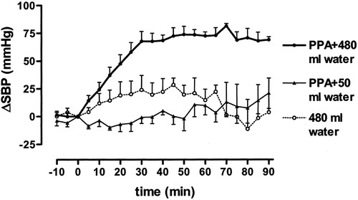
Other agents with vasoconstriction properties have been used to treat OH. These include: Atomoxetine, Yohimbine, Pyridostigmine, and Octreotide. We have also eluded to volume expansion agents with Fludrocortisone and Desmopressin. Fludrocortisone has some vasoconstrictive properties, but is more viewed as a volume-expansion agent.
Figure 22: Change in systolic blood pressure in patients with autonomic failure after administration of phenylpropanolamine (PPA). Pressor effect of phenylpropanolamine taken with 50 mL of water is compared with pressor effect of same dose of phenylpropanolamine taken with 480 mL of water and with pressor effect of 480 mL of water alone. p<0.0001 between interventions by ANOVA. [Reprinted from 68, open access]
The selective Norepinephrine transported inhibitor Atomoxetine increases seated and standing BP and improves OI even when given in pediatric doses of 18 mg [,,]. It has been shown to be effective in Multiple System Atrophy (MSA) patients due to the presence of residual Sympathetic tone. Avoid with structural cardiac diseases, liver diseases, and psychiatric diseases. Suicidal Ideation, Sudden Cardiac Death, Stroke, Myocardial Infarction, Hepatotoxicity and Depression have been reported. The alpha-2 Adrenergic antagonist Yohimbine has also been shown to increase seated and standing BP and reduces pre-Syncopal episodes in patients with Autonomic Failure []. This drug acts centrally on the Sympathetic outflow and Norepinephrine release from post-ganglionic Sympathetic neurons. It works well in MSA patients. It is available only from compounding pharmacies. Pyridostigmine (Mestinon), in 60 mg doses, preferentially increases upright BP and improves Orthostatic symptoms without worsening supine Hypertension. Mestinon may be the drug of choice for patients who have very severe, high BP and severe supine Hypertension when Midodrine and Northera cannot be used. However, this drug is not as powerful as Midodrine and Northera and, oftentimes, if one has severe Autonomic Failure, it is not sufficient. It is an excellent add-on medicine to Midodrine or Northera in patients with NOH. It is also an excellent add-on agent in the treatment of POTS when Midodrine and Beta-Blockers are ineffective in controlling symptoms and HR. The Somatostatin analogue, Octreotide, which is used subcutaneously, is also very effective in the treatment of OH by constricting Splanchnic circulation to prevent venous pooling [,]. However, it has side effects of Hyperglycemia and abdominal pain and can cause diarrhea. Oftentimes, combination therapy with Midodrine is used with this agent in people with post-prandial Hypotension. One study showed sympathomimetic agents, such as Midodrine and Ephedra Alkaloids, have a synergistic effect on BP when combined with 480 mL bolus of water [16].
Desmopressin (DDAVP) has been used to acutely improve symptoms in patients with POTS []. We typically use it chronically in these patients at a dosage of 0.1 to 0.2 mg once a week and not daily to avoid too much free water accumulation with hyponatremia, increased headache, and edema. DDAVP is an agonist to the Vasopressin type-2 receptor and not type-1 receptor and therefore does not raise BP [4]. We often find Desmopressin valuable in patients who cannot consume sufficient quantities of water due to Gastroparesis or find no relief with 48 oz to 64 oz of water a day, including with electrolytes. Fludrocortisone is a powerful mineralocorticoid that acts as a volume expander. It is not recommended in patients with CHF or Hypertension, edema, or hypokalemia. Desmopressin may be safer in these patients, but not in patients with a history of blood clots, as it can theoretically increase Factor 8 and Von Willebrand factor. We prescribe it prn as a “pill in the pocket” for occasional decompensation episodes and during the menstrual cycle when female patients may be symptomatic due to fluid loss.
A study of seven patients with recurrent Syncope and positive head-up tilt prescribed Methylphenidate (Ritalin, 10 mg, tid) resulted in six of the seven patients (85.7%) responding favorably []. Rarely has Methylphenidate been used off-label in OH patients. It has been used in the treatment of Narcolepsy, Bipolar and Depressive disorders, Attention Deficit Disorders, and for enhancing performance, especially in cognition and memory. Methylphenidate carries addiction and dependence potential, and we strive to stay away from using it on our patients when there are better alternatives available.
One very important point is that many patients are taking central stimulants, such as Ritalin and Adderall for treatment of so-called Attention Deficit Hyperactivity Disorder. However, in reality, these patients have impaired memory and cognitive function many times from lack of blood supply to their head due to OI disorders. Oftentimes, we will treat these patients with vasoactive agents first to see if their cognition improves and brain fog lessens before even considering them for treatment with central stimulants by Psychiatry. In the United States, Methylphenidate is classified as Schedule II controlled substance. It is recognized to have medical value but presents a high potential for abuse.

CONCLUSIONS
Midodrine, which was approved by the USFDA in 1996 and was re-evaluated in 2010, continues to stay on the market for FDA treatment and approval of OH. However, significant data now supports use off-label in certain situations, such as intra-Dialysis, Hypotension, Cirrhosis and Ascites Hepatorenal Syndrome, Vasovagal Syncope, and POTS. It is also being used in Heart Failure patients with low BPs in order to titrate Heart Failure medications up more fully. It is also used in ICUs to have patients both come off of vasopressors early and decrease length of stay when they have Hypotension postoperatively or Septic Shock. In those instances, much higher doses are used than for Autonomic Dysfunction treatment.
Midodrine appears to be the mainstay of treatment in OI symptoms with Dysautonomia and is a first-line pharmacological agent. Many patients discontinue the use of Midodrine initially because of side-effects. Therefore, if one is properly warned that these side-effects can occur, and they should be interpreted as though the medicine is working properly, they will continue use until they eventually adapt to the medication; starting at very low doses, as low as 1.25 mg once a day, may be necessary. Midodrine is a pure alpha-Adrenergic agonist similar to Phenylephrine, which is given intravenously. However, unlike Phenylephrine, in which a tachyphylaxis can be seen when patients get used to that medication, this is not the case with Midodrine, and it is useful long-term without losing its effectiveness. Oftentimes, add-on medications are needed, such as volume expanders like Desmopressin and Fludrocortisone (we prefer not to use this medication if possible), Mestinon (Pyridostigmine), and other agents.
For patients who cannot tolerate Midodrine or are contraindicated for Midodrine, Mestinon is the second-line pharmaceutical therapy. If Mestinon is not tolerated, then Northera is prescribed. While we believe that we are able to anticipate those patients who will eventually tolerate Northera, its cost and whether insurances will reimburse for it requires that Midodrine and Mestinon be attempted and found ineffective first. While Alpha-Lipoic Acid is a useful adjunct to pharmaceutical therapy, it may also be able to replace pharmaceutical therapy in cases where no pharmaceutical therapy is tolerated or preferred. In most cases, pharmaceutical therapy helps to accelerate the relief of Dysautonomias that ALA is known to treat.
Northera (Droxidopa) is a very efficacious drug in treating OI disorders, especially OH and also in some select cases of POTS. Northera has a low side-effects profile and is better tolerated than Midodrine and produces less supine Hypertension than Midodrine. If need be, the two agents can be used together, carefully, by experienced physicians. Mestinon (Pyridostigmine) can also be added onto these agents and has little effect on supine Hypertension.
Pseudoephedrine is also a possibility for Orthostatic Dysfunction therapy, however, rarely in the clinical setting, unless in those rare cases where there is decreased ability of postganglionic Sympathetic neurons to release Norepinephrine. The limited utility is further necessary due to its contraindications in diabetes, heart disease, and the others listed above. Pseudoephedrine is most often used (when it is used) in the intensive or critical care setting.
All of these therapies, once titrated appropriately for the individual patient, have been found to be very effective in ultimately relieving the Dysautonomia(s) and related symptoms. Titration is based on symptoms and P&S Monitoring. Dysautonomia therapy may take up to 24 months because it takes small, gentle changes to correct the P&S nervous systems. Unfortunately, faster, larger doses cause more problems by pushing P&S balance too far in the other direction. This is in part why we use multiple modalities when possible (e.g., low-and-slow exercise with very low-dose anti-cholinergics or high dose ALA with low-dose Midodrine or Northera). Together, with the cooperation of the patient, these therapy plans restore these complex patients to health and function, improving Quality of Life and returning them to productive lifestyles.

REFERENCES

aka., P&S Monitoring [5]
Clinically speaking, lightheadedness is the result of Orthostatic Dysfunction, and Dizziness is the result of Vestibular Dysfunction.
There are seven pathways to increase BP, but medicine is able to block only three or four, so the body has other pathways via which to defeat therapy.
The clinical criteria for POTS is a rise in HR upon standing (or tilt-table testing – postural change) of 30 bpm for adults (40 bpm for pediatrics), or a HR of over 120 bpm within the first 10 minutes of postural change, after ruling out OH.
The clinical criteria for OH (including NOH) is a drop of 20 mmHg in systolic BP or a drop of 10 mmHg in diastolic BP within two to five minutes of standing (or tilt-table testing – postural change), or if postural change causes signs or symptoms of lightheadedness, nausea, etc.
Higher, typically clinical doses of anti-cholinergics (e.g., > 25 mg Nortriptyline, qd, dinner) aggravate symptoms or cause additional symptoms, often being the very symptoms that are being treated or prevented.
Persistent Fatigue is what we call fatigue that has some, but not all, of the symptoms of Chronic Fatigue Syndrome.
DePace NL, Vinik AI, Acosta CR, Pinales JM, Yayac M, Colombo J. Improved Patient Outcomes by Normalizing Sympathovagal Balance: Midodrine and Parasympathetic and Sympathetic Monitoring. Cardio Open. 2021; 6(1): 111-18.
Vinik AI, Camacho PM, Davidson JA, Handelsman Y, Lando HM, Leddy AL, Reddy SK, Cook R, Spallone V, Tesfaye S, Ziegler D; Task Force to Develop an AACE Position Statement on Autonomic Testing. American Association of Clinical Endocrinologists and American College of Endocrinology position statement on testing for Autonomic and Somatic nerve dysfunction. Endocr Pract. 2017 Dec;23(12):1472-1478. doi: 10.4158/EP-2017-0053. PMID: 29320641.
Grant AO. Pharmacological management of POTS. www.slideshare.net/DukeHeartCenter/4b-pots-summit
Freeman R, Abuzinadah AR, Gibbons C, Jones P, Miglis MG, Sinn DI. Orthostatic Hypotension: JACC State-of-the-Art Review. J Am Coll Cardiol. 2018 Sep 11;72(11):1294-1309. doi: 10.1016/j.jacc.2018.05.079.
Colombo J, Arora RR, DePace NL, Vinik AI. Clinical Autonomic Dysfunction: Measurement, Indications, Therapies, and Outcomes. Springer Science + Business Media, New York, NY, 2014.
DePace NL, Colombo J. Autonomic and Mitochondrial Dysfunction in Clinical Diseases: Diagnostic, Prevention, and Therapy. Springer Science + Business Media, New York, NY, 2019.
Murray GL and Colombo J. (r)Alpha Lipoic Acid Is a Safe, Effective Pharmacologic Therapy of Chronic Orthostatic Hypotension Associated with Low Sympathetic Tone. Int J Angiol. Feb. 22, 2019; 28(3): 188-93. doi: 10.1055/s-0038-1676957
DePace NL, Bateman JA, Yayac M, Oh J, Siddique M. Acosta C, Pinales JM, Vinik AI, and Bloom HL. Improved Patient Outcomes by Normalizing Sympathovagal Balance: Differentiating Syncope—Precise Subtype Differentiation Leads to Improved Outcomes. Cardiology Research and Practice Volume 2018, Article ID 9532141, 8 pages https://doi.org/10.1155/2018/953214
Vinik AI, Maser RE, Nakave AA. Diabetic cardiovascular autonomic nerve dysfunction. US Endocrine Disease. 2007; Dec: 2-9.
Vinik A, Ziegler D. Diabetic cardiovascular autonomic neuropathy. Circulation. 2007; 115: 387-397.
Osswald S, Trouton TG. Neurocardiogenic (vasodepressor) syncope. N Engl J Med, Images in Clinical Medicine. 1993 July 1; 329: 30. doi: 10.1056/NEJM199307013290106
Fu Q, Levine BD. Exercise in the postural orthostatic tachycardia syndrome. Auton Neurosci. 2015 Mar;188:86-9. doi: 10.1016/j.autneu.2014.11.008. Epub 2014 Nov 21.
Arora RR, Bulgarelli RJ, Ghosh-Dastidar S, Colombo J. Autonomic mechanisms and therapeutic implications of postural diabetic cardiovascular abnormalities. J Diabetes Science and Technology. 2008; 2(4): 568-71.
Prakash S, Garg AX, Heidenheim AP, House AA. Midodrine appears to be safe and effective for dialysis-induced hypotension: a systematic review. Nephrol Dial Transplant. 2004 Oct; 19(10): 2553-8. Epub 2004 Jul 27.
Arnold AC and Raj SR. Orthostatic Hypotension: A Practical Approach to Investigation and Management. Can J Cardiol. 2017 Dec; 33(12):1725-1728. doi: 10.1016/j.cjca.2017.05.007. Epub 2017 May 17.
Arnold AC and Shibao C. Current Concepts in Orthostatic Hypotension Management. Curr Hypertens Rep. 2013 Aug; 15(4): 304–312. doi: 10.1007/s11906-013-0362-3
Figueroa JJ, Basford JR, Low PA. Preventing and treating orthostatic hypotension: As easy as A, B, C. Cleve Clin J Med. May 2010; 77 (5): 298-306. DOI: 10.3949/ccjm.77a.09118
Raj SR. Postural Orthostatic Tachycardia Syndrome (POTS). Circulation. 11 June 2013; 127(23): 2336-2342. doi: 10.1161/CIRCULATIONAHA.112.144501
Cambridgeshire and Peterborough. Midodrine for orthostatic hypotension and neurocardiogenic syncope. www.cambridgeshireandpeterboroughccg.nhs.uk/easysiteweb/getresource.axd?assetid=10918&type=0&servicetype=1
Izcovich A, González Malla C, Manzotti M, Norberto Catalano H, Guyatt G. Midodrine for orthostatic hypotension and recurrent reflex syncope: A systematic review. Neurology. Sep 2014, 83 (13) 1170-1177; DOI: 10.1212/WNL.0000000000000815
Smith W, Wan H, Much D, Robinson AG, Martin P. Clinical benefit of midodrine hydrochloride in symptomatic orthostatic hypotension: a phase 4, double-blind, placebo-controlled, randomized, tilt-table study. Clin Auton Res. 2016 Aug; 26(4): 269-77. doi: 10.1007/s10286-016-0363-9. Epub 2016 Jul 2.
Jacob G, Shannon JR, Black B, Biaggioni I, Mosqueda-Garcia R, Robertson RM, Robertson D. Effects of volume loading and pressor agents in idiopathic orthostatic tachycardia. Circulation. 1997; 96: 575–580.
Ross AJ, Ocon AJ, Medow MS, Stewart JM. A double-blind placebo-controlled cross-over study of the vascular effects of midodrine in neuropathic compared with hyperadrenergic postural tachycardia syndrome. Clin Sci (Lond). 1 February 2014; 126 (4): 289–296. doi: https://doi.org/10.1042/CS20130222
Miller AJ, Raj SR. Pharmacotherapy for postural tachycardia syndrome. Auton Neurosci. 2018 Dec; 215: 28-36. doi: 10.1016/j.autneu.2018.04.008. Epub 2018 May 4.
Hale GM, Valdes J, Brenner M. The treatment of primary orthostatic hypotension. Ann Pharmacother. 2017 May;51(5):417-428. doi: 10.1177/1060028016689264. Epub 2017 Jan 16.
Lei L, Raj S, Sheldon R. Midodrine for the prevention of vasovagal syncope: A systematic review and meta-analysis. Canada J Cardiol. Oct 1, 2019; 35(10), Suppl: S46. doi: 10.1016/j.cjca.2019.07.440.
Kaufmann H. Treatment of orthostatic and postprandial hypotension. UpToDate. 2018. https://www.uptodate.com/contents/treatment-of-orthostatic-and-postprandial-hypotension
Gutman LB, Wilson BJ. The role of midodrine for hypotension outside of the intensive care unit. J Popul Ther Clin Pharmacol. 2017 Aug 23; 24(3): e45-e50. doi: 10.22374/1710-6222.24.3.4.
Zakir RM, Folefack A, Saric M, Berkowitz RL. The use of midodrine in patients with advanced heart failure. Congest Heart Fail. 2009 May-Jun;15(3):108-11. doi: 10.1111/j.1751-7133.2008.00042.x.
Shankar Kikkeri N, Nagarajan E, Premkumar K, Nattanamai P. Reversible Cerebral Vasoconstriction Syndrome Due to Midodrine in a Patient with Autonomic Dysreflexia. Cureus. 2019 Mar 20;11(3):e4285. doi: 10.7759/cureus.4285.
Wecht JM, Rosado-Rivera D, Handrakis JP, Radulovic M, Bauman WA. Effects of midodrine hydrochloride on blood pressure and cerebral blood flow during orthostasis in persons with chronic tetraplegia. Arch Phys Med Rehabil. 2010 Sep; 91(9): 1429-35. doi: 10.1016/j.apmr.2010.06.017.
Palma J, Gonzalez-Duarte A and Kaufmann H. Orthostatic hypotension in hereditary transthyretin amyloidosis: epidemiology, diagnosis and management. Clin Auton Res. 2019; 29, 33–44. doi: 10.1007/s10286-019-00623-x
Whitson, Micah R. et al. Feasibility, utility, and safety of midodrine during recovery phase from septic shock. CHEST, 2016; 149(6): 1380 -3. doi: 10.1016/j.chest.2016.02.657. Epub 2016, Mar 4.
Hammond DA, Smith MN, Peksa GD, Trivedi AP, Balk RA, Menich BE. Midodrine as an Adjuvant to Intravenous Vasopressor Agents in Adults With Resolving Shock: Systematic Review and Meta-Analysis. J Intensive Care Med. 2019 Apr 28: online. doi: 10.1177/0885066619843279.
Splete H. Midodrine cuts ICU days in septic shock patients. CHEST Physician. June 14 2016.
Mattos ÂZ, Schacher FC, Mattos AA. Vasoconstrictors in hepatorenal syndrome - A critical review. Ann Hepatol. 2019 Mar - Apr;18(2):287-290. doi: 10.1016/j.aohep.2018.12.002. Epub 2019 Apr 16.
Rizvi MS, Trivedi V, Nasim F, Lin E, Kashyap R, Andrijasevic N, Gajic O. Trends in Use of Midodrine in the ICU: A Single-Center Retrospective Case Series. Crit Care Med. 2018 Jul; 46(7): e628-e633. doi: 10.1097/CCM.0000000000003121.
Anstey MH, Wibrow B, Thevathasan T, Roberts B, Chhangani K, Ng PY, Levine A, DiBiasio A, Sarge T, Eikermann M. Midodrine as adjunctive support for treatment of refractory hypotension in the intensive care unit: a multicenter, randomized, placebo controlled trial (the MIDAS trial). BMC Anesthesiol. 2017 Mar 21; 17(1): 47. doi: 10.1186/s12871-017-0339-x.
Jordan J, Shibao C, Biaggioni I. Multiple system atrophy: using clinical pharmacology to reveal pathophysiology. Clin Auton Res. 2015 Feb;25(1):53-9. doi: 10.1007/s10286-015-0271-4. Epub 2015 Mar 11. PMID: 25757803; PMCID: PMC4431657.
Robertson D, Goldberg MR, Hollister AS, Wade D, Robertson RM. Clonidine raises blood pressure in severe idiopathic orthostatic hypotension. Am J Med. 1983 Feb;74(2):193-200. doi: 10.1016/0002-9343(83)90607-1. PMID: 6824002.
Grijalva CG, Biaggioni I, Griffin MR, Shibao CA. Fludrocortisone Is Associated With a Higher Risk of All-Cause Hospitalizations Compared With Midodrine in Patients With Orthostatic Hypotension. J Am Heart Assoc. 2017 Oct 12;6(10). pii: e006848. doi: 10.1161/JAHA.117.006848.
Gibbons CH, Schmidt P, Biaggioni I, Frazier-Mills C, Freeman R, Isaacson S, Karabin B, Kuritzky L, Lew M, Low P, Mehdirad A, Raj SR, Vernino S, Kaufmann H. The recommendations of a consensus panel for the screening, diagnosis, and treatment of neurogenic orthostatic hypotension and associated supine hypertension. J Neurol. 2017 Aug;264(8):1567-1582. doi: 10.1007/s00415-016-8375-x. Epub 2017 Jan 3. PMID: 28050656; PMCID: PMC5533816.
Wright RA, Kaufmann HC, Perera R, Opfer-Gehrking TL, McElligott MA, Sheng KN, Low PA. .A double-blind, dose-response study of midodrine in neurogenic orthostatic hypotension. Neurology. 1998 Jul;51(1):120-4.
Gee ME, Watkins AK, Brown JN, Young EJA. Ivabradine for the Treatment of Postural Orthostatic Tachycardia Syndrome: A Systematic Review. Am J Cardiovasc Drugs. 2018 Jun;18(3):195-204. doi: 10.1007/s40256-017-0252-1. PMID: 29330767.
Al Turk AA, Odanovic NR, Waller AH, and Mazza VJ. Midodrine and pyridostigmine; Novelties in heart failure therapy. J Cardiovasc Dis Res. 2017l 8(4), 104-107. https://doi.org/10.5530/jcdr.2017.4.24
Kymes S, Jackson K, Widolff M, Sullivan C, Hewitt LA, Raj SR. Droxidopa and Midodrine Treatment Persistence in Patients With Orthostatic Hypotension. Neurology Abstr. Oct 7, 2018.
Patrick K, Martin T. Effectiveness of droxidopa compared to midodrine in standing blood pressure and orthostatic tolerance in adults with neurogenic orthostatic hypotension: a systematic review protocol. JBI Database System Rev Implement Rep. 2017 Sep;15(9):2287-2294. doi: 10.11124/JBISRIR-2016-003306.
Hewitt LA, Kymes S, Jackson K, Widolff M, Sullivan C, Raj SR. Droxidopa and Midodrine Treatment Persistence in Patients With Orthostatic Hypotension (P3.6-047). Neurology Apr 2019, 92 (15 Supplement) P3.6-047.
Kaufmann, H. Droxidopa for symptomatic neurogenic orthostatic hypotension: what can we learn? Clin Auton Res. 2017; 27, 1–3. https://doi.org/10.1007/s10286-017-0426-6
Biaggioni I, Freeman R, Mathias CJ, Low P, Hewitt LA, Horacio Kaufmann H, and on behalf of Droxidopa 302 Investigators. Randomized Withdrawal Study of Patients With Symptomatic Neurogenic Orthostatic Hypotension Responsive to Droxidopa. Hypertension. 2015; 65: 101–107. doi: 10.1161/HYPERTENSIONAHA.114.04035
Ross AJ, Stewart JM. Prospects for droxidopa in neurogenic orthostatic hypotension. Hypertension. 2015 Jan;65(1):34-5. doi: 10.1161/HYPERTENSIONAHA.114.04204. Epub 2014 Oct 27. (commentary on Baggioni, et al.[41])
Isaacson S, Vernino S, Ziemann A, Rowse GJ, Kalu U, White WB. Long-term safety of droxidopa in patients with symptomatic neurogenic orthostatic hypotension. J Am Soc Hypertens. 2016; 10(10): 755-762. doi: 10.1016/j.jash.2016.07.010.
What's Hot in PD? Could Northera (Droxidopa) Be an Alternative Treatment for Low Blood Pressure and Passing Out Symptoms in Parkinson's Disease? https://www.parkinson.org/blogs/whats-hot/northera-droxidopa-alternative-treatment
White WB, Hauser RA, Rowse GJ, Ziemann A, Hewitt LA. Cardiovascular Safety of Droxidopa in Patients With Symptomatic Neurogenic Orthostatic Hypotension. Am J Cardiol. 2017 Apr 1;119(7):1111-1115. doi: 10.1016/j.amjcard.2016.11.066. Epub 2017 Jan 6.
Raj SR, Hewitt LA. Use of droxidopa for the long-term treatment of neurogenic orthostatic hypotension. Eur Heart J. 2019 Jan 1; 40(1): 69-70. doi: 10.1093/eurheartj/ehy779.
Chen JJ, Han Y, Tang J, Portillo I, Hauser RA, Dashtipour K. Standing and Supine Blood Pressure Outcomes Associated With Droxidopa and Midodrine in Patients With Neurogenic Orthostatic Hypotension: A Bayesian Meta-analysis and Mixed Treatment Comparison of Randomized Trials. Ann Pharmacother. 2018 Dec;52(12):1182-1194. doi: 10.1177/1060028018786954. Epub 2018 Jul 4.
Ruzieh M, Dasa O, Pacenta A, Karabin B, Grubb B. Droxidopa in the Treatment of Postural Orthostatic Tachycardia Syndrome. Am J Ther. 2017 Mar/Apr;24(2):e157-e161. doi: 10.1097/MJT.0000000000000468.
Northera Improves Postural Tachycardia Syndrome (POTS) and Postural Vasovagal Syncope (VVS). https://www.centerwatch.com/clinical-trials/listings/78506/postural-tachycardia-syndrome-pots-northera-improves-postural-tachycardia/
Hauser RA, Isaacson S, Lisk JP, Hewitt LA, Rowse G. Droxidopa for the short-term treatment of symptomatic neurogenic orthostatic hypotension in Parkinson's disease (nOH306B). Mov Disord. 2015 Apr 15;30(5):646-54. doi: 10.1002/mds.26086. Epub 2014 Dec 9.
Kremens D, Lew M, Claassen D, Goodman BP. Adding droxidopa to fludrocortisone or midodrine in a patient with neurogenic orthostatic hypotension and Parkinson disease. Clin Auton Res (2017) 27 (Suppl 1):S29–S31. DOI 10.1007/s10286-017-0434-6
Donnelly JP, Hanna M, Sperry BW, Seitz WH Jr. Carpal Tunnel Syndrome: A Potential Early, Red-Flag Sign of Amyloidosis. J Hand Surg Am. 2019;44(10):868‐876. doi:10.1016/j.jhsa.2019.06.016
Oommen J, Chen J, Wang S, Caraccio T, and Hanna A. Droxidopa for Hypotension of Different Etiologies: Two Case Reports. P&T. March 2019; 44(3): 125-44.
Weinstock LB, et al. Successful treatment of postural orthostatic tachycardia and mast cell activation syndromes using naltrexone, immunoglobulin and antibiotic treatment. BMJ Case Rep 2018, 6p. doi:10.1136/bcr-2017-221405
Olshansky B, Muldowney J. Cardiovascular Safety Considerations in the Treatment of Neurogenic Orthostatic Hypotension. Am J Cardiol. 2020;125(10):1582‐1593. doi:10.1016/j.amjcard.2020.01.037
Mocniak M, Durkin CM, and Early K. The use of sudafed for priapism in pediatric patients with sickle cell disease. J Pediatr Nurs. 2012 Feb;27(1):82-4. doi: 10.1016/j.pedn.2011.10.006.
Van Berkel MA, Fuller LA, Alexandrov AW, and Jones GM. Methylene blue, midodrine, and pseudoephedrine: a review of alternative agents for refractory hypotension in the intensive care unit. Crit Care Nurs Q. 2015 Oct-Dec;38(4):345-58. doi: 10.1097/CNQ.0000000000000086
Patterson A, Bourgault AM, and Crawford BR. Correction of severe hypotension by oral pseudoephedrine in a patient with idiopathic autonomic dysfunction. Am J Crit Care. 2008 Sep;17(5):484, 481-3.
Jordan J, Shannon JR, Diedrich A, Black B, Robertson D, Biaggioni I. Water potentiates the pressor effect of ephedra alkaloids. Circulation. 2004 Apr 20;109(15):1823-5. Epub 2004 Apr 5.
Eschlböck S, Wenning G, and Fanciulli A. Evidence-based treatment of neurogenic orthostatic hypotension and related symptoms. J Neural Transm. 2017; 124: 1567–1605. https://doi.org/10.1007/s00702-017-1791-y
Green EA, Raj V, Shibao CA, Biaggioni I, Black BK, Dupont WD, Robertson D, Raj SR. Effects of norepinephrine reuptake inhibition on postural tachycardia syndrome. J Am Heart Assoc. 2013 Sep 3;2(5):e000395. doi: 10.1161/JAHA.113.000395.
Okamoto LE, Shibao CA, Gamboa A, Diedrich A, Raj SR, Black BK, Robertson D, and Biaggioni I. Synergistic Pressor Effect of Atomoxetine and Pyridostigmine in Patients With Neurogenic Orthostatic Hypotension. Hypertension. 2019 Jan;73(1):235-241. doi: 10.1161/HYPERTENSIONAHA.118.11790.
Byun JI, Kim DY, Moon J, Shin HR, Sunwoo JS, Lee WJ, Lee HS, Park KI, Lee ST, Jung KH, Jung KY, Kim M, Lee SK, and Chu K. Efficacy of atomoxetine versus midodrine for neurogenic orthostatic hypotension. Ann Clin Transl Neurol. 2020 Jan;7(1):112-120. doi: 10.1002/acn3.50968. Epub 2019 Dec 19. Erratum in: Ann Clin Transl Neurol. 2020 Mar;7(3):402
Shibao C, Okamoto LE, Gamboa A, Yu C, Diedrich A, Raj SR, Robertson D, Biaggioni I. Comparative efficacy of yohimbine against pyridostigmine for the treatment of orthostatic hypotension in autonomic failure. Hypertension. 2010 Nov;56(5):847-51. doi: 10.1161/HYPERTENSIONAHA.110.154898. Epub 2010 Sep 13.
Ong AC, Myint PK, Shepstone L, and Potter JF. A systematic review of the pharmacological management of orthostatic hypotension. Int J Clin Pract. 2013 Jul;67(7):633-46. doi: 10.1111/ijcp.12122.
Hoeldtke RD, Bryner KD, Hoeldtke ME, and Hobbs G. Treatment of postural tachycardia syndrome: a comparison of octreotide and midodrine. Clin Auton Res. 2006 Dec;16(6):390-5. Epub 2006 Oct 11.
Coffin ST, Black BK, Biaggioni I, et al. Desmopressin acutely decreases tachycardia and improves symptoms in the postural tachycardia syndrome. Heart Rhythm. 2012;9(9):1484‐1490. doi:10.1016/j.hrthm.2012.05.002
Grubb BP, Kosinski D, Mouhaffel A, Pothoulakis A. The use of methylphenidate in the treatment of refractory neurocardiogenic syncope. Pacing Clin Electrophysiol. 1996 May;19(5):836-40.

