COVID-19 REMINDS US HOW VITAL KNOWLEDGE AND TREATMENT OF PATIENTS’ AUTONOMIC NERVOUS SYSTEM (ANS) ABNORMALITIES ARE IN CARDIOVASCULAR DISEASE (CVD)
Gary L. Murray, M.D, FACC, FICA (posthumous), Joseph Colombo, PhD, DNM, DHS
ABSTRACT
Introduction. The immune (inflammatory) and autonomic interaction critically affects development and progression of adult cardiovascular disease (CVD) and is unnecessarily under-appreciated and untreated, since the technology to accurately diagnose and effectively treat Parasympathetic (P) and Sympathetic (S) abnormalities is available. Focus. This a review of our publications regarding COVID-19 immune-P&S interactions and CV complications and suggested therapy based upon improved outcomes associated with improved P&S status in systemic hypertension (HTN), coronary artery disease (CAD), congestive heart failure (CHF), and neurogenic orthostatic hypotension (NOH). The results are: 1) P&S dysfunction likely determines the severity of COVID-19 CV complications; 2) Sympathovagal Balance (SB= resting S/P) >2.5 best noninvasively predicts Major Adverse Cardiac Events (MACE=sudden/non-sudden cardiac death, acute coronary syndromes (ACS), acute CHF, ventricular tachycardia/fibrillation (VT/VF) (p<0.001) (OR=7.03, CI=4.59-10.78, sensitivity=0.59, specificity=0.83, PPV 0.64, NPV 0.80), for example, reduction of SB by Ranolazine (RAN) is associated with 24-63% MACE reduction; 3) preserving and improving resting P>0.10 bpm² (CAN/AAD) reduces sudden cardiac death (SCD) in adult diabetes mellitus (DM II) (RRR=43%, p=0.0076) using (r)alpha lipoic acid (ALA); 4) tailoring HTN treatment to P&S activity more than doubles treatment goal achievement to 74% by 8.35 months on less medicine compared to standard therapy (e.g., JNC 8; p<0.001; with improved systolic BP, diastolic BP, and pulse); 5) (r)ALA successfully treats NOH in 66% of systolic and 88% diastolic OH patients. Conclusions. Inexpensive, user-friendly, accurate technology assessing the ANS via concurrent Heart Rate Variability (HRV=P + S) and Respiratory Activity (RA=P analysis in the frequency domain), allowing safe, effective treatment of abnormalities is vital to regulate the immune response as well as to reduce MACE in COVID-19 and other major cardiovascular diseases.
Copyright: © 2022 by the authors. Submitted for open access publication under the Journal of Individualized Medicine and Therapies, of the Society of Individualized Medicine and Therapies, Inc.

INTRODUCTION
By the end of 2021 in Shelby County, TN, there have been 67,198 reported COVID-19 cases and 891 deaths. COVID-19 can be complicated (Figure 1) or fatal via two pathways []. One path is through the Vagus Nerve, the Parasympathetic pathway(Figure 2). The other path is through the Sympathetic nervous system, the Sympathetic pathway (Figure 3).
COVID-19 DIRECT CARDIO-VASCULAR INFECTION
In the first pathway, COVID-19 affects ACE2 receptor-containing cells in the

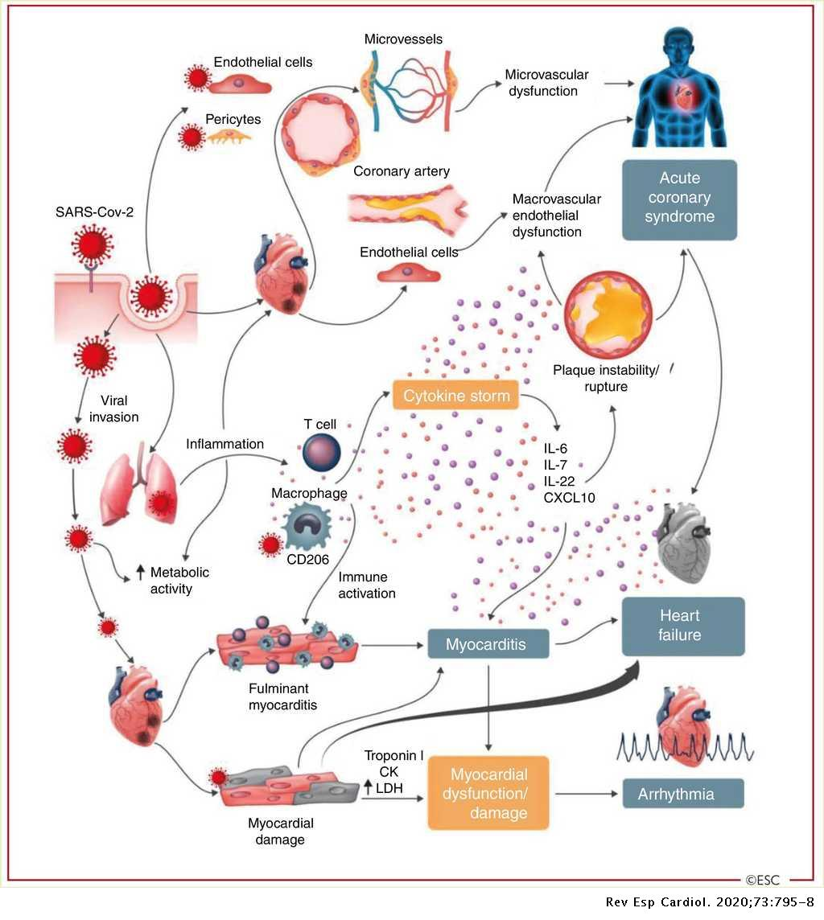
Figure 1. See legend on next page [Rev Esp Carsiol. 2020;73:795-8].
Figure 1 Legend. Cardiovascular involvement in COVID-19 – key manifestations and hypothetical mechanisms. SARS-CoV-2 anchors on trans-membrane angiotensin-converting enzyme-2 to enter the host cells including type-2 pneumocytes, macrophages, endothelial cells, pericytes and cardiac myocytes leading to inflammation and multi- organ failure. Infection of endothelial cells or pericytes is of particular importance because this could lead to severe microvascular and macrovascular dysfunction. In addition, immune over-reactivity can potentially destabilize atherosclerotic plaques and explain the development of acute coronary syndromes. Infection of the respiratory tract, particularly type-2 pneumocytes, by SARS-CoV-2 is manifested by the progression of systemic inflammation and immune cell over-reaction leading to “cytokine storm”, resulting in increased levels of cytokines such as IL-6, IL-7, IL-22 and CXCL10. Subsequently, it is possible that activated T cell and macrophages may infiltrate infected myocardium resulting in the development of fulminant myocarditis and sever cardiac damage. This process may be further intensified by a cytokine storm. Similarly, the viral invasion my case cardiac myocyte damage directly leading to myocardial dysfunction and contribute to the development of arrhythmias []. Reproduced from the original work “ESC Guidance for the Diagnosis and Management of CV Disease during the COVID-19 Pandemic” https://www.escardio.org/Education/COVID-19-and-Cardiology/ESC-COVID-19-Guidance []. From © The European Society of Cardiology 2020. All rights reserved.

myocardium and macro- and microvasculature. This results in inflammation and myocardial dysfunction and channelopathies largely mediated by Ca ⁺⁺ Calmodulase Kinase II (Ca ⁺⁺ MK II) and intracellular cytokines, as well as endothelial dysfunction, and thrombosis. These results cause Congestive Heart Failure (CHF), ventricular tachycardia/fibrillation (VT/VF), acute coronary syndromes (ACS), Atrial Fibrillation (AF), and cellular death.
IMMUNE – ANS INTERACTION
In the second pathway, cytokines directly stimulate Parasympathetic (P) nerve endings (cholinergic anti-inflammatory pathway (CAP), Figure 2). Cytokines also enter the Central Nervous System (CNS) via areas without a blood-brain barrier, or stimulate blood-brain barrier cells to produce their own cytokines. The pro-inflammatory Sympathetic (S) system activates (if healthy), increasing cardiac output to provide energy and antigens to the immune system and increases immune cell recruitment as well as lymph flow, but at a price (Figures 3, 4) [,].
The proinflammatory S-activity primarily results from increased nuclear factor (NF) ĸB. P-stimulation is the “break” on S-activity. Insufficiently low P -activity results in a high Sympathovagal Balance (SB) as well as a cytokine storm. Cardiovascular complications follow (Figure 4).
High risk COVID-19 patients (the elderly and those with comorbid conditions) most often have asymptomatic, pre-existing P&S dysfunction that could have been diagnosed and treated prior to infection (Figure 5) []; thereby, mitigating or preventing these cardiovascular (CV) complications, as we will illustrate by the results of our studies of systemic hypertension (HTN), coronary artery disease (CAD), congestive heart failure (CHF), and neurogenic orthostatic hypotension (NOH).
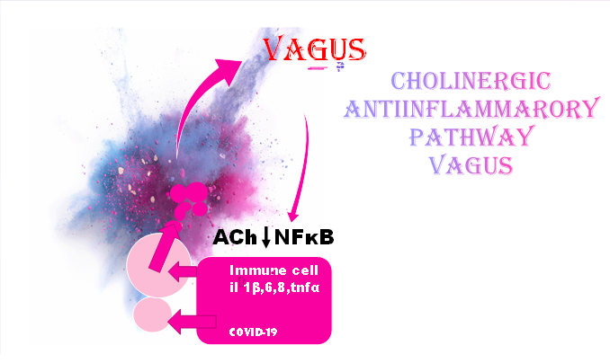
Immune Cell
IL 1β,6,8, & TNFα

COVID-19
Figure 2. Cholinergic (Parasympathetic) anti-inflammatory pathway. Ach=acetyl choline; IL=interleukin; NFkB=nuclear factor kappa B; TNF=tumor necrosis factor

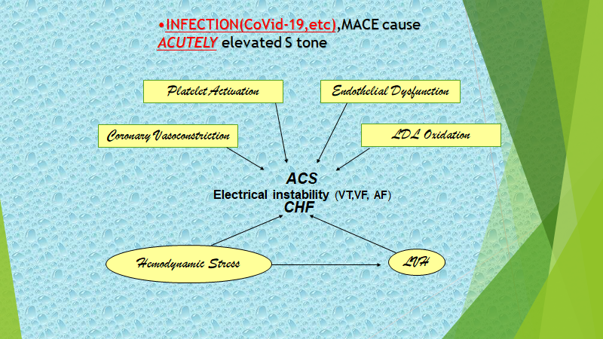
Figure 3. Pro-inflammatory Sympathetic activation. ACS=acute coronary syndrome; AF=atrial fibrillation; CHF=congestive heart failure; LDL=low density lipoprotein; S=sympathetic; VF=ventricular fibrillation; VT=ventricular tachycardia

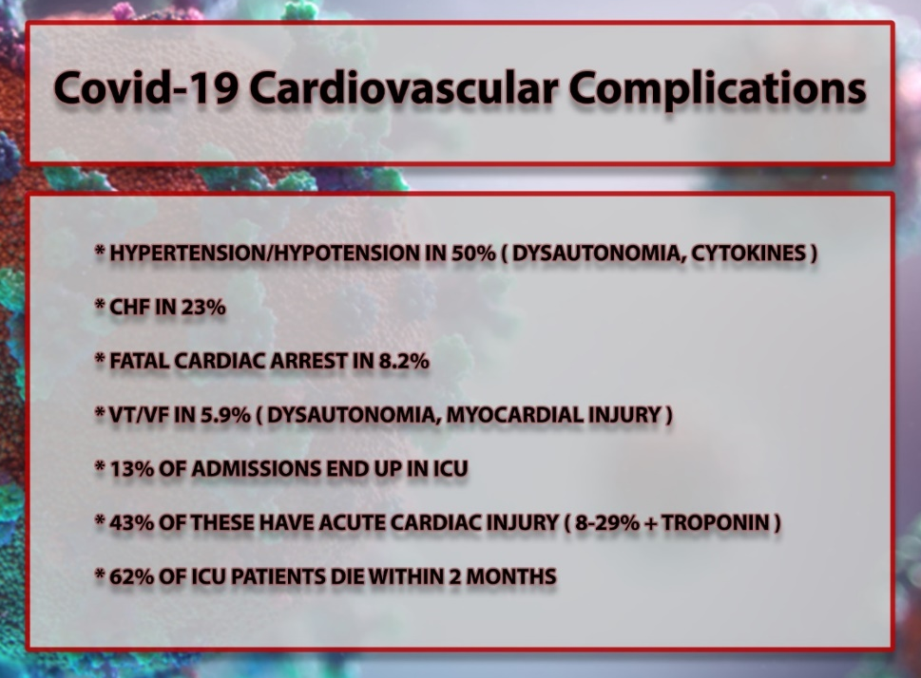
Figure 4. COVID-19 cardiovascular (CV) complications in hospitalized patients. CHF=congestive heart failure; ICU-intensive care unit; +=positive; VF=ventricular fibrillation; VT=ventricular tachycardia
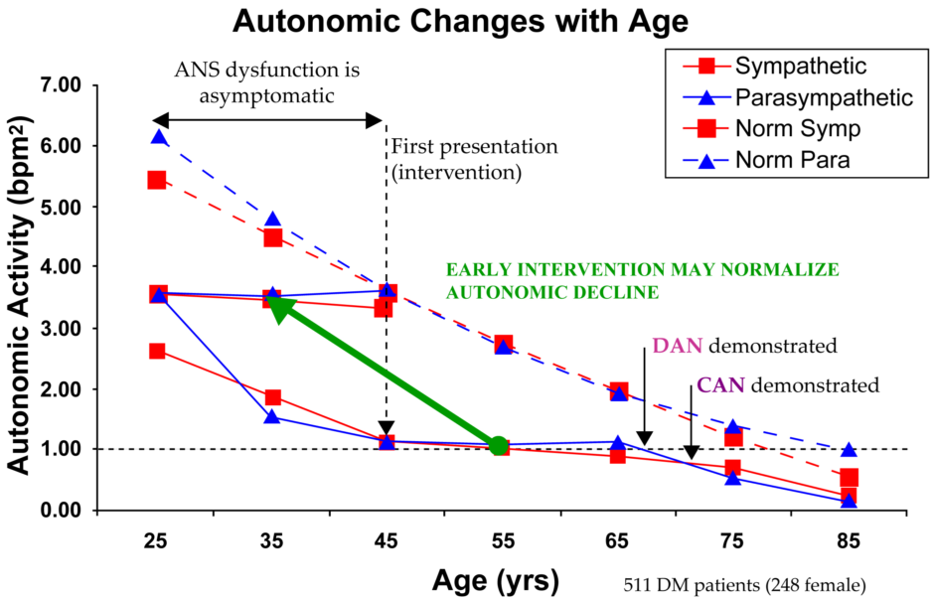
Figure 5. ANS age-related changes in a population of patients diagnosed with type 2 Diabetes (DMII) as compared with a population of normal subjects. Here DMII is used as a model of chronic disease effects on the ANS [6]. ANS=autonomic nervous system; CAN=cardiovascular autonomic neuropathy; DAN=diabetic autonomic neuropathy; DM=diabetes mellitus.
METHODS
The methods are detailed in each of our publications [7,8,9,10,11,12]. However, the new technology used to measure P&S bears repeating.
Parasympathetic and Sympathetic (P&S) function was assessed noninvasively with the ANX 3.0 autonomic function monitor (PhysioPS, Atlanta, GA USA), which computes simultaneous, independent measures of P&S activity based on continuous, time-frequency analysis of Heart Rate Variability and Respiratory Activity (RA). RA analyses concurrent with HRV analyses corrects for the ambiguities found in HRV-alone, eliminating the assumptions and approximation required to theorize P from S in HRV-alone. The following variables were recorded. (1) the center of the spectrum of P-activity was computed from peak spectral power in the respiratory activity spectrum (known as the Fundamental Respiratory Frequency, or FRF). (2) Seated resting (5 min) P-activity (respiratory frequency area, or RFa) was defined as the spectral power within a 0.12 Hz-wide window centered on the FRF in the HRV spectrum. (3) Seated resting S-activity was computed from the remaining spectral power in the low-frequency area (LFa), after RFa is computed. All spectral activity was identified from time-frequency analysis. FRF identifies vagal outflow, RFa is a measure of P-activity, and LFa was defined as the remaining spectral power in the low frequency spectrum of HRV (0.04-0.15 Hz, a measure of total autonomic activity), after computation of RFa. High Sympathovagal Balance (SB=LFa/RFa) was defined as a resting LFa/RFa ratio >2.5. (3) The average SB reported is the average of the ratios recorded during the sampling period, not a ratio of averages. (4) The 30:15 ratio is the ratio of the 30th heart beat interval (R-R) after a quick head-up postural change (standing) to the 15th R-R interval after standing. The 30:15 ratio reflects the reflex bradycardia upon standing that depends on Sympathetic vasoconstriction. (5) The Valsalva ratio is the ratio of the longest R-R interval to the shortest R-R during a 15-second Valsalva maneuver. (6) The E/I ratio is the ratio of the R-R interval during peak exhalation over that during peak inhalation during paced breathing (breathing at 6 breathes/min). The E/I ratio is a measure of more or less Vagal tone, as are the 30:15 and Valsalva ratios. Cardiovascular Autonomic Neuropathy CAN is defined in standard fashion (resting P<0.10 bpm²), reflecting very low P-activity. Advanced Autonomic Dysfunction (AAD) in non-diabetics is equivalent to Diabetic Autonomic Neuropathy (DAN) in diabetics. Both are precursors to Cardiovascular Autonomic Neuropathy (CAN): AAD/DAN: P or S < 0.5 bpm²; CAN: P (only) < 0.1bpm².
RESULTS
Influence Of High Sb And Low P, Including Can And Benefits Of Their Treatment In Chronic Disease
High SB
Four hundred eighty-three (483) patients were studied (Table 1) []. Yearly myocardial perfusion imaging (MPI) stress and 2-dimensional echo (2DE) exams were obtained, and Major Adverse Cardiovascular Events (MACE, i.e., new angina, ACS, acute CHF, appropriate defibrillator therapies, cardiac death) were recorded over a mean follow-up of 4.92 years. Of this cohort: (Group 1) 127 pts. were with risk factors for CAD, using the Framingham Risk Score (FRS); (Group 2) 224 pts. were with CAD; and (Group 3) 132 pts. were with CHF. As a predictor of MACE, SB was found to outperformed the FRS, positive

Table 1 High SB best predicts cardiac events.
CHF=congestive heart failure; CI=confidence interval; CD=coronary disease; LVEF=left ventricular ejection fraction; MACE=major adverse cardiac events; MPI=myocardial perfusion imaging; NPV=negative predictive value; p=p-value; +=positive; PPV=positive predictive value; SB=sympathovagal balance; 2DE=two-dimensional echocardiogram

MPI (+MPI), and 2DE left ventricular ejection fraction (LVEF),
In 105 anginal CAD patients, when SB was > 2.5, MACE occurred in 55% (r=0.0117, p=0.005) of those patients. With SB < 2.5, 85% of these patients were MACE-free (r=0.0046, p=0.0014). Ranolazine reduced high SB and MACE by 63%, mainly by ACS reduction [].
In 109 CHF patients, when SB was > 2.5, 59% of these patients suffered MACE. When SB was < 2.5, 81% of these patients were MACE-free. Ranolazine reduced high SB and MACE 40% (SCD 5.6% vs. 12.77%, VT/VF 11.8% vs. 23.7%, CHF admissions 23.2% vs. 27.3%) []. It also increased LVEF in 70% of patients by an average of 11.3 ejection fraction (EF) units. P&S and LVEF changes were independent of each other. Ranolazine directly inhibits P&S neuronal sodium channel 1.7 in a strongly use-dependent manner.
Cardiovascular Autonomic Neuropathy, Low Resting Parasympathetic Activity
In 133 DM II patients, r-ALA reduced sudden cardiac death (SCD) by 43% (Figure 6) []. The difference between life and SCD depended more upon preserved and improved resting P-activity than a normal SB, although both favored survival (Table 2).
Baseline (Bx) RFa, increased in 55/90 (60%) of this cohort’s patients, by a mean of 12.5% in survivors, and severely decreased in 29/43 (67%) non-survivors, by a mean of 59.5%, (p<0.0001). SB increased 17.6% in survivors, but had a greater increase in SCD to > 2.5: +29.5% (p=0.064).
Non-Survivors demonstrated a more abnormal final alpha-S-response upon standing, SW (-24.4% vs., -13.8%; p=0.066), indicating greater Baroreceptor Reflex dysfunction, which increases SCD risk. Parasympathetic Excess (PE) upon standing developed more significantly in survivors (+65%) verses SCD (+29%) because initial to final standing RFa increased in survivors verses decreasing in SCD (p=0.022).

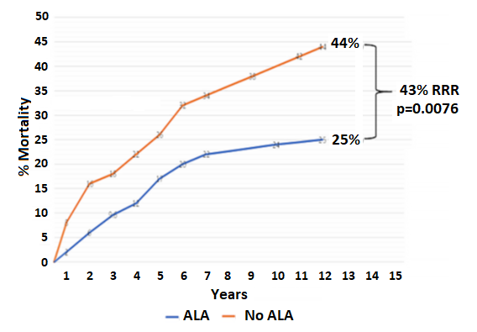
Figure 6. SCD in DM II patients (with N=83, without N=50) (r)ALA. ALA=alpha lipoic acid; p=p-value; RRR=relative risk reduction

Table 2 Comparison between Survivors and Sudden Cardiac Death patients, Mean P&S Measures.
 | Survivors(r)ALA+CONTROLS |  |  |  | SCD(r)ALA+CONTROLS
N | 90 |  |  |  | 43
 | Initial | Final | Δ% | p | Initial | Final | Δ% | p
Sitting (Rest)
LFa (bmp²) | 1.25  ±2.19 | 1.10  ±1.55 | -12 | 0.045 | 0.89  ±1.60 | 0.93  ±1.09 | +4.5 | 0.039
RFa (bmp²) | 1.20  ±2.33 | 1.35  ±1.50 | +12.5 | 0.079 | 1.11  ±1.93 | 0.45  ±0.47 | -59.5 | 0.054
SB 1.23  ±1.50 | 1.76  ±1.47 | 2.07  ±1.49 | +17.6 | 0.064 | 2.03  ±1.92 | 2.63  ±2.60 | +29.5 | 0.064
Standing
LFa (bmp²) | 1.16  ±2.05 | 1.00  ±1.22 | -13.8 | 0.056 | 0.90  ±1.28 | 0.68  ±0.91 | -24.4 | 0.005
RFa (bmp²) | 0.97  ±1.70 | 1.75  ±1.95 | +80.4 | 0.051 | 0.82  ±1.21 | 0.58  ±0.66 | -29.3 | < 0.001
ALA=Alpha Lipoic Acid; bmp=beats per min.²; ∆=change; LFa=low frequency area; +=plus; RFa=respiratory frequency area; SB=sympathovagal balance

In parallel, SCD patients experienced a dramatic 59.5% decrease in resting P in addition to SW. All P- and S-final values were lower in SCD, the lowest being resting P. Since HRV = S + P, HRV was lower in SCD (p<0.0001) mainly due to lower P.
Only (r)ALA survivors demonstrated an increase in final, resting P (and HRV). Increased P reduces VT/VF and silent ischemia. Resting P increased 36.2% versus a 7.6% decrease for Control survivors. P decreased 10.5% for (r)ALA SCD patients, and 67.5% for Control SCD patients. The progressive increase in the decline of resting P indicated mortality was from the lowest decline in resting P in Control survivors, to the next greater decline in (r)ALA SCDs, to those with the greatest decline in Control SCDs (p < 0.001). Changes in P were proportional to (r)ALA dose.
Final high SB or CAN results are shown in Table 3. The percent of the four groups with either high SB or CAN or both were: Group AA = 14.5%, Group NA = 25.0%, Group ND = 45.5%, Group AD = 67.0%. CAN decreased by 37.5% in (r)ALA survivors (Group AA) and increased by 67% in Control SCDs (Group ND).
In the CAD study, CAN occurred in 10% of MACE patients verses 6.2% of patients without MACE (p=0.0245). CAN, although present, did not alter MACE, as opposed to high SB.
Influence Of P&S In Hypertension Control
The P&S results of our randomized,
Table 3. Final P & S Measures in DM II. Comparison by group of patients with high SB or CAN.
Groups Compared | % with Hi SB or CAN |  | p
AA vs NA | 14.5 | 25.0 | 0.103
AD vs ND | 67.0 | 45.5 | 0.033
AA vs ND | 14.5 | 45.5 | 0.029
NA vs AD | 25.0 | 67.0 | 0.016
AA=ALA Alive; AD=ALA Dead; CAN=Cardiovascular Autonomic Neuropathy; NA=No ALA Alive; ND=No ALA Dead; P=Parasympathetic; p=p-value; S=Sympathetic; SB=Sympathovagal Balance
prospective, open-label study [] are presented in Table 4. After a mean of 8.35 months, 74% of P&S guided therapy patients reached treatment goal verses 30.5% of JNC8 patients (p<0.001 systolic BP, diastolic BP, pulse) on a mean of 2.3 anti-hypertensives verses 3 in the JNC8 group. Group P&S demonstrated improved final office P&S measures (Table 4), including: lower resting (sitting) S-tone (LFa = 0.90, p < 0.001), higher final P-tone (RFa = 0.71, p < 0.001), and higher standing P-tone (RFa = 1.56, p = 0.005) as compared with final Group JNC values. All of these differences are consistent with improved HTN control.
Influence Of Low S In Neurogenic Orthostatic Hypotension
In our 118-patient study [], (r)ALA/ALA controlled 66% of systolic and 88% of diastolic NOH patients (Table 5). Responsiveness depended upon baseline S (Table 6).

Table 4. P&S and BP measures
 | P&S Guided Therapy |  | JNC8-Guided Therapy
 | Base-line | Goal | Base-line | Goal | p
REST
Pulse (bpm) | 82 | 61 | 76 | 72 | <0.001
LFa (bpm²) | 2.11 | 0.90 | 0.57 | 1.19 | <0.001
RFa (bpm²) | 2.15 | 0.71 | 0.47 | 0.62 | <0.001
SB (unitless) | 3.26 | 1.86 | 1.83 | 1.84 | 0.004
BP (mmHg) | 151/74 | 138/71 | 155/73 | 146/65 | <0.001
STAND (PC)
LFa (bpm²) | 3.19 | 2.35 | 0.67 | 2.31 | Ns
RFa (bpm²) | 1.67 | 1.56 | 0.50 | 0.88 | 0.005
BP (mmHg) | 153/79 | 138/71 | 155/73 | 145/65 | <0.001
BP=blood pressure; bpm=beats per minute; LFa=Sympathetic activity measure; mmHg=millimeters of mercury; PC=postural change; RFa=Parasympathetic activity measure; SB=Sympathovagal Balance (SB=resting LFa/resting RFa; an average of ratios, not a ration of averages).

DISCUSSION
Oxidative Stress
Many acute, chronic, and serious pathologies cause an over-production of oxidants, including reactive oxygen and nitrogen species (ROS, NOS), causing oxidative stress. While some level of oxidants is required by the immune system in defense against pathogens, excess oxidants cause damage, most significantly to mitochondria. The heart and the nervous system have the most mitochondria per cell and are more vulnerable to oxidative stress damage. P&S dysfunction, including due to oxidative stress such as from COVID-19 infection, accelerates cardiovascular disease into a downward spiral, often before symptoms manifest.
The Oxidative Stress – Cardiovascular Disease Connection
Presently, although we are aware of the paradigm depicted in Figure 7 [], we still treat primarily the symptoms resulting from oxidative stress with stents, coronary artery bypass (or peripheral vascular interventions), defibrillators, ablations, and certain medications, rather than treating the oxidative stress per se or the autonomic dysfunction it causes. The exception is the neurohumoral paradigm of systolic CHF. Our approach to managing chronic CVD such as CAD, CHF, systemic HTN, NOH, and DM II SCD has been to diagnose and treat the P&S abnormalities, most likely caused by oxidative stress, that result in MACE.

Table 5. Autonomic and Blood Pressure measures

 | NOH |  |  |  |  |  | OI |  |  |  |  |  | CONTROLS (N=20)
 | R+ (N=19) |  |  | R– (N=9) |  |  | R+ (N=40) |  |  | R– (N=20)
 | PRE | POST | p | PRE | POST | p | PRE | POST | p | PRE | POST | p | Bx | End | p
Rest (sitting)
sBP | 145 | 126 | 0.0023 | 136 | 136 | ns | 130 | 124 | 0.0061 | 138 | 130 | 0.0167 | 140 | 138 | ns
dBP | 73 | 66 | 0.0039 | 77 | 76 | ns | 70 | 69 | ns | 71 | 69 | ns | 76 | 72 | ns
LFa | 0.78 | 1.20 | 0.0172 | 0.20 | 0.25 | ns | 0.77 | 0.72 | ns | 0.41 | 0.56 | 0.0362 | 1.14 | 0.90 | 0.0301
RFa | 0.97 | 1.83 | 0.0199 | 0.34 | 0.27 | ns | 0.71 | 0.67 | ns | 0.49 | 0.59 | ns | 0.51 | 0.70 | 0.0517
SB | 1.35 | 1.59 | ns | 1.25 | 1.12 | ns | 1.55 | 1.61 | ns | 1.43 | 1.37 | ns | 2.28 | 2.20 | ns
Valsalva
SB | 9.59 | 8.90 | ns | 12.5 | 13.6 | ns | 9.09 | 11.1 | ns | 6.10 | 20.0 | 0.0652 | 14.0 | 12.6 | ns
sBP | 117 | 126 | 0.0210 | 104 | 107 | ns | 121 | 130 | ns | 125 | 118 | 0.0433 | 127 | 125 | ns
dBP | 67 | 68 | ns | 68 | 65 | ns | 71 | 73 | ns | 52 | 71 | 0.0338 | 75 | 75 | ns
Stand (PC)
LFa | 0.53 | 0.88 | 0.0361 | 0.11 | 0.29 | 0.0362 | 0.92 | 0.98 | ns | 0.48 | 0.62 | ns | 1.69 | 0.55 | 0.0221
RFa | 0.69 | 1.03 | 0.0300 | 0.14 | 0.11 | ns | 0.47 | 0.47 | ns | 0.40 | 0.55 | ns | 1.69 | 0.55 | 0.0056
SB | 2.24 | 1.69 | 0.0083 | 1.70 | 2.46 | 0.0654 | 2.94 | 4.20 | 0.0271 | 2.37 | 1.99 | ns | 4.08 | 1.91 | 0.0164
∆sBP | -28 | 0 | 0.0129 | -32 | -29 | ns | -9 | 6 | <0.001 | -13 | -12 | ns | -13 | -13 | ns
∆dBP | -6 | 2 | 0.0456 | -9 | -11 | ns | 1 | 2 | ns | -19 | 2 | 0.0068 | -1 | 3 | ns
BP=blood pressure, s&d=systolic and diastolic, respectively, (mmHg); Bx= Baseline initial measurement; ∆=change; LFa=low frequency area = the measure of Sympathetic activity (bpm²); N=number; NOH= Neurogenic Orthostatic Hypotension; OI= Orthostatic Intolerance; RFa= respiratory frequency area = the measure of Parasympathetic activity (bpm²); R–=(r)Alpha Lipoic Acid non-responders; R+=(r)Alpha Lipoic Acid responders; SB=Sympathovagal Balance (unitless)

Table 6. Sympathetic activity as measured by LFa (bpm²)
LFa | R– |  |  | R+
 | OH | OI | p | OH | OI | p
Pre-Rx
Sit | 0.20 | 0.41 | 0.0230 | 0.78 | 0.77 | na
Stand | 0.11 | 0.48 | 0.0107 | 0.53 | 0.92 | 0.0220
Post-Rx
Sit | 0.25 | 0.56 | 0.0258 | 1.20 | 0.92 | 0.0345
Stand | 0.29 | 0.12 | 0.0253 | 0.88 | 0.98 | na
Abbreviations as in Table 5. Rx= treatment with (r)ALA.

(r)ALA is a naturally occurring substance, a powerful thiol antioxidant that restores and recycles vitamins A, C, E, and Glutathione, enhancing their efficacy, as well as its own. ALA also improves hyperglycemia, endothelial dysfunction, endothelial nitric oxide levels, reduces NF κB activity. ALA is essential for the function of certain oxidative enzymatic activities, and is protective against silent myocardial ischemia, VT/VF, and shortens the QTc. It exists as two enantiomers, with (r)ALA much more active than (s)ALA, and does not require a prescription. It primarily increases resting P (which is known to be cardio-protective), thereby secondarily decreasing SB. However, in NOH, it increases low alpha-S (a dynamic measure, not a resting measure).
Ranolazine is also an antioxidant. It inhibits CRP, IL-1 and IL-6, and TNF alpha, although this is unlikely to be its major mode of action.
In all our studies in chronic CVD, better P&S profiles were associated with up to a 63% reduction in MACE. Why should not this be true in acute diseases as well?
Regarding COVID, its CV (and pulmonary, CAP) outcome likely vitally depends upon the preexisting P&S status. If the CAP is impaired, especially by CAN or its precursor, Advanced Autonomic Dysfunction (AAD, aka., Diabetic Autonomic Neuropathy (DAN) in Diabetics , SB will be secondarily increased, promoting a pro-inflammatory state (cytokine storm). If resting S is severely depressed, direct infection (due to low S decreasing the immune and inflammatory response) could cause serious complications.
Acute illness, such as COVID-19
In a study of blunt and invasive trauma [], 100% of patients with CAN/AAD suffered in-hospital SCD.
So, we have proposed the following therapy for COVID-19 CV involvement (Fig.8). Upon hospital admission, all patients could be started on (r)ALA 300mg bid if P&S testing is unavailable. If troponin, echocardiogram, or cardiac MRI indicate cardiac involvement, RAN 1000mg po bid, should be given. For ventilator-dependent patients, ALA can be given per feeding tube along with RAN crushed and given 250mg per feeding tube every 3 hours.

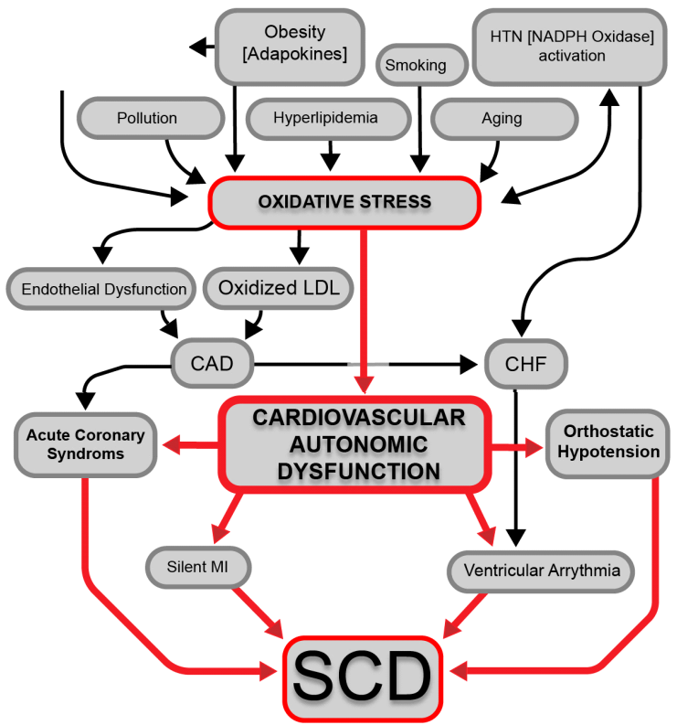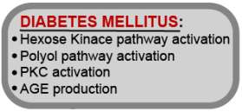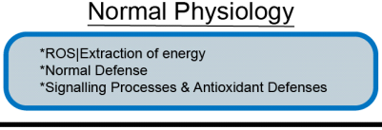
Figure 7. Free radicals and CVD. AGE=advanced glycation end products; AMI=acute myocardial infarction; CAD=coronary disease; CHF=congestive heart failure; HTN = hypertension; LDL=low density lipoprotein; NADPH= Nicotinamide adenine dinucleotide phosphate; PKC=protein kinase C; SCD=sudden cardiac death. [adapted from 13]

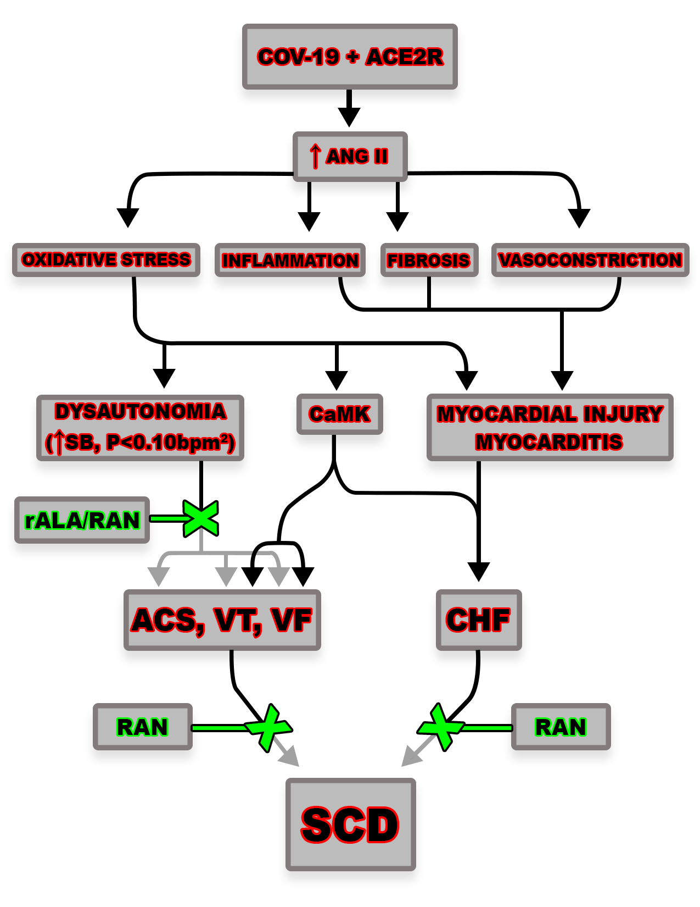
Figure 8. Proposed CV complication management. ACE2R-angiotensin 2 receptor; ACS=acute coronary syndrome; CaMK=calcium calmodulin kinase II; CHF=congestive heart failure; p=p-value; RAN=ranolazine; rALA=r alpha lipoic acid: SCD=sudden cardiac death; VF=ventricular fibrillation; VT=ventricular tachycardia

CONCLUSIONS
It is vital to diagnose and treat P&S abnormalities, especially P < 0.10 bpm² with SB > 2.5, in CV patients, yet we rarely do. Treatment is remarkably safe. (r)ALA is one of the body’s most potent antioxidants and is essentially harmless. Since Ranolazine’s 2006 launch, no death has ever been attributed to it, and it protects against torsades de pointes. Neither agent should be used in severe renal disease, and ALA should not be used in chemotherapy patients. We suggest beginning with 300mg (r)ALA po or per feeding tube bid and 1000 mg ranolazine po bid. It can be safely crushed, if needed, and given 250 mg per tube q 3hr.

REFERENCES

Murray G. CoVid-19 Cardiac Complications: Is an Easy, Safe Treatment Strategy Right Under Our Noses? Cardiovascular Diseases and Diagnosis.2020;8(5):1-15
T.J. Guzik, S.A. Mohiddin, A. Dimarco, et al. COVID-19 and the cardiovascular system: implications for risk assessment, diagnosis, and treatment options. Cardiovasc Res., 2020, http://dx.doi.org/10.1093/cvr/cvs164
European Society of Cardiology. ESC Guidance for the Diagnosis and Management of CV Disease during the COVID-19 Pandemic. Available at: https://www.escardio.org/Education/COVID-19-and-Cardiology/ESC-COVID-19-Guidance. Accessed 14 January 2022.
Kenney MJ,Ganta CK.Autonomic nervous system and immune system interactions.Comp Physiol.2014 July;4(3):1177-1200.
Pongrtz G,Straub R.The sympathetic nervous response in inflammation.Arthritis Research & Therapy.3014;16:504-18.
Colombo J, Arora RR, DePace NL, Vinik AI. Clinical Autonomic Dysfunction: Measurement, Indications, Therapies, and Outcomes. Springer Science + Business Media, New York, NY, 2014
Murray GL; Colombo J; Routine Measurement of Cardiac Parasympathetic and Sympathetic Nervous Systems Assists in Primary and Secondary Risk Stratification and Management of Cardiovascular Clinic Patients. Clinical Cardiology and Cardiovascular Medicine.2019; 3(1):27-33.
Murray G,Colombo J. Ranolazine Therapy Reduces Non-ST-Segment-Elevation Myocardial Infarction and Unstable Angina in Coronary Disease Patients with Angina.Int J Angiol. 2016;25:159–164
Murray GL; Colombo J; Ranolazine Preserves and Improves Left Ventricular Ejection Fraction When Added to Guideline – Driven Therapy in Congestive Heart Failure, Heart International. 2014; 9(12):66-73
Murray G, Colombo J. Maintenance (r)Alpha Lipoic Acid Reduces Sudden Cardiac Death 43% in Geriatric Diabetes II Patients. Clinical Cardiology and Cardiovascular Medicine.2020;4(1):6-11.
Murray GL; Colombo J; The Feasibility of Blood Pressure Control with Autonomic-Assisted Hypertension Therapy Versus JNC 8 Therapy. Clinical Cardiology and Cardiovascular Medicine.2020;4(1):1-5.
Murray GL; Colombo J; (R) Alpha Lipoic Acid: A New, Effective, Natural Treatment of Neurogenic Orthostatic Hypotension and Orthostasis. International Journal of Angiology. 2019;28:188-193
Gary L Murray. (2020) (r)Alpha Lipoic Assists With Control of Neurogenic Orthostatic Hypotension, Hypertension, and Reduces Sudden Cardiac Death in Geriatric Diabetics. Int J Pharm Sci Clin Pharm 1(1): 32-52. https://doi.org/10.47890/IJPSCP/GaryLMurray/2020/24148305
Colombo J, Shoemaker WC, Belzberg H, Hatzakis G, Fathizadeh P, Demetriades D. Noninvasive Monitoring of the Autonomic Nervous System and Hemodynamics of Patients With Blunt and Penetrating Trauma. J Trauma. 2008; 65(6): 1364-1373.

