**Hypermobility: An Autonomic Conundrum Like Diabetes**

Vinik AI, DePace NL, and Colombo J

ABSTRACT

Hypermobility, as a connective tissue disorder, involves every system of the human body. Diabetes Mellitus is a disease that also involves every system of the body. Medicine now knows Diabetes. Here, we consider the development of diagnostic, therapeutic, and management modalities in Diabetes as a model for developing similar modalities in Hypermobility. Perhaps we may learn important lessons from Diabetes research and development and make faster progress in Hypermobility research and development.

**Copyright**: © 2022 by the authors. Submitted for open access publication under the Journal of Individualized Medicine and Therapies, of the Society of Individualized Medicine and Therapies, Inc.

INTRODUCTION

Diabetes is a disease of the energy delivery system of the body. It has been characterized as a car having a full gas tank with a clogged fuel line, thus affecting virtually every cell in the body. However, it goes well beyond just the energy supply. The persistent excess sugar in the blood stream leading to sugar acidosis also impacts the entire body, starting with the two most sensitive body tissue types: the nerves and the filtration systems of the kidneys. In this way, it further affects every system of the body. Moreover, the onslaught on the kidneys’ filtration processes amplifies the disease process by leading to uremia acidosis. The effects on the nervous system, starting with the autonomic nervous system, also affect the whole body, including blood flow to virtually every cell and the control or coordination of all body systems. The multipronged attack on the whole body by Diabetes, like any generalized attack, makes the weakest sector the most vulnerable and it is affected first, followed by the next weakest and so on. The weakest sector is determined by the individual’s history, lifestyle, genetic composition, and mental disposition.

Over the decades, diagnostic and therapeutic standards have been developed that have helped to better understand the disease and enable targeted management. In type 2 Diabetes, there is the possibility of prevention, and for type 1 and 2, medical and lifestyle therapies have been developed, as well as pain-free devices for glucose measurement and insulin delivery, resulting in improved patient outcomes and reduced healthcare costs and enhancing the individual’s quality of life and that of their loved ones. One of the early advances in the recognition of Diabetes as a risk factor for mortality came in the understanding of Diabetic Autonomic Neuropathy (DAN) as the precursor to Cardiovascular Autonomic Neuropathy (CAN), indicating significantly increased mortality risk. Moreover, DAN also indicates significantly increased morbidity risk and involves a severe depletion of the function of the two autonomic branches: the Parasympathetics and the Sympathetics (referenced hereafter as P&S). See Figure 1 [[1]]. This depletion causes increased morbidity and mortality risks much earlier in the progression of the disease than symptoms will suggest, which degrades quality of life, productivity, and patient outcomes, while increasing

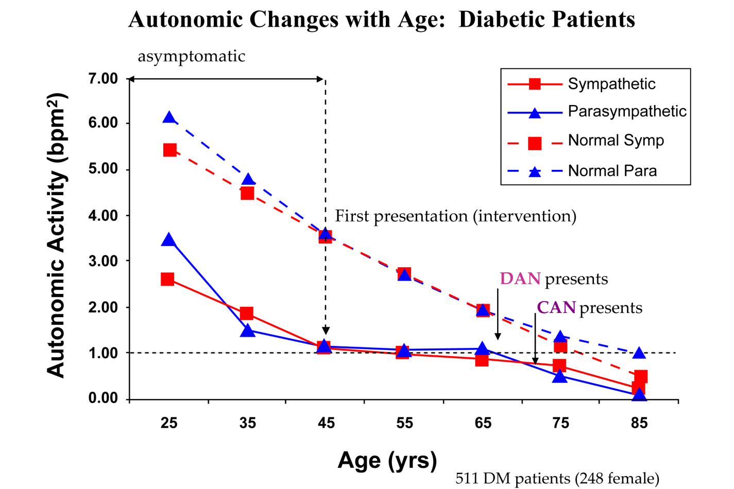

**Figure 1**: Diabetes as a model of chronic disease. P (blue) and S (red) changes over time from 309 known healthy volunteers from ages 3 to 96 y/o (76 Female, 31.6%, broken lines) and 511 type 2 Diabetic Mellitus patients (212 Female, 41.4%, solid lines). These data are age-matched. The broken line at the 1.0 level is the threshold for advanced autonomic dysfunction (aka DAN, if diabetic), based on Framingham Heart Study findings. These curves offer several insights into autonomic decline. On average, P&Slevels are approximately 50% depleted upon first diagnosis, *and it is asymptomatic*. This seems to reflect the ADA’s indication that by the time of diagnosis, a type 2 diabetic has had the disease for up to five years and confirms the ADA recommendation for P&S Monitoring within two years of a diagnosis of type 2 diabetes [3]. The seven years (five plus two) of the disease and the pre-diabetic conditions have already significantly depleted the PSNS and the SNS (You have not previously abbreviated these terms like this before), before the disease is even detected. At both ends of the age range, Parasympathetic activity is normally higher than Sympathetic activity (SB is in the low normal range: 0.4 < SB < 1.0). In the early years, this reflects the Parasympathetic involvement in development. In the later years, the low-normal SB reflects the added Parasympathetic activity that has been shown to protect the heart, reduce morbidity and mortality, and improve outcomes. This has become the recommended autonomic balance for geriatric patients [2,4,5]. In the middle years, the balance is approximately 1.0 (the curves overlie each other) or a little above 1.0. This may reflect the need of young adults to have the additional energy for child-rearing. The effect of chronic disease on autonomic function is to accelerate P&S decline, apparently causing earlier mortality risk, including heart diseases. By the time symptoms present, P&Slevels are 80% depleted, *and the decline was asymptomatic*. Disease seems to cause late stage (relative) Sympathetic dominance (SB > 3.0), which is known to increase morbidity and mortality. 012_fig002.jpg

healthcare costs to the individual and society. Normalizing the balance between P&S (known as Sympathovagal Balance, or SB), “flattens” or slows P&S decline. See the middle section of the Diabetes curves in Figure 1 [[2],[3],[4],[5]]. As shown in Figure 2, normalizing the chronic disease patient’s SB earlier may return the patient to the healthy path, reducing morbidity and mortality risks, maintaining or improving quality of life, productivity, and patient outcomes, while decreasing hospitalizations and re-hospitalizations and reducing healthcare costs to the individual and society.

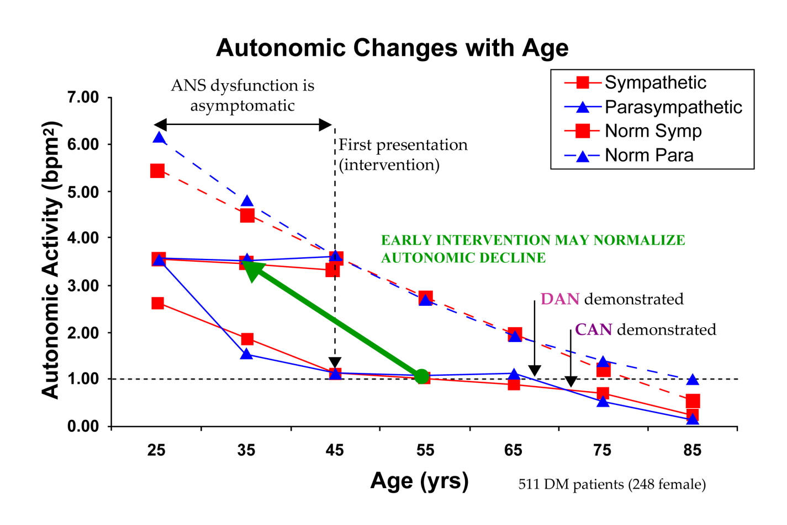

**Figure 2**: Benefits of Early Intervention. Figure 1 is repeated here with an indication of the effects of early intervention to normalize Sympathovagal Balance (SB = S/P). This helps to slow P&S decline. Normalizing SB is a function of complying with the standards of care in Diabetes, as early as possible, long before symptoms present. Note how flat the patients’ curves are after “first presentation” and intervention around age 45, until decline continues (in parallel with normals) around age 65. This flat portion is the slowing of P&S decline. If adopted earlier, it seems as if therapy could translate the patient’s P&S response curves to the more normal autonomic decline curves of the normal subjects, minimizing or reducing morbidity and mortality and improving outcomes.

Hypermobility and Ehlers-Danlos Syndrome (EDSh) affects connective tissue throughout the body, including the P&S nervous systems, as well as the immune system and, like Diabetes, every other system of the body. EDSh causes long “stretchy” collagen that leads to “leaky” connective tissue. As is well known, some of connective tissue’s functions are to contain things, like gastric juices in the stomach, and it forms the blood-brain barrier and the barrier between the outside world and the patient’s “inside world.” As a result, and similar to Diabetes, it is a whole-body disease capable of affecting all body organs and systems. In fact, the complexity of Diabetes has been summed up as such: “In knowing Diabetes, one knows the whole of medicine!” (Aaron Vinik, MD, PhD)

EDSh is a genetic disorder (whether inherited or acquired) and has no known cure. EDSh affects the nervous system directly through “leakage” and indirectly through the immune system. EDSh not only permits substances to leak out of the body, but permits foreign substances, including infections, outside the body to “leak in.” This places the immune system on constant “high alert.” As a result, since the Parasympathetic nervous system is the memory for and controls and coordinates the immune system, the Parasympathetics are constantly overactive. This overactivity is known as Parasympathetic Excess (PE) [1,[6]], which leads to many of the symptoms of EDSh, either directly or indirectly through forcing persistent and excessive Sympathetic responses, including persistent, exaggerated inflammation, pain, histaminergic, and BP responses, and Anxiety-like symptoms.

Again, EDSh has no known cure. Perhaps dietary collagen may help to manage the disease by permitting the body access to normal collagen to “plug the leaks.” In the meantime, there are patients to be treated, and recognizing, diagnosing, and treating P&S imbalances, both at rest and in response to challenges, helps to restore productivity and quality of life to patients. EDSh awareness is rising and may be more common than currently thought. Either way, EDSh provides another probe into the human body and into the P&S nervous systems and, like Diabetes, may help to advance the science of smedicine in this generation for the future.

**Diabetes Mellitus: A Model of Chronic Disease (*Vinik’s life work summary*)**

Early in the study of Autonomic Neuropathy, the Ewing or Time Domain ratios (E/I, Valsalva, and 30:15) provide some qualitative insight to more or less HRV during different challenges [[7]]. Eventually, the data indicated that only the E/I ratio held any meaning for patients over 55. Yet the Ewing Ratios still provided more information than was available previously, helping to identify some initial indications. Using these three ratios, DAN was indicated if any two of the three were abnormally low and CAN if all three were abnormally low. These helped improve patient outcomes for nearly two decades. In the mid-1990s, HRV (including Time Domain ratios) were standardized.

Using these ratios, r-Alpha Lipoic Acid (rALA, a naturally occurring, powerful antioxidant) was found to be a helpful agent in staying or relieving autonomic neuropathy, and DAN and CAN became well known within the Diabetes world. The prevalence of Diabetes helped to spread the new knowledge being gained through HRV applications in research and in the clinic to other areas of medicine related to Diabetes. However, HRV-alone was not enough, and simply managing a patient’s blood glucose more aggressively was also not enough [[8],[9]]. More information was still needed to reduce the long-term mortality and morbidity effects of Diabetes [[10]], thereby reducing hospitalization and re-hospitalization, improving patient outcomes, and reducing healthcare costs both to the individual and to the nation. P&S monitoring also helps to provide more information [1].

# P&S Monitoring is a unique, FDA-cleared technique of non-invasively measuring the P&S nervous systems simultaneously and independently. It was first introduced in the late 1990s, and serves as a “Crystal Ball” [6] identifying autonomic neuropathy earlier [[11],[12],[13],[14]] (see Figure 1). It has led to earlier indications of the morbidity risks of DAN [[15],[16],[17],[18],[19],[20],[21],[22]] and the mortality risks of CAN [[23],[24],[25],[26],[27]], including risk of Orthostatic dysfunction [[28],[29],[30]], Hypertension [[31]], peripheral neuropathy associated with poor peripheral circulation which slows wound healing [[32]], inflammation [[33]], vasculitis [[34]], and eventually cardiovascular disease [22,[35],[36]], including Major Adverse Cardiovascular Events such as Sudden Cardiac Death [[37],[38],[39]], and more [[40],[41]]; with Orthostatic dysfunction arguably being the most debilitating of them all, as a threat to quality of life and productivity [[42],[43]]. Treating autonomic neuropathy to delay CAN became part of the standard of care in 2008 [[44]]. More recently, P&S changes have been noted to help characterize pre-Diabetes [[45],[46],[47]]. The more information provided by P&S Monitoring (see Figure 3) was recognized in the 2017 American Association of Clinical Endocrinologists and American College of Endocrinology Position Statement on Testing for Autonomic and Somatic Nerve Dysfunction [[48], p1476], referencing Respiratory frequency area (RFa) and Low Frequency area (LFa) as the technical parameters that are the measures of P&S activity, respectively.

Unfortunately, Autonomic Neuropathy (AN) was previously mistakenly thought to be untreatable; perhaps due to the name “neuropathy” indicating “dead nerves” and the knowledge that once nerves are dead, they cannot be treated. Also, it was believed that the individual P&S branches could not be directly measured. All other measures, including the Ewing Ratios, were measures of only one branch or both P&S branches together, forcing assumption and approximation to theorize the individual P&S responses [[49]]. With P&S Monitoring, specifically the ability to independently and simultaneously measure Parasympathetic activity, autonomic neuropathy was found to be treatable by balancing P&S (see Figure 4) [[50]]. Balancing P&S slows or stays the progression of Autonomic decline (see Figure 2) and leads to greater longevity, as well as greater quality of life and productivity (see Figure 5). The beginning of Autonomic Dysfunction (Neuropathy), like neuropathy in general, is from inflammation and oxidative stress (see Figure 6) [15,18] often due to a significant insult to the body, including: disease (including viral) or trauma, including mental trauma; multiple pregnancies; surgeries; and more.

Autonomic Neuropathy is treatable [46] (see Figure 7). The oxidative stress in Diabetes is caused by sugar acidosis and other factors of Diabetes. Oxidative stress damages cell walls, DNA, and organelles including the Mitochondria that powers cells. Since nerve and cardiac cells include the highest numbers of Mitochondria, these are the most effected, thereby amplifying the whole-body effect. The damage due to Oxidative Stress, including to the Mitochondria, may be reversed with antioxidants, like rALA (it is a “super” antioxidant in that it adds to its power by recycling other antioxidants and is selective for nerves) [[51],[52]],[53]]. In more advanced cases where cardiovascular



Figure 3: The natural history of autonomic balance, based on Diabetes as a model of the effect of chronic disease on the autonomic nervous system. IL-6 = Interleukin-6, an inflammatory marker; HMWA/L = high-molecular weight adiponectin-to-leptin ratio, an inflammatory marker; LFa = low frequency area, a pure measure of sympathetic activity (based on concurrent spectral analyses of continuous measures of both respiratory activity and HRV) ; RFa = respiratory frequency area, a pure measure of parasympathetic activity (based on concurrent spectral analyses of continuous measures of both respiratory activity and HRV); E/I ratio = the ratio of the peak exhalation R-R interval to the peak inhalation R-R interval. R-R interval is the interval between two consecutive heart beats and is a qualitative measure of more or less parasympathetic activity; rmsSD = root mean square of standard deviation, a statistical measure of heart rate variability (HRV), and is a qualitative measure of more or less parasympathetic activity; PAI-1 = plasminogen activator Inhibitor 1, an inflammatory marker; TA/L ratio = total adiponectin/leptin ratio, an inflammatory marker; Valsalva ratio = the ratio of the longest to shortest R-R interval during a 15-second Valsalva maneuver, a qualitative measure of more or less parasympathetic activity; TSP = total spectral power, a measure of gross autonomic activity (parasympathetic plus sympathetic activity); sdNN = standard deviation of the beat-to-beat (R-R) intervals, a measure of gross autonomic activity (parasympathetic plus sympathetic activity); RFa = respiratory frequency area, a pure measure of parasympathetic activity (based on concurrent spectral analyses of continuous measures of both respiratory activity and HRV); SB = Sympathovagal Balance = ratio of resting sympathetic activity to resting parasympathetic activity. Very low RFa is a definition of Cardiovascular Autonomic Neuropathy (CAN), increased indicating mortality risk. CAN with high SB is associated with high mortality risk. [1] Adapted from [33]

disease is involved, Co-Enzyme Q10 (CoQ10, another natural, “super” antioxidant that adds to its power by recycling other antioxidants and is selective for cardiovascular muscles) is recommended to also help reverse the damage of oxidative stress [[54],[55],[56]]. In addition to managing the Diabetes, P&S Monitoring helps to elucidate the underlying autonomic dysfunctions that are involved. Two common autonomic dysfunctions are (1) Sympathetic Withdrawal (SW, an alpha-adrenergic deficit that underlies Orthostatic Dysfunction and poor cardiac and cerebral perfusion and associated symptoms) [[57]] and (2) Parasympathetic Excess (PE, an abnormal Parasympathetic response to a Sympathetic challenge, underlying Vasovagal Syncope and poor cerebral perfusion and associated symptoms) [2].

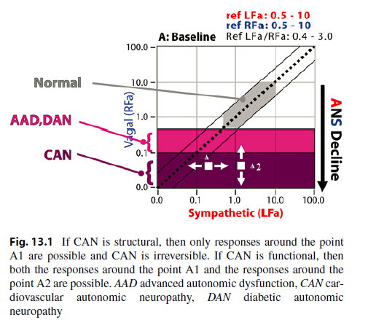

**A2**

**A1**

Figure 4: Autonomic Neuropathy (AN) is treatable by normalizing Sympathovagal Balance; this will slow or stay the progression of AN from normal (in the gray area) through DAN and CAN. There are two forms of CAN: structural and functional. If CAN is structural, then only the responses around point A1 are possible and CAN is irreversible. If CAN is functional, then both the responses around both points A1 & A2 are possible. AAD, Advanced Autonomic Dysfunction (similar to DAN without the insulin and blood sugar issues), DAN, Diabetic Autonomic Neuropathy, CAN, Cardiovascular Autonomic Neuropathy. [50]

High-dose rALA also helps to relieve SW [[58]], in addition to Oxidative Stress, and helps to significantly reduce the risk of Major Adverse Cardiovascular Events [35]. “Low and Slow” exercise helps to relieve PE [[59]]. Very low-dose pharmaceutical therapy (*i.e.*, Oral Vasoactives for SW and low-dose Anticholinergics for PE) helps to accelerate the relief of Autonomic Dysfunction (Neuropathy) and is expected to be short-term [[60]]. Follow-up P&S Monitoring helps to track the patient to titrate therapy to the individual patient. Often, treating these dysautonomias helps to normalize resting P&S balance (Sympathovagal Balance, or SB) [[61]]. Whatever symptoms and SB abnormalities remain after normalizing the dynamic dysfunctions are then treated with more classical protocols, such as anti-hypertensives for high BP.

Carvedilol is a common pharmaceutical to treat cardiovascular disease in Diabetes, helping to reduce morbidity and mortality risk. It provides cardiovascular protection as a beta-adrenergic blocker in concert with its alpha-adrenergic blockade (see Figure 7). It provides additional protection (*i.e.*, over that of Metoprolol [[62],[63]]), due to its antioxidant properties, including helping to restore some resting Parasympathetic activity, which is known to be cardio-protective [2,[64]], and thereby protective of other organ systems.

Nitrates, as well as L-Arginine, L-Citrulline, and L-Carnitine, help to increase Nitric Oxide production which helps to improve Parasympathetic nerve activity, vascular function (including by reducing atherosclerosis), and endothelial health in general [55]. Nitric Oxide also helps to

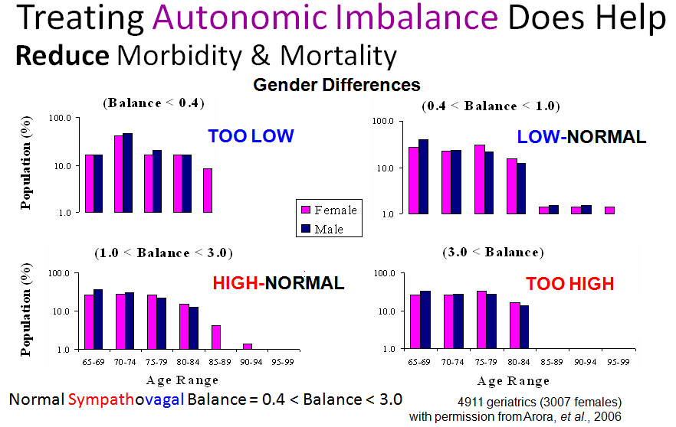

Figure 5: The results from a large population of geriatric patients, demonstrating the mortality (longevity) consequences of the four different ranges of SB [1]. Adapted from [23]. ANSfigures.ppt

reduce inflammation, along with other anti-inflammatories such as Ω-3 Fatty Acids. These supplements and pharmacopeia are supported by and help to support the healthful effects of mild to moderate exercise, proper diet (*i.e.*, Mediterranean Diet or Japo-Mediterranean Diet), and Psychosocial Stress reduction [55]. All of these therapies effect P&S balance (see Figure 7) and may be titrated to the individual patient over time, maintaining normal P&S balance (both at rest and in response to challenges) to improve patient outcomes [[65]].

CAN increases morbidity and mortality in Diabetes and may have greater predictive power than traditional risk factors for cardiovascular events [35,62]. Significant morbidity and mortality may now be attributable to autonomic imbalance between the P&S nervous systems’ regulation of cardiovascular function. New and emerging syndromes include orthostatic tachycardia, orthostatic bradycardia and an inability to use heart rate as a guide to exercise intensity because of the resting tachycardia. Recent studies have shown that P&S imbalance may be a predictor of risk of sudden death with intensification of glycemic control [4,[66]]. The association between autonomic dysregulation and the role of inflammatory cytokines and adipocytokines that promote cardiovascular risk has been demonstrated. In this way, P&S balance is both a “prophet of doom” and a “scope for hope” [62].

There is now strong evidence of inflammation with activation of inflammatory cytokines such as IL-6 and leptin in newly-diagnosed type 2 Diabetes. This may not be limited to Diabetes, such as

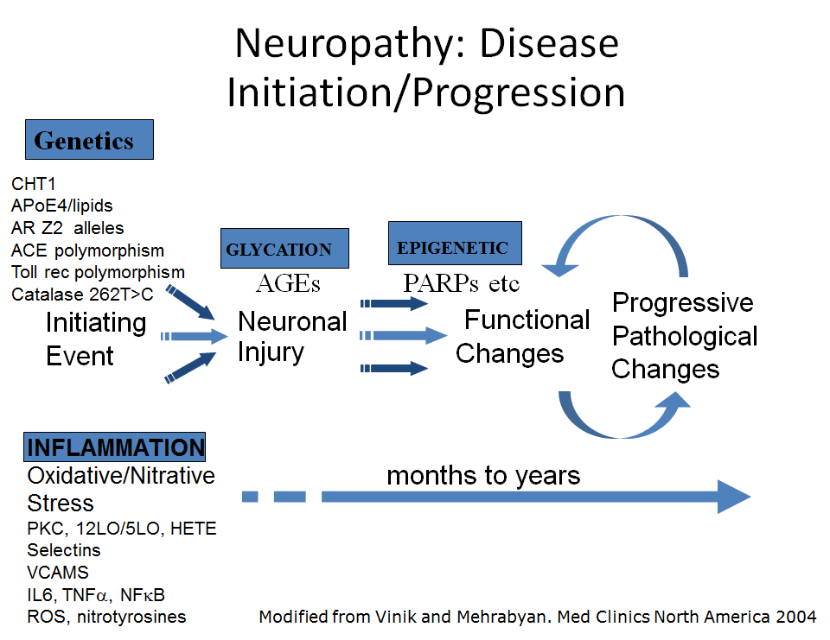

Figure 6: Pathogenesis of diabetic neuropathy: the initiation and progression of diabetes. See text. Adapted from [19]

the recent association of cytokine storms with viruses. These changes correlate with abnormalities in P&S balance. A better understanding of P&S dysfunction and adipose tissue inflammation seen early in the development of Diabetes will lead to further measures for determining which individuals are at the highest risk for cardiovascular disease and mortality. Moreover, it may also lead to the development of new therapies for reducing risk. Glucose activation of inflammatory cytokines activates the efferent arm of the brain stem reflex arc via a branch of the Vagus N. This reflex may be affected by anti-cholinergics to cause a decrease in pro-inflammatory cytokine production and a reduction in disease severity [[67]]. This correlation between the Vagus N. and early type 2 Diabetes exists in other inflammatory human diseases, such as Rheumatoid Arthritis and Lupus. It is well known that the nervous system and the endocrine system are intimately linked, where hormones are now recognized as neurotransmitters and not only neuromodulators. In this way, the P&S nervous system also controls endocrine glands. Studies implicate the hypothalamus as “the conductor of the endocrine orchestra” [64] and show that the earliest changes that are detectable in the evolution of Diabetes (Figure 3) are abnormalities in P&S balance. It is not beyond the realms of reason that we could reverse the unfortunate evolutionary profile by targeting the hypothalamic set point of P&S balance.

**Figure 7:** Possible therapeutic approaches to the treatment or prevention of autonomic dysfunction in diabetes. Central to this evolving concept is the role of adipocytokines and inflammation. AGE, advanced glycation end product; ARB, angiotensin receptor blocker; ARI, aldose reductase inhibitor; CoQ10, Co-Enzyme Q10; e-NOS, endothelial nitric oxide synthase; IL-6 interleukin 6; i-NOS, inducible nitric oxide synthase; NFkB, nuclear factor-kappa B; PKC, protein kinase C; PPAR, peroxisome proliferator activated receptor; ROS, reactive oxygen species; SOD, superoxide dimutase; TNF-a, tumor necrosis factor alpha. Adapted with permission from [65].

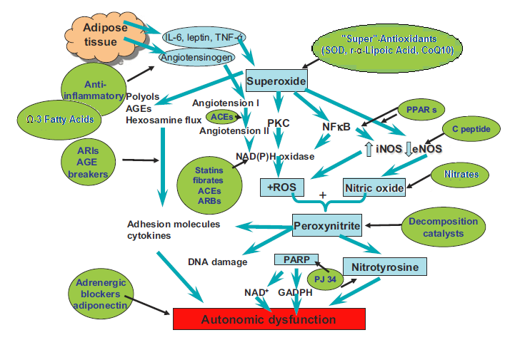

**EDSh SYMPTOMS AND DIAGNOSES**

EDSh, as a collagen-based, connective tissue disorder, also affects the whole body. This is not only due to the ubiquitous presence of defective connective tissue throughout the body but indeed the secondary P&S effects throughout the whole body which amplify the primary effects of EDSh. In same the way that Diabetes attacks the whole body, including through the P&S nervous systems, so does EDSh, and perhaps lessons learned from the progress in the fight against Diabetes may help to accelerate the fight against EDSh and provide methods to reset and restore P&S balance. While EDS and Hypermobility are both genetic disorders of the connective tissue, specifically collagen, the primary difference between them is that EDS is inherited and Hypermobility is acquired. There are 13 types of EDSh. Only one may be life threatening. The Cardiac-Valvular type of EDSh is the only potentially life-threatening type and is very rare. The classical signs of EDSh are: 1) the skin is hyper-extensible (if it may be stretched over 1.5 cm for the distal part of the forearms and the dorsum of the hands; or 3 cm for neck, elbow and knees); 2) joint hypermobility (evaluated according to the Beighton score; >5/9 is considered positive for younger patients and <5/9 may be considered positive based on history); and 3) abnormal scarring. The Beighton scoring system assesses skin and joints, indicating general joint hypermobility. The Beighton score is incorporated in the EDS questionnaire (https://www.ehlers-danlos.com/heds-diagnostic-checklist/) that provides a more comprehensive assessment of EDSh. Either way, there is no known cure for the genetic disorder. However, most of these patients are highly symptomatic. Most if not all symptoms are direct or indirect consequences of P&S imbalance.***

The initial P&S imbalance is a primary effect of the loose and “leaky” connective tissue, including inflammation and oxidative stress. This is continuously compounded by the fact that the “leaky” connective tissue permits foreign substances to enter the body that otherwise would not. This causes a persistent, heightened immune response, including persistent inflammation. The persistent, heightened immune response causes a persistent, heightened Parasympathetic response (PE). PE will cause a secondary, persistent Sympathetic Excess (SE, the beta-adrenergic response) which will exacerbate and amplify the (Sympathetically mediated) inflammation. Both of these processes also cause persistent, heightened oxidative stress, among other effects, exacerbating the Fatigue caused by PE leading to poor cerebral perfusion. All of this is further compounded by SW which, like in Diabetes, is a first symptom of P&S imbalance, arguably the most debilitating of dysautonomias (leading to both poor cardiac and, thereby, cerebral perfusion) [38,39], and one of the most difficult of dysautonomias to relieve.

**Lessons learned from Diabetes applied to EDSh**

EDSh patients typically present when young. During development (until late teens or early 20s), the heightened P&S activity supporting development often masks any dysautonomias associated with EDSh, except perhaps Orthostatic dysfunction (Orthostatic hypotension, typically in males, and POTS, typically in females) and sleep difficulties. Most of the time, these symptoms are blamed on development. With symptom development and a young and still healthy nervous system, the P&S systems work together in an attempt to compensate, but are on average much more active than normal (see Figure 8 and compare with Figure 1). Eventually, the P&S declines, perhaps fatigues as a result of the long-standing oxidative stress. After the decline, as with Diabetes, the EDSh patients’ resting Sympathetic activity remains higher than their resting Parasympathetic activity, and more so than that of the patients with Diabetes, perhaps due to the difference in pain and possibly inflammation levels between Diabetes and EDSh. However, the patients’ P&S activity remains below that of the non-diseased subjects, suggesting a reduction in longevity.

Comparing SB for the EDSh patient with that of the non-diseased, the two populations present with similar values of SB until about age 45 (Figure 8). Again, SB is a resting measure of total autonomic activity. Measures of total autonomic activity at these earlier stages continue to confound and are the basis for why these patients seem normal with the average test, because: 1) the patient is at rest (no additional energy is required and therefore the effects of oxidative stress

Figure 8: Age-matched comparison of 243 EDSh patients and 309 known healthy volunteers from Figure 1. See Figure 1 legend and the text for details.

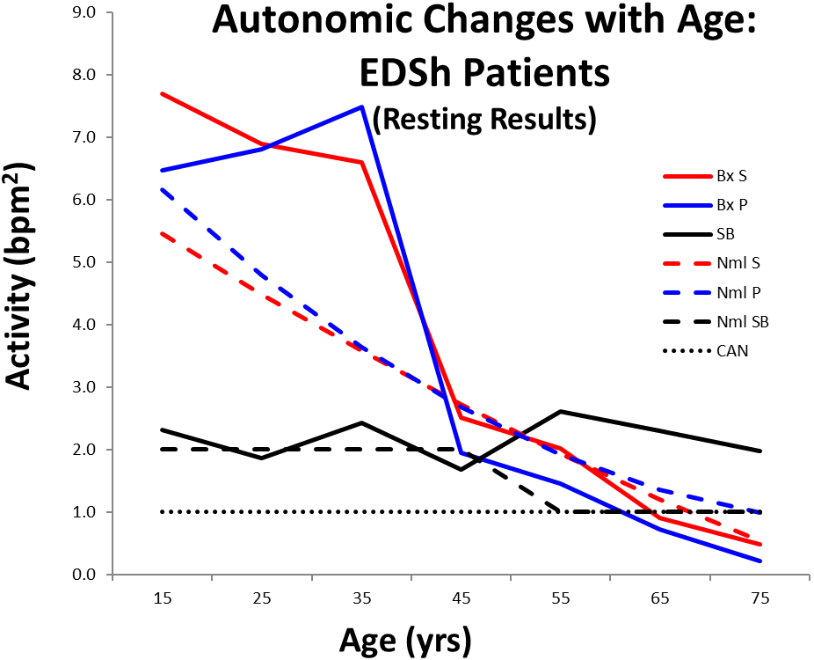

are not demonstrated), and 2) no other autonomic test is able to differentiate Parasympathetic activity from Sympathetic activity independently and simultaneously, so the absolute values are lost. Beyond age 45, the average patients’ SB remains high-normal or becomes even higher, adding to the morbidity and mortality risks, whereas, the average non-diseased population tends towards low-normal SB, which is known to be protective in the older patients.

As with Diabetes, SW & PE are both associated with a constellation of symptoms due to their effects on all other systems of the body [1]. In addition to Fatigue, these lead to Anxiety/Depression, brain-fog, memory and cognitive difficulties, sleep difficulties, GI upset, pain, headache or migraine, and more. Leaky connective tissue causes inflammation and oxidative stress, exacerbating the above symptoms. However, with EDSh, PE with secondary (beta) SE may result in Mast Cell Activation Syndrome, Celiac Disease, and autoimmune disorders. Mast Cell Activation Syndrome presents due to the (beta-)SE secondary to PE. EDSh may involve Celiac disease due to the “leaky” connective tissue in the gut. We find that most autoimmune disorders associated with EDSh are secondary to PE and are relieved when PE is relieved. Since most of these P&S effects present are challenge responses, these patients often appear normal at rest, which is when most patients are assessed. Therefore, they are either not believed or misdiagnosed. The rheumatological effects of inflammation and collagen disorder may misrepresent EDSh as other disorders such as Rheumatoid Arthritis and Lupus. However, rheumatological disorders often accompany EDSh as a result of disordered collagen.

Like with Diabetes, establishing and maintaining normal P&S balance both in response to challenge and at rest also reduces morbidity and mortality. However, unlike Diabetes, the constant assault on the immune system prevents the Parasympathetics from remaining normal. In this way, the P&S are constantly being pulled out of balance to support the immune system and protect the body. Therefore, the EDSh patient’s P&S is not able to support a balanced condition for very long. In contrast, in Diabetes, once P&S balance is established, it may be maintained organically until some other clinical event. In EDSh, the next clinical event (another potential infection) may only be moments away. Therefore, life-long maintenance therapy is likely to be required for the EDSh patient. Fortunately, maintenance therapy may be limited to lifestyle and supplements, mainly antioxidants and anti-inflammatories, such as rALA and Ω-3 Fatty Acids, respectively. As with Diabetes-induced P&S dysfunction, pharmaceutical therapy is often short-lived, helping to accelerate the effect of therapeutic doses of the supplements. Once the therapy protocol that works for the individual EDSh patient is found, it should be remembered, for it may need to be implemented if and when another serious clinical event occurs, including pregnancy in females, when they may need to be weaned of many of the pharmaceuticals at the very least.

The Dysautonomia therapies mentioned above for Diabetes are applicable to EDSh patients. EDSh patients, since many of them have been to numerous other physicians over many years, often have become desensitized to most pharmaceuticals used to treat P&S imbalance, especially if they are prescribed at the much higher clinical doses as may be indicated for the associated symptom. P&S therapy requires low doses over time to gently normalize balance. Higher doses often create side-effects that further upset P&S balance [1].

In addition to therapy targeting the defective genes of EDSh and as with pancreatic- and insulin-targeted therapies in Diabetes, there may be a therapy that may target the connective tissue itself in EDSh. Since the patient’s own collagen is defective (long and “stretchy”), perhaps (normal, short, and “stiff”) dietary collagen may be used by the patient’s body to “plug the holes” in the patient’s “leaky” connective tissue. A preliminary investigation of this concept is underway [personal communication].

The P&S similarities between type 2 Diabetes and EDSh may help to accelerate therapy protocols for the EDSh patients to help restore quality of life and productivity to this typically young portion of our population. Other reports in this volume will provide more detailed analyses of SW and PE perspectives and Cardiology and Rheumatology perspectives on EDSh.

REFERENCES

1. Colombo J, Arora RR, DePace NL, Vinik AI. Clinical Autonomic Dysfunction: Measurement, Indications, Therapies, and Outcomes. Springer Science + Business Media, New York, NY, 2014.
2. Umetani K, Singer DH, McCraty R, and Atkinson M. Twenty-four hour time domain heart rate variability and heart rate: Relations to age and gender over nine decades. JACC. 1998; 31(3), 593 – 601.
3. American Diabetes Association. Standards of medical care in diabetes--2013. Diabetes Care. 2013 Jan;36 Suppl 1(Suppl 1):S11-66. doi: 10.2337/dc13-S011. PMID: 23264422; PMCID: PMC3537269.
4. Arora RR, Ghosh Dastidar S, Colombo J Autonomic balance is associated with decreased morbidity. American Autonomic Society, 17th International Symposium, Kauai, HI, 29 Oct – 1 Nov, 2008.
5. Waheed A, Ali MA, Jurivich DA, et al. Gender differences in longevity and autonomic function. Presented at the Geriatric Medicine Society Meeting, Chicago. May 3-7, 2006.
6. Tobias H, Vinitsky A, Bulgarelli RJ, Ghosh-Dastidar S, Colombo J. Autonomic nervous system monitoring of patients with excess parasympathetic responses to sympathetic challenges – clinical observations. US Neurology. 2010; 5(2): 62-66.
7. Clarke B, Ewing D, Campbell I. Diabetic autonomic neuropathy. Diabetologia. 1979; 17:195-212.
8. Pop-Busui R, Evans GW, Gerstein HC, Fonseca V, Fleg JL, Hoogwerf BJ, Genuth S, Grimm RH, Corson MA, Prineas R; Action to Control Cardiovascular Risk in Diabetes Study Group. Effects of cardiac autonomic dysfunction on mortality risk in the Action to Control Cardiovascular Risk in Diabetes (ACCORD) trial. Diabetes Care. 2010 Jul;33(7):1578-84. doi: 10.2337/dc10-0125. Epub 2010 Mar 9. PMID: 20215456; PMCID: PMC2890362.
9. Tang Y, Shah H, Bueno Junior CR, Sun X, Mitri J, Sambataro M, Sambado L, Gerstein HC, Fonseca V, Doria A, Pop-Busui R. Intensive Risk Factor Management and Cardiovascular Autonomic Neuropathy in Type 2 Diabetes: The ACCORD Trial. Diabetes Care. 2021 Jan;44(1):164-173. doi: 10.2337/dc20-1842. Epub 2020 Nov 3. PMID: 33144354; PMCID: PMC7783932.
10. Vinik AI, Maser RE, Ziegler D. Neuropathy. The crystal ball for cardiovascular disease. Diabetes Care. 2010; 33(7): 1688-1690.
11. Vinik AI, Aysin B, Colombo J. Differentiation of autonomic dysfunction by enhanced frequency domain analysis reveals additional stages in the progression of autonomic decline in diabetics. Diabetes Technology Conference, San Francisco, CA, 10-12 Nov 2005.
12. Vinik AI, Aysin B, Colombo J. Resting enhanced frequency domain analysis improves heart rate variability sensitivity in early and late diabetics. Diabetes Technology Conference, San Francisco, CA, 10-12 Nov, 2005.
13. Vinik AI, Aysin B, Colombo J. Dynamic enhanced frequency domain analysis indicates a significant decline in autonomic function before age 50. Presented at the Diabetes Technology Conference, San Francisco. Nov. 10-12, 2005.
14. Vinik AI, Arora RR, Colombo J. Age Matched Attenuation of Both Autonomic Branches in Chronic Disease: II. Diabetes Mellitus. Cleveland Clinic Heart-Brain Summit, Cleveland Clinic Lou Ruvo Center for Brain Health, Las Vegas, NV, 23-24 September 2010
15. Vinik AI, Erbas T. Recognizing and treating diabetic autonomic neuropathy. Cleveland Clinic J. of Med. 2001; 68(11): 928-44.
16. Vinik AI, Freeman R, Erbas T: Diabetic autonomic neuropathy. Semin Neurol. 2003; 23:365-372.
17. Vinik AI, Maser RE, Mitchell BD, Freeman R. Diabetic autonomic neuropathy. Diabetes Care. 2003; 26(5): 1553-1579.
18. Vinik A, Erbas T, Pfeifer M, Feldman E, Stevens M, Russell J: Diabetic autonomic neuropathy, 2004. In The Diabetes Mellitus Manual: A Primary Care Companion to Ellenberg and Rifkin’s 6th Edition. In Zucchi SE, Ed. New York, McGraw Hill, 2004, p. 351.
19. Vinik AI and Mehrabyan A. Diabetic neuropathies. Med Clin N Am. 2004; 88: 947-99.
20. Vinik AI, Ullal J, Parson HK, and Casellini CM. Diabetic neuropathies: Clinical manifestations and current treatment options. Nat Clin Pract Endocrinol Metab. 2006; 2(4): 1-13.
21. Vinik AI, Nevoret ML, Casellini CM, Parson H. Diabetic Neuropathy. Endocrinol Metab Clin North Am . 2013; 42(4):747-87. doi: 10.1016/j.ecl.2013.06.001. Review.
22. Albers JW, Pop-Busui R. Diabetic neuropathy: mechanisms, emerging treatments, and subtypes. Curr Neurol Neurosci Rep. 2014 Aug;14(8):473. doi: 10.1007/s11910-014-0473-5. PMID: 24954624; PMCID: PMC5084622.
23. Maser R, Mitchell B, Vinik AI, Freeman R. The association between cardiovascular autonomic neuropathy and mortality in individuals with diabetes, a meta analysis. Diabetes Care. 2003; 26(6): 1895-1901.
24. Vinik AI, and Erbas T. Cardiovascular autonomic neuropathy: Diagnosis and management. Curr. Diab.Rep. 2006; 6: 424–430.
25. Vinik AI, Ziegler D. Diabetic cardiovascular autonomic neuropathy. Circulation. 2007 Jan 23;115(3):387-97. doi: 10.1161/CIRCULATIONAHA.106.634949. PMID: 17242296.
26. Vinik AI, Strotmeyer ES, Nakave AA, Patel CV. Diabetic neuropathy in older adults. Clin Ger Med. 2008; 24: 407-435.
27. Vinik AI, Erbas T, Casellini CM. Diabetic cardiac autonomic neuropathy, inflammation and cardiovascular disease. J Diabetes Invest. 2013; 4(1): 4-18.
28. Aysin B, Aysin E, Colombo J, Vinik A. Diabetes May Accelerate the Onset of Orthostasis. 6th Annual Diabetes Technology Meeting, Atlanta, GA, Nov. 2-6, 2006.
29. Colombo J, Jacot J, Aysin E, Aysin B, Iffrig K, Vinik AI. Symptoms of orthostasis may be due to sympathetic/parasympathetic autonomic imbalance and can be evaluated by hrv with respiratory analysis with appropriate pathogenesis oriented therapeutic choices. International Symposium on Diabetes Neuropathy, 7th Annual Congress, Cape Town, South Africa, 29 Nov – 2 Dec 2007.
30. Vinik AI, DePace NL, Arora RR, Bhatkar V, Colombo J. Parasympathetic and Sympathetic Abnormalities During Postural Change Identify Pre-Clinical and Sub-Clinical Symptoms Associated with Dizziness. American Diabetes Association, 72nd Scientific Sessions, Philadelphia, PA, 8-12 June 2012.
31. Vinik AI, Aysin B, Colombo J. Enhanced frequency domain analysis identifies early autonomic dysfunction that may lead to elevated blood pressure in diabetics. Diabetes Technology Conference, San Francisco, CA, 10-12 Nov 2005.
32. Vinik AI, Suwanwalaikorn S, Stansberry KB, et al. Quantitative measurement of cutaneous perception in diabetic neuropathy. Muscle Nerve 1995;18:574–84.
33. Lieb D, Parson H, Mamikunian G, and Vinik A. Cardiac autonomic imbalance in newly diagnosed and established diabetes is associated with markers of adipose tissue inflammation. Exp.Diabetes Res. 2012: 1–8.
34. Ramesh K. Adiraju (2017) Dysautonomia: A Novel Approach to Understanding of Vasculitis and Type Ii Diabetes. J Rheuma­tol Arthritic Dis 2(3): 1-12.
35. Vinik AI, DePace NL, Bhatkar V, Colombo J. Cardiovascular Risks Associated with Parasympathetic and Sympathetic Imbalance. American Diabetes Association, 72nd Scientific Sessions, Philadelphia, PA, 8-12 June 2012.
36. Vinik AI, Casellini C, Parson HK, Colberg SR, and Nevoret M-L. Cardiac Autonomic Neuropathy in Diabetes: A Predictor of Cardiometabolic Events. Front. Neurosci. 2018; 12:591. doi: 10.3389/fnins.2018.00591
37. Kahn JK, Sisson JC, Vinik AI: QT interval prolongation and sudden cardiac death in diabetic autonomic neuropathy. J Clin Endocrinol Metab 1987; 64: 751-4.
38. Kahn JK, Sisson JC, Vinik AI: Prediction of sudden cardiac death in diabetic autonomic neuropathy. J Nucl Med 1988; 29: 1605-6.
39. Murray LG and Colombo J. Maintenance (r) alpha lipoic acid reduces sudden cardiac death in geriatric diabetes mellitus II patients (2020) Clinical Cardiol Cardiovascular Med 4: 6-12.
40. Vinik AI, DePace NL, Arora RR. A Parasympathetic and Sympathetic Therapy-Driven Approach to the Treatment of Depression, Hypertension and Sleep Disorders in a Patient with Diabetes. US Endocrinol. 2012; 6: 82-84.
41. Maser RE, Lenhard MJ, Kolm P. Autonomic modulation in gestational diabetes mellitus. J Diabetes Complications. 2014 Sep-Oct;28(5):684-8. doi: 10.1016/j.jdiacomp.2014.05.005. Epub 2014 May 22. PMID: 24972765.
42. Vinik AI, Maser RE, Nakave AA. Diabetic cardiovascular autonomic nerve dysfunction. US Endocrine Disease. 2007; Dec: 2-9.
43. Vinik A, Ziegler D. Diabetic cardiovascular autonomic neuropathy. Circulation. 2007; 115: 387-397.
44. American Diabetes Association. Standards of medical care in diabetes--2008. Diabetes Care. 2008 Jan;31 Suppl 1:S12-54. doi: 10.2337/dc08-S012. PMID: 18165335.
45. Dimova R, [Tankova T](https://www.ncbi.nlm.nih.gov/pubmed/?term=Tankova%20T%5BAuthor%5D&cauthor=true&cauthor_uid=26036955), Chakarova N, Groseva G, Dakovska L Cardiovascular autonomic tone relation to metabolic parameters and hsCRP in normoglycemia and prediabetes. Diabetes Res Clin Pract. 2015 Aug;109(2):262-70. doi: 10.1016/j.diabres.2015.05.024. Epub 2015 May 21.
46. Dimova R, Tankova T, Kirilov G, Chakarova N, Dakovska L, Grozeva G. Is vaspin related to cardio-metabolic status and autonomic function in early stages of glucose intolerance and in metabolic syndrome? Diabetol Metab Syndr. 2016 Jul 26;8:46. doi: 10.1186/s13098-016-0165-1. PMID: 27462373; PMCID: PMC4960717.
47. Dimova R, Tankova T, Kirilov G, Chakarova N, Grozeva G, Dakovska L Endothelial and Autonomic Dysfunction at Early Stages of Glucose Intolerance and in Metabolic Syndrome. Horm Metab Res. 2019 Sep 17. doi: 10.1055/a-0972-1302. [Epub ahead of print].
48. Vinik AI, Camacho PM, Davidson JA, Handelsman Y, Lando HM, Leddy AL, Reddy SK, Cook R, Spallone V, Tesfaye S, Ziegler D; Task Force to Develop an AACE Position Statement on Autonomic Testing. AMERICAN ASSOCIATION OF CLINICAL ENDOCRINOLOGISTS AND AMERICAN COLLEGE OF ENDOCRINOLOGY POSITION STATEMENT ON TESTING FOR AUTONOMIC AND SOMATIC NERVE DYSFUNCTION. Endocr Pract. 2017 Dec;23(12):1472-1478. doi: 10.4158/EP-2017-0053. PMID: 29320641.
49. A. I. Vinik, MD; B. Aysin, PhD; and J. Colombo, PhD Enhanced Frequency Domain Analysis Replaces Older Heart Rate Variability Methods. Diabetes Technology Conference, San Francisco, CA, 10-12 Nov 2005.
50. Vinik AI, Murray GL. Autonomic neuropathy is treatable. US Endocrinol. 2008; 2: 82-84.
51. Ziegler D, Schatz H, Conrad F, Gries FA, Ulrich H, and Reichel G. Effects of treatment with the antioxidant alpha-lipoic acid on cardiac autonomic neuropathy in NIDDM patients. A 4-month randomized controlled multicenter trial (DEKAN Study). Deutsche Kardiale Autonome Neuropathie. Diabetes Care. 1997; 20: 369–373.
52. Ziegler D, Ametov A, Barinov A, Dyck PJ, Gurieva I, Low PA, Munzel U, Yakhno N, Raz I, Novosadova M, Maus J, Samigullin R. Oral treatment with alpha-lipoic acid improves symptomatic diabetic polyneuropathy: the SYDNEY 2 trial. Diabetes Care. 2006 Nov;29(11):2365-70. doi: 10.2337/dc06-1216. PMID: 17065669.
53. Ziegler D, Low PA, Litchy WJ, Boulton AJM, Vinik AI, Freeman R, and the NATHAN 1 Trial Group. Efficacy and safety of antioxidant treatment with α-lipoic acid over 4 years in diabetic polyneuropathy. Diabetes Care. 2011; 34: 2054-2060.
54. Zozina VI, Covantev S, Goroshko OA, Krasnykh LM, Kukes VG. Coenzyme Q10 in Cardiovascular and Metabolic Diseases: Current State of the Problem. Curr Cardiol Rev. 2018;14(3):164-174. doi: 10.2174/1573403X14666180416115428. PMID: 29663894; PMCID: PMC6131403.
55. Román-Pintos LM, Villegas-Rivera G, Rodríguez-Carrizalez AD, Miranda-Díaz AG, Cardona-Muñoz EG. Diabetic Polyneuropathy in Type 2 Diabetes Mellitus: Inflammation, Oxidative Stress, and Mitochondrial Function. J Diabetes Res. 2016;2016:3425617. doi: 10.1155/2016/3425617. Epub 2016 Dec 12. PMID: 28058263; PMCID: PMC5183791.
56. Sood B, Keenaghan M. Coenzyme Q10. 2020 Apr 16. In: StatPearls [Internet]. Treasure Island (FL): StatPearls Publishing; 2020 Jan–. PMID: 30285386.
57. Arora RR, Bulgarelli RJ, Ghosh-Dastidar S, Colombo J. Autonomic mechanisms and therapeutic implications of postural diabetic cardiovascular abnormalities. J Diabetes Science and Technology. 2008; 2(4): 568-71.
58. Murray GL, Colombo J. (r)Alpha Lipoic Acid Is a Safe, Effective Pharmacologic Therapy of Chronic Orthostatic Hypotension Associated with Low Sympathetic Tone. Int J Angiol. 2019 Sep;28(3):188-193. doi: 10.1055/s-0038-1676957. Epub 2019 Feb 22.
59. DePace NL, Colombo J. Autonomic and Mitochondrial Dysfunction in Clinical Diseases: Diagnostic, Prevention, and Therapy. Springer Science + Business Media, New York, NY, 2019.
60. DePace NL, Vinik AI, Acosta C and Colombo J. Oral vasoactive medications: A Review of Midodrine, Droxidopa, and Pseudoephedrine as Applied to Orthostatic Dysfunction. NEJM. 2021. Submitted.
61. Maser RE, Lenhard MJ, Kolm P, Edwards DG. Direct renin inhibition improves parasympathetic function in diabetes. Diabetes Obes Metab. 2013 Jan;15(1):28-34. doi: 10.1111/j.1463-1326.2012.01669.x. Epub 2012 Sep 9. PMID: 22834767; PMCID: PMC3524360.
62. Vinik AI, Bloom HL, Colombo J. Differential effects of adrenergic antagonists (carvedilol vs. metoprolol) on parasympathetic and sympathetic activity: A comparison of measures. Heart International. Heart Int. 2014; 9(1): 7-14; DOI: 10.5301/HEART.2014.12495.
63. Bloom HL, Vinik AI, Colombo J. Differential effects of adrenergic antagonists (carvedilol vs. metoprolol) on parasympathetic and sympathetic activity: A comparison of clinical results. Heart Int. 2014 ; 9 (1): 15-21; DOI: 10.5301/HEART.2014.12496.
64. Curtis BM, O’Keefe JH. Autonomic tone as a cardiovascular risk factor: The dangers of chronic fight or flight. Mayo Clin Proc. 2002; 77:45-54.
65. Vinik AI, Maser RE, Ziegler D: Autonomic imbalance: prophet of doom or scope for hope? Diabet Med 2011; 28: 643-51.
66. Calles-Escandón J, Lovato LC, Simons-Morton DG, Kendall DM, Pop-Busui R, Cohen RM, Bonds DE, Fonseca VA, Ismail-Beigi F, Banerji MA, Failor A, Hamilton B. Effect of intensive compared with standard glycemia treatment strategies on mortality by baseline subgroup characteristics: the Action to Control Cardiovascular Risk in Diabetes (ACCORD) trial. Diabetes Care. 2010 Apr;33(4):721-7. doi: 10.2337/dc09-1471. Epub 2010 Jan 26. PMID: 20103550; PMCID: PMC2845012.
67. Vinik AI. The conductor of the autonomic orchestra. Front Endocrinol. 2012; 3(71): 1-13.